THEIVANAI AMMAL COLLEGE FOR WOMEN

(An Autonomous Institution, Affiliated to Annamalai University, Chidambaram - Tamil Nadu)

(Accredited with 'A+' Grade (4th Cycle) by NAAC, Recognized under 2(f) and 12(B) by UGC, Approved by AICTE, New Delhi)

Villupuram-Tamil Nadu

DEPARTMENT OF COMPUTER SCIENCE

This is to certify that Ms. D.NIVEDHA, (20524UCSC063) a student of III B.Sc. Computer
Science, has successfully completed the practice-based practical learning component of Advanced
Database Management System – Practical (UCSR513) during the academic year 2026–2027.

The practical examination will be held on 16.10.2026

Course In-charge: Dr. S Manimekalai Head of the Department: Ms. K Manohari

CONTENT

S.NO | EXPERIMENT | PAGE NO | FACULTY SIGNATURE
1 | DDL Commands  - CREATE  - ALTER  - DROP  - TRUNCATE
2 |   DML Commands  - INSERT  - UPDATE  - DELETE
3 | DQL Commands  - SELECT  - WHERE  - ORDER BY  - GROUP BY  - HAVING
4 | Transactions  - COMMIT  - ROLLBACK  - SAVEPOINT
5 | Joins  - Inner Join  - Left Join  - Right Join  - Full Join  - Self Join
6 | SQL Functions  - Aggregate Functions  - String Functions  - Date Functions
7 | Subqueries and Nested Queries
8 | Views, Indexes, and Sequences
9 | Stored Procedures and Functions
10 | Triggers
11 | Cursor Implementation
12 | PL/SQL Exception Handling
13 | Database Normalization (1NF, 2NF, 3NF,  BCNF)
14 | Mini Project
Annexures:
- Khan Academy
- Hacker Rank

- Code Chef

EX. NO: 01 Creation of a DDL operations using Books Table
DATE:09/07/2026

Aim:
To create a Books table, insert sample book records, alter its structure, display all records, truncate the records, and drop the table using DDL commands.

Software Used
Oracle / MySQL / sqlite3

Description
DDL (Data Definition Language) is used to create and modify the structure of database objects in a database.

DDL COMMANDS:
- Create
- Alter
- Drop
- Truncate

CREATE:
Create command is used to create a new table and also use constraints.

Syntax
CREATE TABLE
book_table ( column1 datatype constraints, column2 datatype constraints, column3 datatype constraints
);

Table Structure
SQL> CREATE TABLE
books ( book_id INTEGER PRIMARY KEY,

title TEXT, author TEXT, category TEXT, price INTEGER, published_year INTEGER
);
Table Created

ALTER:
Alter command is used to alter a table or make some changes in a table. It has methods such as ADD, MODIFY, DROP, and RENAME.

ADD:
Add command is used to insert a new attribute/column with data type.

Syntax:
ALTER TABLE book_table ADD column_name datatype; Query:
SQL> ALTER TABLE books ADD availability VARCHAR(20);
Table Altered

MODIFY:
Modify command is used to change the data type or size of a column.

Syntax:
ALTER TABLE book_table MODIFY column_name datatype;

Query:
SQL> ALTER TABLE books MODIFY title VARCHAR(200);
ALTER TABLE books ALTER COLUMN title VARCHAR(200);

DROP:
Drop command is used to delete an attribute or column in a table.

Syntax:
ALTER TABLE book_table DROP COLUMN column_name;

Query:
SQL> ALTER TABLE books DROP COLUMN
availability;

RENAME:
Rename command is used to change the table name or column name.

Query:
SQL> RENAME TABLE books TO
library_books; Table renamed. (OR)
ALTER TABLE books RENAME TO library_books; Column Rename
ALTER TABLE books RENAME COLUMN title TO
book_title;

TRUNCATE:
Truncate command is used to delete all rows from the table. Syntax: TRUNCATE TABLE tablename;
Query: TRUNCATE TABLE books;

DROP:
Delete the table and all its data permanently. Syntax: DROP TABLE tablename;
Query: DROP TABLE books;

Explanation
- Create a table named books.
- Insert library book details into the table.
- Display all book records.
- Retrieve books from the year 2020 onwards and sort them by published year.

- Use ALTER, TRUNCATE, and DROP to demonstrate DDL operations.

Create Table
CREATE TABLE books (
book_id INTEGER PRIMARY KEY,
title TEXT, author TEXT, category TEXT, price INTEGER, published_year INTEGER
);

Sample Data
INSERT INTO books VALUES (1, 'Database Systems', 'R. Elmasri', 'DBMS', 650, 2020); INSERT INTO books VALUES (2, 'Operating System Concepts', 'Silberschatz', 'OS', 720, 2019);
INSERT INTO books VALUES (3, 'Computer Networks', 'A. Tanenbaum', 'Networks', 580, 2021);
INSERT INTO books VALUES (4, 'Python Programming', 'Mark Lutz', 'Programming', 690, 2022);
INSERT INTO books VALUES (5, 'Web Technology', 'Deitel', 'Web', 540, 2018);
INSERT INTO books VALUES (6, 'Data Structures', 'Narasimha Karumanchi', 'DS', 620, 2023);

SQL Query

Query 1: Display all book records
SQL> SELECT * FROM books;

Resultant Query
book_id | title | category | price | published_year
1 | Database Systems | DBMS | 650 | 2020
2 | Operating System Concepts | OS | 720 | 2019
3 | Computer Networks | Networks | 580 | 2021
4 | Python Programming | Programming | 690 | 2022

5 | Web Technology | Web | 540 | 2018
6 | Data Structures | DS | 620 | 2023

Query 2: Display books published from the year 2020 onwards
SQL> SELECT *
FROM books
WHERE published_year >= 2020 ORDER BY
published_year;

Resultant Query
book_id | title | category | published_year
1 | Database Systems | DBMS | 2020
3 | Computer Networks | Networks | 2021
4 | Python Programming | Programming | 2022
6 | Data Structures | DS | 2023

RESULT:
Thus, the Books table was created successfully, sample records were inserted, DDL operations were demonstrated, all book details were displayed, and books published from the year 2020 onwards were retrieved successfully.

EX. NO: 02 Creation of DML operations using Books Table
DATE:12/07/2026

Aim
To insert a new book record, update an existing book price and category, and delete a selected book record from the Books table.

Software Used
Oracle / MySQL / sqlite3

Description
DML (Data Manipulation Language) is used to insert, update, and delete data within database tables. Unlike DDL, DML changes affect the data and not the table structure.

DML COMMANDS:
- Insert
- Update
- Delete

INSERT:
Insert command is used to add new records (rows) into a table.

Syntax:
INSERT INTO table_name (column1, column2, column3, ...) VALUES (value1, value2, value3, ...);

Query:
SQL> INSERT INTO books VALUES (7, 'Machine Learning', 'Tom Mitchell', 'AI', 780, 2024); 1 row created.

UPDATE:
Update command is used to modify existing records in a table.

Syntax:
UPDATE table_name
SET column1 = value1, column2 = value2

WHERE
condition;

Query:
SQL> UPDATE books SET price = 800, category = 'Artificial Intelligence' WHERE book_id = 7; 1 row updated.

DELETE:
Delete command is used to remove existing records from a table.

Syntax:
DELETE FROM table_name WHERE
condition;

Query:
SQL> DELETE FROM books WHERE
book_id = 7; 1 row deleted.

Explanation
- Insert a new book record into the Books table.
- Display all book records after insertion.
- Update the price and category of the new book.
- Delete the same book after the demonstration.

Create Table
CREATE TABLE books (
book_id INTEGER PRIMARY KEY,
title TEXT, author TEXT, category TEXT, price INTEGER, published_year INTEGER
);

Sample Data
INSERT INTO books VALUES (1, 'Database Systems', 'R. Elmasri', 'DBMS', 650, 2020); INSERT INTO books VALUES (2, 'Operating System Concepts', 'Silberschatz', 'OS', 720, 2019);
INSERT INTO books VALUES (3, 'Computer Networks', 'A. Tanenbaum', 'Networks', 580, 2021);
INSERT INTO books VALUES (4, 'Python Programming', 'Mark Lutz', 'Programming', 690, 2022);
INSERT INTO books VALUES (5, 'Web Technology', 'Deitel', 'Web', 540, 2018);
INSERT INTO books VALUES (6, 'Data Structures', 'Narasimha Karumanchi', 'DS', 620, 2023);

SQL Query

Query 1: Insert a new book record
SQL> INSERT INTO books VALUES (7, 'Machine Learning', 'Tom Mitchell', 'AI', 780, 2024); 1 row created.

Query 2: Display all book records after insertion
SQL> SELECT * FROM books;

Resultant Query
book_id | title | category | price | published_year
1 | Database Systems | DBMS | 650 | 2020
2 | Operating System Concepts | OS | 720 | 2019
3 | Computer Networks | Networks | 580 | 2021
4 | Python Programming | Programming | 690 | 2022
5 | Web Technology | Web | 540 | 2018
6 | Data Structures | DS | 620 | 2023
7 | Machine Learning | AI | 780 | 2024
Query 3: Update the price and category of book id 7 SQL> UPDATE books SET price = 800, category = 'Artificial Intelligence' WHERE book_id = 7; 1 row updated.

Resultant Query
book_id | title | category | price

7 | Machine Learning | Artificial Intelligence | 800

Query 4: Delete the record of book id 7
SQL> DELETE FROM books WHERE
book_id = 7; 1 row deleted.

RESULTANT QUERY

book_id | title | category | price
1 | Database Systems | DBMS | 650
2 | Operating System Concepts | OS | 720
3 | Computer Networks | Networks | 580
4 | Python Programming | Programming | 690
5 | Web Technology | Web | 540
6 | Data Structures | DS | 620

RESULT:
Thus, a new book record was inserted, an existing book record was updated, and a selected book record was deleted successfully from the Books table.

EX. NO: 03 Creation of a DQL operations using Books Table
DATE:16/07/2026

Aim
To retrieve and filter records from the Books table using SELECT, WHERE, ORDER BY, GROUP BY, and HAVING clauses.

Software Used
Oracle / MySQL / sqlite3

Description
DQL (Data Query Language) is used to fetch and view data stored in database tables. SELECT is the main command used for querying data, and it can be combined with clauses such as WHERE, ORDER BY, GROUP BY, and HAVING to filter, sort, and summarise results.

DQL COMMANDS:
- Select
- Where
- Order By
- Group By
- Having

SELECT:
Select command is used to retrieve data from one or more columns of a table.

Syntax:
SELECT column1, column2 FROM table_name;

WHERE:
Where clause is used to filter records that satisfy a given condition.

Syntax:
SELECT * FROM table_name WHERE condition;

ORDER BY:
Order By clause is used to sort the result set in ascending or descending order.

Syntax:
SELECT * FROM table_name ORDER BY column_name [ASC|DESC];

GROUP BY:
Group By clause is used to group rows that have the same values in specified columns, often used with aggregate functions.

Syntax:
SELECT column, aggregate_function(column) FROM table_name GROUP BY column;

HAVING:
Having clause is used to filter groups created by GROUP BY, based on a condition.

Syntax:
SELECT column, aggregate_function(column) FROM table_name GROUP BY column HAVING condition;

Explanation
- Retrieve selected columns from the Books table.
- Filter books belonging to the DBMS category.
- Sort books by price in descending order.
- Group books by category and count them.
- Filter categories having more than one book.

Create Table
CREATE TABLE books (
book_id INTEGER PRIMARY KEY,
title TEXT, author TEXT, category TEXT, price INTEGER, published_year INTEGER
);

Sample Data
INSERT INTO books VALUES (1, 'Database Systems', 'R. Elmasri', 'DBMS', 650, 2020); INSERT INTO books VALUES (2, 'Operating System Concepts', 'Silberschatz', 'OS', 720, 2019);
INSERT INTO books VALUES (3, 'Computer Networks', 'A. Tanenbaum', 'Networks', 580, 2021);
INSERT INTO books VALUES (4, 'Python Programming', 'Mark Lutz', 'Programming', 690, 2022);
INSERT INTO books VALUES (5, 'Web Technology', 'Deitel', 'Web', 540, 2018);
INSERT INTO books VALUES (6, 'Data Structures', 'Narasimha Karumanchi', 'DS', 620, 2023); SQL Query

Query 1: Display book title, author, and category
SQL> SELECT title, author, category FROM books;

Resultant Query
title | author | category
Database Systems | R. Elmasri | DBMS
Operating System Concepts | Silberschatz | OS
Computer Networks | A. Tanenbaum | Networks
Python Programming | Mark Lutz | Programming
Web Technology | Deitel | Web
Data Structures | Narasimha Karumanchi | DS
Query 2: Display books belonging to the DBMS category SQL> SELECT * FROM books WHERE category = 'DBMS'; Resultant Query
book_id | title | category | price
1 | Database Systems | DBMS | 650

Query 3: Display books sorted by price in descending order
SQL> SELECT * FROM books ORDER BY price DESC;

Resultant Query
book_id | title | price
2 | Operating System Concepts | 720
4 | Python Programming | 690

1 | Database Systems | 650
6 | Data Structures | 620
3 | Computer Networks | 580
5 | Web Technology | 540
Query 4: Display the number of books in each category SQL> SELECT category, COUNT(*) AS total_books FROM books
GROUP BY category;

Resultant Query
category | total_books
DBMS | 1
OS | 1
Networks | 1
Programming | 1
Web | 1
DS | 1
Query 5: Display categories having more than one book SQL> SELECT category, COUNT(*) AS total_books FROM books
GROUP BY category HAVING COUNT(*) > 1;

Resultant Query

category | total_books
No category has more than one book in the sample data.

RESULT:
Thus, the book records were successfully retrieved, filtered, sorted, grouped, and summarised using the DQL commands SELECT, WHERE, ORDER BY, GROUP BY, and HAVING.

EX. NO: 04 Transaction Control operations using Library Tables
DATE:20/07/2026

Aim
To perform transaction control operations such as COMMIT, ROLLBACK, and SAVEPOINT on library records.

Software Used
Oracle / MySQL / sqlite3

Description
TCL (Transaction Control Language) commands are used to manage the changes made during transactions. A transaction groups one or more SQL statements so that the required changes can be saved or undone as a unit.

TRANSACTIONS:
- Commit
- Rollback
- Savepoint

COMMIT:
Commit command is used to permanently save all changes made during the current transaction.

Syntax:
COMMIT;

ROLLBACK:
Rollback command is used to undo changes made in the current transaction, either completely or up to a savepoint.

Syntax:
ROLLBACK [TO savepoint_name];

SAVEPOINT:
Savepoint command is used to set a point within a transaction to which a later rollback can be performed.

Syntax:
SAVEPOINT savepoint_name;

Explanation
- Insert a new book record.
- Create a savepoint after the insertion.
- Update the price of the new book.
- Rollback to the savepoint to undo the update.
- Commit the insertion permanently.

Create Table
CREATE TABLE books (
book_id INTEGER PRIMARY KEY, title TEXT, author TEXT, category TEXT, price INTEGER, published_year INTEGER
);

SQL Query

Query 1: Insert a new book record
SQL> INSERT INTO books VALUES (8, 'Cloud Computing', 'Rajkumar', 'Cloud', 760, 2025); 1 row created.

Query 2: Create a savepoint
SQL> SAVEPOINT sp1;
Savepoint created.

Query 3: Update the price of the new book
SQL> UPDATE books SET price = 900 WHERE
book_id = 8; 1
row updated.

Resultant Query
book_id | title | price
8 | Cloud Computing | 900

Query 4: Rollback to the savepoint
SQL> ROLLBACK TO
sp1; Rollback complete.

Resultant Query
book_id | title | price
8 | Cloud Computing | 760

Query 5: Commit the transaction
SQL> COMMIT;
Commit complete.

RESULT:
Thus, the transaction control operations COMMIT, ROLLBACK, and SAVEPOINT were performed successfully on the library data.

EX. NO: 05 Creation of Join operations using Books, Members and Issues Tables
DATE:23/07/2026

Aim
To combine related records using Inner Join, Left Join, Right Join, Full Join, and Self Join.

Software Used
Oracle / MySQL / sqlite3

Description
A Join is used to combine rows from two or more tables based on related columns. Joins allow library information stored in separate Books, Members, and Issues tables to be queried together.

JOINS:
- Inner Join
- Left Join
- Right Join
- Full Join
- Self Join

INNER JOIN:
Returns only the rows that have matching values in both tables.

Syntax:
SELECT columns FROM table1
INNER JOIN table2 ON table1.column = table2.column;

LEFT JOIN:
Return all rows from the left table, along with matching rows from the right table.

Syntax:
SELECT columns FROM table1
LEFT JOIN table2 ON table1.column = table2.column;

RIGHT JOIN:
Return all rows from the right table, along with matching rows from the left table.

Syntax:
SELECT columns FROM table1
RIGHT JOIN table2 ON table1.column = table2.column;

FULL JOIN:
Returns all rows from both tables, with NULLs where a match does not exist.

Syntax:
SELECT columns FROM table1
FULL JOIN table2 ON table1.column = table2.column;

SELF JOIN:
A table is joined with itself, typically to compare rows within the same table.

Syntax:
SELECT a.columns, b.columns FROM table_name a, table_name b WHERE condition;

Explanation
- Create Books, Members, and Issues tables.
- Join Books, Issues, and Members to show issued book details.
- Use LEFT JOIN to show all books even if they are not issued.
- Use RIGHT JOIN to show all members and their issues.
- Use FULL JOIN to include unmatched rows from both sides.
- Use SELF JOIN to find books in the same category.

Create Tables
CREATE TABLE
books ( book_id INTEGER PRIMARY
KEY, title TEXT, author TEXT, category

TEXT, price INTEGER,
published_year INTEGER
);
CREATE TABLE
members ( member_id INTEGER PRIMARY
KEY, member_name TEXT, department TEXT, join_year INTEGER
);
CREATE TABLE
issues ( issue_id INTEGER PRIMARY
KEY, book_id INTEGER, member_id INTEGER, issue_date DATE, return_date DATE
);

Sample Data
INSERT INTO books VALUES (1, 'Database Systems', 'R. Elmasri', 'DBMS', 650, 2020); INSERT INTO books VALUES (2, 'Operating System Concepts', 'Silberschatz', 'OS', 720, 2019);
INSERT INTO books VALUES (3, 'Computer Networks', 'A. Tanenbaum', 'Networks', 580, 2021);
INSERT INTO books VALUES (4, 'Python Programming', 'Mark Lutz', 'Programming', 690, 2022);
INSERT INTO books VALUES (5, 'Web Technology', 'Deitel', 'Web', 540, 2018);
INSERT INTO books VALUES (6, 'Data Structures', 'Narasimha Karumanchi', 'DS', 620, 2023); INSERT INTO members VALUES (101, 'Arun Kumar', 'CSE', 2022);
INSERT INTO members VALUES (102, 'Meena Ravi', 'ECE', 2021); INSERT INTO members VALUES (103, 'Kavin Raj', 'CSE', 2023); INSERT INTO members VALUES (104, 'Priya Devi', 'IT', 2020); INSERT INTO members VALUES (105, 'Nithya S', 'CSE', 2022); INSERT INTO members VALUES (106, 'Vijay Anand', 'IT', 2024);
INSERT INTO issues VALUES (1, 1, 101, DATE '2026-01-10', DATE '2026-01-20');
INSERT INTO issues VALUES (2, 2, 102, DATE '2026-02-05', DATE '2026-02-15');

INSERT INTO issues VALUES (3, 4, 103, DATE '2026-02-12', NULL);
INSERT INTO issues VALUES (4, 1, 104, DATE '2026-03-01', DATE '2026-03-10');
INSERT INTO issues VALUES (5, 6, 105, DATE '2026-03-15', NULL);
INSERT INTO issues VALUES (6, 3, 106, DATE '2026-04-01', DATE '2026-04-12');

SQL Query

Query 1: Inner Join - books with members who issued them
SQL> SELECT b.title, m.member_name, i.issue_date FROM books b
INNER JOIN issues i ON b.book_id = i.book_id
INNER JOIN members m ON i.member_id = m.member_id;

Resultant Query
title | member_name | issue_date
Database Systems | Arun Kumar | 2026-01-10
Operating System Concepts | Meena Ravi | 2026-02-05
Python Programming | Kavin Raj | 2026-02-12
Database Systems | Priya Devi | 2026-03-01
Data Structures | Nithya S | 2026-03-15
Computer Networks | Vijay Anand | 2026-04-01

Query 2: Left Join - all books, with issue date if available
SQL> SELECT b.title, i.issue_date
FROM books b LEFT JOIN issues i ON b.book_id = i.book_id;

Resultant Query
title | issue_date
Database Systems | 2026-01-10
Database Systems | 2026-03-01
Operating System Concepts | 2026-02-05
Computer Networks | 2026-04-01
Python Programming | 2026-02-12
Web Technology | NULL
Data Structures | 2026-03-15

Query 3: Right Join - all members, with issue information if available
SQL> SELECT m.member_name, i.book_id, i.issue_date
FROM issues i RIGHT JOIN members m ON i.member_id = m.member_id;

Resultant Query
member_name | book_id | issue_date
Arun Kumar | 1 | 2026-01-10
Meena Ravi | 2 | 2026-02-05
Kavin Raj | 4 | 2026-02-12
Priya Devi | 1 | 2026-03-01
Nithya S | 6 | 2026-03-15
Vijay Anand | 3 | 2026-04-01

Query 4: Full Join - all books and all issue rows
SQL> SELECT b.title, i.issue_id FROM books b
FULL JOIN issues i ON b.book_id = i.book_id;

Resultant Query
title | issue_id
Database Systems | 1
Operating System Concepts | 2
Computer Networks | 6
Python Programming | 3
Web Technology | NULL
Data Structures | 5

Query 5: Self Join - books in the same category
SQL> SELECT a.title AS book1, b.title AS book2, a.category FROM books a, books b
WHERE a.category = b.category AND a.book_id < b.book_id;

Resultant Query
No pair of books has the same category in the sample data.

RESULT:
Thus, the Books, Members, and Issues tables were successfully combined using Inner Join, Left Join, Right Join, Full Join, and Self Join.

EX. NO: 06 Creation of SQL Functions using Books Table
DATE:27/07/2026

Aim
To apply Aggregate Functions, String Functions, and Date Functions to library records.

Software Used
Oracle / MySQL / sqlite3

Description
SQL functions are built-in operations that perform calculations or transformations on data. Aggregate functions summarise multiple rows, string functions manipulate text values, and date functions operate on date and time values.

SQL FUNCTIONS:
- Aggregate Functions
- String Functions
- Date Functions

AGGREGATE FUNCTIONS:
Aggregate functions perform a calculation on a set of values and return a single value. Common functions are COUNT, SUM, AVG, MIN, and MAX.

Syntax:
SELECT aggregate_function(column) FROM table_name;

STRING FUNCTIONS:
String functions operate on text values. Common functions are UPPER, LOWER, LENGTH, CONCAT, and SUBSTR.

Syntax:
SELECT string_function(column) FROM table_name;

DATE FUNCTIONS:
Date functions operate on date and time values. Common functions include CURRENT_DATE, EXTRACT, and date arithmetic.

Syntax:
SELECT date_function(column) FROM table_name;

Explanation
  - Apply aggregate functions to summarise book price data.
  - Apply string functions on the book title.
  - Apply date functions on issue dates.
  - Calculate the number of days between issue and return dates.

Create Tables
CREATE TABLE
books ( book_id INTEGER PRIMARY KEY,
title TEXT, author TEXT, category TEXT, price INTEGER,
published_year INTEGER
);
CREATE TABLE
issues ( issue_id INTEGER PRIMARY
KEY, book_id INTEGER, member_id INTEGER, issue_date DATE, return_date DATE
);

Sample Data
INSERT INTO books VALUES (1, 'Database Systems', 'R. Elmasri', 'DBMS', 650, 2020); INSERT INTO books VALUES (2, 'Operating System Concepts', 'Silberschatz', 'OS', 720, 2019);
INSERT INTO books VALUES (3, 'Computer Networks', 'A. Tanenbaum', 'Networks', 580, 2021);

INSERT INTO books VALUES (4, 'Python Programming', 'Mark Lutz', 'Programming', 690, 2022);
INSERT INTO books VALUES (5, 'Web Technology', 'Deitel', 'Web', 540, 2018);
INSERT INTO books VALUES (6, 'Data Structures', 'Narasimha Karumanchi', 'DS', 620, 2023); INSERT INTO issues VALUES (1, 1, 101, DATE '2026-01-10', DATE '2026-01-20');
INSERT INTO issues VALUES (2, 2, 102, DATE '2026-02-05', DATE '2026-02-15');
INSERT INTO issues VALUES (3, 4, 103, DATE '2026-02-12', NULL);
INSERT INTO issues VALUES (4, 1, 104, DATE '2026-03-01', DATE '2026-03-10');

SQL Query

Query 1: Aggregate Functions - count, total, average, minimum and maximum price
SQL> SELECT COUNT(*) AS total_books, SUM(price) AS total_price, AVG(price) AS average_price, MIN(price) AS minimum_price,
MAX(price) AS maximum_price FROM books;

Resultant Query
total_books | total_price | average_price | minimum_pric e | maximum_pric e
6 | 3800 | 633.33 | 540 | 720

Query 2: String Functions - title in uppercase and its length
SQL> SELECT title, UPPER(title) AS title_upper, LENGTH(title) AS title_length FROM books;

Resultant Query
title | title_upper | title_length
Database Systems | DATABASE SYSTEMS | 16
Operating System Concepts | OPERATING SYSTEM CONCEPTS | 25
Computer Networks | COMPUTER NETWORKS | 17
Python Programming | PYTHON PROGRAMMING | 18

Query 3: Date Function - extract issue year
SQL> SELECT issue_id, issue_date, EXTRACT(YEAR FROM issue_date) AS issue_year FROM issues;

Resultant Query
issue_id | issue_date | issue_year
1 | 2026-01-10 | 2026
2 | 2026-02-05 | 2026
3 | 2026-02-12 | 2026
4 | 2026-03-01 | 2026

Query 4: Date Difference - days issued
SQL> SELECT issue_id, issue_date, return_date, (return_date - issue_date) AS days_issued
FROM issues
WHERE return_date IS NOT NULL;

Resultant Query
issue_id | issue_date | return_date | days_issued
1 | 2026-01-10 | 2026-01-20 | 10
2 | 2026-02-05 | 2026-02-15 | 10
4 | 2026-03-01 | 2026-03-10 | 9

RESULT:
Thus, aggregate, string, and date functions were successfully applied to the library database.

EX. NO: 07 Creation of Subqueries and Nested Queries using Books Table DATE:31/07/2026
Aim
To retrieve library records using single-row, multi-row, correlated, and EXISTS subqueries.

Software Used
Oracle / MySQL / sqlite3

Description
A subquery is a query written inside another SQL query. The inner query supplies a value or set of values used by the outer query.

SUBQUERY TYPES:
- Single-Row Subquery
- Multi-Row Subquery
- Correlated Subquery
- EXISTS

SINGLE-ROW SUBQUERY:
Used when the inner query returns one value.

Syntax:
SELECT column1, column2 FROM table_name
WHERE column > (SELECT aggregate_function(column) FROM table_name);

MULTI-ROW SUBQUERY:
Used when the inner query returns a set of values.

Syntax:
SELECT columns FROM table_name
WHERE column IN (SELECT column FROM table_name WHERE condition);

CORRELATED SUBQUERY:
The inner query refers to a column from the outer query.

Syntax:
SELECT b1.columns FROM table_name b1
WHERE b1.value > (SELECT AVG(b2.value) FROM table_name b2 WHERE b2.group_col = b1.group_col);

EXISTS:
Checks whether the subquery returns at least one row.

Syntax:
SELECT DISTINCT group_col FROM table_name b
WHERE EXISTS (SELECT 1 FROM table_name x WHERE x.group_col = b.group_col);

Explanation
- Retrieve books priced above the average price.
- Retrieve books belonging to categories having books published after 2020.
- Retrieve books priced above the average price of their own category.
- Retrieve categories that have at least one book.

Create Table and Data
CREATE TABLE
books ( book_id INTEGER PRIMARY KEY,
title TEXT, author TEXT, category TEXT, price INTEGER,
published_year INTEGER
);
INSERT INTO books VALUES (1, 'Database Systems', 'R. Elmasri', 'DBMS', 650, 2020); INSERT INTO books VALUES (2, 'Operating System Concepts', 'Silberschatz', 'OS', 720, 2019);

INSERT INTO books VALUES (3, 'Computer Networks', 'A. Tanenbaum', 'Networks', 580, 2021);
INSERT INTO books VALUES (4, 'Python Programming', 'Mark Lutz', 'Programming', 690, 2022);
INSERT INTO books VALUES (5, 'Web Technology', 'Deitel', 'Web', 540, 2018);
INSERT INTO books VALUES (6, 'Data Structures', 'Narasimha Karumanchi', 'DS', 620, 2023);

SQL Query

Query 1: Single-row subquery - books above average price
SQL> SELECT title, category, price FROM books
WHERE price > (SELECT AVG(price) FROM books);

Resultant Query
title | category | price
Operating System Concepts | OS | 720
Python Programming | Programming | 690

Query 2: Multi-row subquery - categories with books published after 2020
SQL> SELECT title, category FROM books
WHERE category IN (SELECT category FROM books WHERE published_year >= 2021);

Resultant Query
title | category
Computer Networks | Networks
Python Programming | Programming
Data Structures | DS

Query 3: Correlated subquery - price above category average
SQL> SELECT b1.title, b1.category, b1.price FROM books b1
WHERE b1.price > (SELECT AVG(b2.price) FROM books b2 WHERE b2.category = b1.category);

Resultant Query
No row is returned because each category contains only one book in the sample data.

Query 4: EXISTS - categories that contain at least one book

SQL> SELECT DISTINCT category FROM books b
WHERE EXISTS (SELECT 1 FROM books x WHERE x.category = b.category);

Resultant Query
category
DBMS
OS
Networks
Programming
Web
DS

RESULT:
Thus, single-row, multi-row, correlated, and EXISTS-based subqueries were successfully executed on the Books table.

EX. NO: 08 Creation of Views, Indexes, and Sequences using Books Table DATE:03/08/2026
Aim
To create a view, an index, and a sequence on the Books table and use them for data retrieval and insertion.

Software Used
Oracle / MySQL / sqlite3

Description
A View is a virtual table based on a SELECT query. An Index improves retrieval speed on indexed columns. A Sequence generates sequential numeric values, commonly used for primary keys.

TOPICS:
- View
- Index
- Sequence

VIEW:
A view stores a SELECT definition and can be queried like a table.

Syntax:
CREATE OR REPLACE VIEW view_name AS SELECT column1, column2
FROM table_name WHERE condition;

INDEX:
An index is created on one or more columns to support efficient lookup.

Syntax:
CREATE INDEX index_name ON table_name(column_name);

SEQUENCE:
A sequence generates sequential numbers.

Syntax:
CREATE SEQUENCE sequence_name START WITH 1 INCREMENT BY 1;

Explanation
- Create a view showing DBMS books.
- Create an index on category.
- Create a sequence for generating book IDs.
- Insert a new book using the sequence and display it.

Create Table and Data
CREATE TABLE
books ( book_id INTEGER PRIMARY KEY,
title TEXT,
author TEXT,
categoy TEXT,
price INTEG ER,
publishe d_year INTEG ER
);
INSERT INTO books VALUES (1, 'Database Systems', 'R. Elmasri', 'DBMS', 650, 2020); INSERT INTO books VALUES (2, 'Operating System Concepts', 'Silberschatz', 'OS', 720, 2019);
INSERT INTO books VALUES (3, 'Computer Networks', 'A. Tanenbaum', 'Networks', 580, 2021);
INSERT INTO books VALUES (4, 'Python Programming', 'Mark Lutz', 'Programming', 690, 2022);
INSERT INTO books VALUES (5, 'Web Technology', 'Deitel', 'Web', 540, 2018);
INSERT INTO books VALUES (6, 'Data Structures', 'Narasimha Karumanchi', 'DS', 620, 2023); SQL Query

Query 1: Create and display a view of DBMS books
SQL> CREATE OR REPLACE VIEW dbms_books AS
SELECT book_id, title, price FROM books WHERE category = 'DBMS';
SQL> SELECT * FROM dbms_books;

Resultant Query
book_id | title | price
1 | Database Systems | 650

Query 2: Create an index on category
SQL> CREATE INDEX idx_book_category ON books(category); Index Created

Query 3: Create sequence and insert a new book
SQL> CREATE SEQUENCE book_seq START WITH 7 INCREMENT BY 1;
SQL> INSERT INTO books
VALUES (book_seq.NEXTVAL, 'Artificial Intelligence', 'Stuart Russell', 'AI', 850, 2024); 1 row created.

Query 4: Display the new record
SQL> SELECT * FROM books WHERE book_id
= 7;

Resultant Query
book_id | title | category | price | published_year
7 | Artificial Intelligence | AI | 850 | 2024

RESULT:
Thus, the view, index, and sequence were successfully created and used on the Books table.

EX. NO: 09 Creation of Stored Procedures and Functions using Library Tables
DATE:07/08/2026

Aim
To create a stored procedure to insert a book and a function to return the number of books in a given category.

Software Used
Oracle / MySQL / sqlite3

Description
A stored procedure is a named PL/SQL block that performs a task. A function returns a single value and can be used in SQL expressions.

TOPICS:
- Stored Procedure
- Function

STORED PROCEDURE:
A procedure can accept input parameters and perform an action such as inserting a row.

Syntax:
CREATE OR REPLACE PROCEDURE
procedure_name ( p_id IN NUMBER, p_title IN VARCHAR2
) IS
BEGIN
-- SQL statements END;
/

FUNCTION:
A function returns a value and can be called from a SQL statement.

Syntax:
CREATE OR REPLACE FUNCTION function_name (p_value IN VARCHAR2)

RETURN NUMBER IS
v_count NUMBE R; BEGIN
-- SQL statements RETURN v_count; END;
/

Explanation
- Create a procedure add_book to insert a book.
- Execute the procedure to add a new book.
- Create a function get_category_count to count books in a category.
- Call the function for the Programming category.

Create Table
CREATE TABLE
books ( book_id INTEGER PRIMARY KEY,
title TEXT, author TEXT, category TEXT, price INTEGER,
published_year INTEGER
);

Procedure
CREATE OR REPLACE
PROCEDURE add_book ( p_id IN NUMBER, p_title IN VARCHAR2,
p_author IN VARCHAR2, p_category IN VARCHAR2,

p_price IN NUMBER, p_year IN NUMBER
) IS
BEGIN
INSERT INTO books VALUES
(p_id, p_title, p_author, p_category, p_price, p_year); COMMIT;
END;
/

Call Procedure

SQL> EXECUTE add_book(7, 'Java Programming', 'Herbert Schildt', 'Programming', 740, 2024); 1 row created.

Function
CREATE OR REPLACE FUNCTION get_category_count (p_category IN VARCHAR2) RETURN NUMBER
IS
v_count NUMBER; BEGIN
SELECT COUNT(*) INTO v_count
FROM books WHERE category = p_category; RETURN v_count;
END;
/

Call Function
SQL> SELECT get_category_count('Programming') AS total_programming_books FROM dual;

Resultant Query
TOTAL_PROGRAMMING_BOOKS
2

RESULT:
Thus, the stored procedure add_book and the function get_category_count were successfully created and executed.

EX. NO: 10 Creation of Triggers using Library Tables
DATE:13/08/2026

Aim
To create triggers that automatically log book price changes and validate book prices before insertion.

Software Used
Oracle / MySQL / sqlite3

Description
A Trigger is a stored PL/SQL block that fires automatically when a specified DML event occurs on a table.

TRIGGER TYPES:
- BEFORE Trigger
- AFTER Trigger
- Row-Level Trigger

BEFORE TRIGGER:
Runs before the triggering operation and can validate input values.

Syntax:
CREATE OR REPLACE TRIGGER trigger_name BEFORE INSERT ON table_name
FOR EACH ROW BEGIN
-- validation statements END;
/

AFTER TRIGGER:
Runs after the triggering operation and can be used for audit logging.

Syntax:
CREATE OR REPLACE TRIGGER trigger_name AFTER UPDATE OF column_name ON table_name FOR EACH ROW
BEGIN

-- audit statements END;
/

Explanation
- Create a book_audit table to record price changes.
- Create an AFTER UPDATE trigger to log old and new prices.
- Update a book price and verify the audit record.
- Create a BEFORE INSERT trigger to reject negative prices.

Create Books Table
CREATE TABLE
books ( book_id INTEGER PRIMARY KEY,
title TEXT, author TEXT, category TEXT, price INTEGER,
published_year INTEGER
);

Create Audit Table
CREATE TABLE
book_audit ( audit_id INTEGER PRIMARY
KEY, book_id INTEGER, old_price INTEGER, new_price INTEGER, changed_on DATE
);

AFTER UPDATE Trigger
CREATE OR REPLACE TRIGGER trg_book_price_update

AFTER UPDATE OF price ON books FOR EACH ROW
BEGIN
INSERT INTO book_audit
VALUES (book_audit_seq.NEXTVAL, :OLD.book_id, :OLD.price, :NEW.price, SYSDATE); END;
/

Audit Sequence
CREATE SEQUENCE book_audit_seq START WITH 1 INCREMENT BY 1;

Fire Trigger
SQL> UPDATE books SET price = 700 WHERE book_id = 1; 1 row updated.

Verify Audit
SQL> SELECT * FROM book_audit;

Resultant Query
audit_id | book_id | old_price | new_price | changed_on
1 | 1 | 650 | 700 | 03-OCT-2026

BEFORE INSERT Trigger
CREATE OR REPLACE TRIGGER trg_check_book_price BEFORE INSERT ON books
FOR EACH ROW BEGIN
IF :NEW.price < 0 THEN
RAISE_APPLICATION_ERROR(-20001, 'Book price cannot be negative'); END IF;
END;
/

Test Validation
SQL> INSERT INTO books VALUES (9, 'Test Book', 'Test Author', 'Test', - 100, 2025);

Expected Output
Negative-price insertion is rejected with: ORA-20001: Book price cannot be negative.

RESULT:
Thus, the triggers for auditing price changes and validating book prices were successfully created and verified.

EX. NO: 11 Cursor Implementation using Books Table DATE:17/08/2026
Aim
To implement an explicit cursor to retrieve and display book records row by row.

Software Used
Oracle / MySQL / sqlite3

Description
A cursor is a pointer to the context area used by Oracle to process SQL statements. An explicit cursor is declared by the programmer and fetches a multi-row result set one row at a time.

CURSOR ATTRIBUTES:
- Explicit Cursor
- %FOUND
- %NOTFOUND
- %ROWCOUNT
- %ISOPEN

Syntax:
DECLARE
CURSOR cursor_name IS SELECT column1, column2 FROM table_name; variable1 table_name.column1%TYPE; BEGIN
OPEN cursor_name; LOOP
FETCH cursor_name INTO variable1; EXIT WHEN cursor_name%NOTFOUND;
-- statements END LOOP;
CLOSE cursor_name; END;
/

Explanation
- Declare a cursor for DBMS books.
- Open the cursor and fetch rows one by one.
- Display title, category, and price.
- Use %ROWCOUNT to display row numbers.

Create Table and Data
CREATE TABLE
books ( book_id INTEGER PRIMARY KEY,
title TEXT, author TEXT, category TEXT, price INTEGER,
published_year INTEGER
);
INSERT INTO books VALUES (1, 'Database Systems', 'R. Elmasri', 'DBMS', 650, 2020); INSERT INTO books VALUES (2, 'Operating System Concepts', 'Silberschatz', 'OS', 720, 2019);
INSERT INTO books VALUES (3, 'Computer Networks', 'A. Tanenbaum', 'Networks', 580, 2021);
INSERT INTO books VALUES (4, 'Python Programming', 'Mark Lutz', 'Programming', 690, 2022);
INSERT INTO books VALUES (5, 'Web Technology', 'Deitel', 'Web', 540, 2018);
INSERT INTO books VALUES (6, 'Data Structures', 'Narasimha Karumanchi', 'DS', 620, 2023);

Cursor for DBMS Books
DECLARE
CURSOR c_books IS SELECT title, category, price FROM books
WHERE category = 'DBMS'; v_title books.title%TYPE;

v_category books.category%TYP E; v_price books.price%TYPE; BEGIN
OPEN c_books; LOOP
FETCH c_books INTO v_title, v_category, v_price; EXIT WHEN c_books%NOTFOUND; DBMS_OUTPUT.PUT_LINE(
v_title || ' - ' || v_category || ' - ' || v_price
);
END LOOP;
CLOSE c_books; END;
/

Output
Database Systems - DBMS - 650
PL/SQL procedure successfully completed.

Cursor with %ROWCOUNT
DECLARE
CURSOR c_all IS SELECT title FROM books; v_title books.title%TYPE;
BEGIN
OPEN c_all; LOOP
FETCH c_all INTO v_title;
EXIT WHEN c_all%NOTFOUND; DBMS_OUTPUT.PUT_LINE(
'Row ' || c_all%ROWCOUNT || ': ' || v_title
);
END LOOP;
CLOSE c_all; END;
/

Expected Output
Row 1: Database Systems
Row 2: Operating System Concepts Row 3: Computer Networks
Row 4: Python Programming Row 5: Web Technology Row 6: Data Structures
PL/SQL procedure successfully completed.

RESULT:
Thus, the explicit cursors were successfully declared, opened, fetched, and closed to display the Books table records row by row.

EX. NO: 12 PL/SQL Exception Handling using Library Tables DATE:21/08/2026
Aim
To handle predefined and user-defined exceptions while accessing and validating records in the Books table.

Software Used
Oracle / MySQL / sqlite3

Description
Exception Handling in PL/SQL is used to handle runtime errors so that appropriate messages can be displayed. Exceptions can be predefined by the Oracle engine or user-defined by the programmer.

EXCEPTION TYPES:
- Predefined Exception
- User-Defined Exception

PREDEFINED EXCEPTION:
Predefined exceptions are raised automatically by the Oracle engine when an internal error occurs, such as NO_DATA_FOUND or TOO_MANY_ROWS.

Syntax:
BEGIN
-- statements EXCEPTION
WHEN exception_name THEN
-- handler statements END;
/

USER-DEFINED EXCEPTION:
A user-defined exception is declared in the DECLARE section and raised explicitly using the RAISE statement when a business condition is violated.

Syntax:
DECLARE

exception_name EXCEPTION; BEGIN
IF condition THEN RAISE exception_name; END IF;
EXCEPTION
WHEN exception_name THEN
-- handler statements END;
/

Explanation
- Handle the NO_DATA_FOUND exception when searching for a non-existent book id.
- Handle the TOO_MANY_ROWS exception when a query unexpectedly returns more than one row into ascalar variable.
- Declare and raise a user-defined exception to reject a negative price value.

Create Table and Data
CREATE TABLE
books ( book_id INTEGER PRIMARY KEY,
title TEXT, author TEXT, category TEXT, price INTEGER,
published_year INTEGER
);
INSERT INTO books VALUES (1, 'Database Systems', 'R. Elmasri', 'DBMS', 650, 2020); INSERT INTO books VALUES (2, 'Operating System Concepts', 'Silberschatz', 'OS', 720, 2019);
INSERT INTO books VALUES (3, 'Computer Networks', 'A. Tanenbaum', 'Networks', 580, 2021);
INSERT INTO books VALUES (4, 'Python Programming', 'Mark Lutz', 'Programming', 690, 2022);
INSERT INTO books VALUES (5, 'Web Technology', 'Deitel', 'Web', 540, 2018);

INSERT INTO books VALUES (6, 'Data Structures', 'Narasimha Karumanchi', 'DS', 620, 2023);

SQL Query
Query 1: Predefined exception - NO_DATA_FOUND
SQL> DECLARE
v_title books.title%TYPE; BEGIN
SELECT title INTO v_title FROM books WHERE book_id = 50; DBMS_OUTPUT.PUT_LINE(v_title);
EXCEPTION
WHEN NO_DATA_FOUND THEN
DBMS_OUTPUT.PUT_LINE('No book found with the given id.'); END;
/

Output
No book found with the given id.
PL/SQL procedure successfully completed.
Query 2: Predefined exception - TOO_MANY_ROWS
SQL> DECLARE
v_title books.title%TYPE; BEGIN
SELECT title INTO v_title FROM books WHERE category = 'CSE'; DBMS_OUTPUT.PUT_LINE(v_title);
EXCEPTION
WHEN TOO_MANY_ROWS THEN
DBMS_OUTPUT.PUT_LINE('More than one book found in this category.'); END;
/

Output
More than one book found in this category. PL/SQL procedure successfully completed. Query 3: User-defined exception - invalid price SQL> DECLARE
invalid_price
EXCEPTION; v_price books.price%TYPE :=
-250; BEGIN

IF v_price < 0 THEN RAISE invalid_price; END IF; EXCEPTION
WHEN invalid_price THEN
DBMS_OUTPUT.PUT_LINE('Error: Book price cannot be negative.'); END;
/

Output
Error: Book price cannot be negative. PL/SQL procedure successfully completed.

RESULT:
Thus, the predefined exceptions NO_DATA_FOUND and TOO_MANY_ROWS, and a user-defined exception, were successfully handled in PL/SQL blocks on the Books table.

EX. NO: 13 Database Normalization (1NF, 2NF, 3NF, BCNF) for Library Database

DATE:25/08/2026

Aim
To normalize an unnormalized Library_Issue table into First Normal Form, Second Normal Form, Third Normal Form, and Boyce-Codd Normal Form.

Software Used
Oracle / MySQL / sqlite3

Description
Normalization is the process of organizing data in a database to reduce redundancy and avoid update, insertion, and deletion anomalies. It is carried out in progressive stages called normal forms, each removing a specific type of dependency.
member_id | member_name | books | author | category | issue_date
101 | Arun Kumar | Database Systems, Python Programming | R. Elmasri, Mark Lutz | DBMS,  Programming | 2026-01-  10,  2026-02-  12

member_id | member_name | books | author | category | issue_date
102 | Meena Ravi | Operating System Concepts | Silberschatz | OS | 2026-02-  05

NORMAL FORMS:
  - First Normal Form (1NF)
  - Second Normal Form (2NF)
  - Third Normal Form (3NF)
  - Boyce-Codd Normal Form (BCNF)

1NF:
A table is in 1NF if all attributes contain only atomic (indivisible) values and there are no repeating groups.

2NF:
A table is in 2NF if it is in 1NF and every non-key attribute is fully functionally dependent on the whole of every candidate key, with no partial dependency on part of a composite key.

3NF:
A table is in 3NF if it is in 2NF and has no transitive dependency, meaning no non-key attribute depends on another non-key attribute.

BCNF:
A table is in BCNF if, for every functional dependency X -> Y, X is a candidate key of the table. BCNF is a stricter version of 3NF.

Explanation
- Consider an unnormalized Library_Issue table storing member, book, author, category, and issue detailstogether.
- Convert the table to 1NF by splitting repeating book values into separate rows.
- Convert the table to 2NF by removing attributes that depend only on part of the composite key.
- Convert the table to 3NF by removing transitive dependencies.
- Verify BCNF by checking that every determinant is a candidate key in its relation.

Unnormalized Table (UNF) 1NF - Atomic Rows
Library_Issue_1NF(member_id, book_id, issue_date, return_date, member_name, department, book_title, author_id, author_name, category_id, category_name)
Primary Key: (member_id, book_id, issue_date)

Sample 1NF Rows

member_id | book_i d | issue_date | member_name | book_title | category
101 | 1 | 2026-01-10 | Arun Kumar | Database Systems | DBMS
101 | 4 | 2026-02-12 | Arun Kumar | Python Programming | Programming
102 | 2 | 2026-02-05 | Meena Ravi | Operating System Concepts | OS

2NF - Remove Partial Dependencies Members(member_id, member_name, department) Books(book_id, book_title, author_id, category_id)
Issues(member_id, book_id, issue_date, return_date)
3NF - Remove Transitive Dependencies Authors(author_id, author_name) Categories(category_id, category_name) Members(member_id, member_name, department) Books(book_id, book_title, author_id, category_id)
Issues(member_id, book_id, issue_date, return_date)

BCNF - Verification Functional dependencies:
member_id -> member_name, department author_id -> author_name category_id -> category_name
book_id -> book_title, author_id, category_id
All determinants are candidate keys in their respective relations.

Create Normalized Tables
CREATE TABLE
authors ( author_id NUMBER PRIMARY
KEY, author_name VARCHAR2(100)
);
CREATE TABLE
categories ( category_id NUMBER PRIMARY
KEY, category_name VARCHAR2(50)
);

CREATE TABLE library_books ( book_id NUMBER PRIMARY KEY, book_title VARCHAR2(100), author_id NUMBER REFERENCES authors(author_id), category_id NUMBER REFERENCES categories(category_id)
);
CREATE TABLE
library_members ( member_id NUMBER PRIMARY KEY,
member_name VARCHAR2(100),
department VARCHAR2(50)
);
CREATE TABLE library_issues ( member_id NUMBER REFERENCES
library_members(member_id), book_id NUMBER REFERENCES
library_books(book_id), issue_date DATE, return_date DATE,
PRIMARY KEY (member_id, book_id, issue_date)
);

Verification Query
SQL> SELECT l.member_id, m.member_name, l.book_id, b.book_title FROM library_issues l
JOIN library_members m ON l.member_id = m.member_id JOIN library_books b ON l.book_id =
b.book_id;

Resultant Query
member_id | member_name | book_id | book_title
101 | Arun Kumar | 1 | Database Systems
101 | Arun Kumar | 4 | Python Programming
102 | Meena Ravi | 2 | Operating System Concepts

RESULT:
Thus, the Library_Issue data was normalized into 1NF, 2NF, 3NF, and BCNF with reduced redundancy and appropriate keys.

EX. NO:14 MINI PROJECT
DATE:05/09/2026 Personal Finance and Expense Management

Aim
To develop a Personal Finance and Expense Management system using SQL and PL/SQL to track expenses, categorize spending, calculate monthly expenditure, and generate budget-versus-expense reports.

Software Used
- Oracle Database
- SQL
- PL/SQL
- Oracle SQL Developer / SQL*Plus

Description
The Personal Finance and Expense Management System is developed to manage and track personal expenses. The system stores user details, expense dates, categories, descriptions, amounts, and payment methods.
SQL queries are used to retrieve and analyze expense information, calculate monthly expenditure, identify the highest expenses, categorize spending, and analyze payment methods. PL/SQL procedures and functions are used to add expenses after validation, calculate user-wise monthly expenses, and generate monthly budget-versus-expense reports.

The system helps users understand their spending patterns and manage their monthly budget effectively.

TABLE CREATION:

CREATE TABLE personal_expenses ( expense_id NUMBER PRIMARY KEY, user_id VARCHAR2(10) NOT NULL,
expense_date DATE NOT NULL,

category VARCHAR2(30) NOT NULL,
description VARCHAR2(100),
amount NUMBER(10,2) NOT NULL,
payment_method VARCHAR2(30) NOT NULL
);

Table Created
The PERSONAL_EXPENSES table was created successfully with PRIMARY KEY and NOT NULL constraints for maintaining unique and valid expense records.

DATASET INSERTION

INSERT INTO personal_expenses VALUES (1001, 'U001', '2026-01-02', 'Food', 'Breakfast', 120, 'UPI');
INSERT INTO personal_expenses VALUES (1002, 'U001', '2026-01-05', 'Transport','Bus Travel', 80, 'Cash');
INSERT INTO personal_expenses VALUES (1003, 'U002', '2026-01-07', 'Shopping', 'Clothes', 1500, 'Card');
INSERT INTO personal_expenses VALUES (1004, 'U003', '2026-01-10', 'Bills', 'Electricity Bill', 1200, 'Net Banking');
INSERT INTO personal_expenses VALUES (1005, 'U002', '2026-01-12', 'Food', 'Lunch', 250, 'UPI');
INSERT INTO personal_expenses VALUES (1006, 'U004', '2026-01-15', 'Entertainment', 'Movie Ticket', 400, 'Card');
INSERT INTO personal_expenses VALUES (1007, 'U005', '2026-01-18', 'Healthcare', 'Medicine', 650, 'Cash');
INSERT INTO personal_expenses VALUES (1008, 'U001', '2026-01-20', 'Education','Books', 750, 'UPI');
INSERT INTO personal_expenses VALUES (1009, 'U003', '2026-01-22', 'Food', 'Dinner', 350, 'UPI');
INSERT INTO personal_expenses VALUES (1010, 'U004', '2026-01-25', 'Transport','Taxi', 500, 'Card');

INSERT INTO personal_expenses VALUES (1011, 'U005', '2026-02-02', 'Food', 'Breakfast', 150, 'Cash');
INSERT INTO personal_expenses VALUES (1012, 'U001', '2026-02-05', 'Shopping', 'Groceries', 1800, 'UPI');
INSERT INTO personal_expenses VALUES (1013, 'U002', '2026-02-08', 'Bills', 'Internet Bill', 900, 'Net Banking');
INSERT INTO personal_expenses VALUES (1014, 'U003', '2026-02-11', 'Entertainment', 'OTT Subscription', 299, 'Card');
INSERT INTO personal_expenses VALUES (1015, 'U004', '2026-02-14', 'Food', 'Lunch', 300, 'UPI');
INSERT INTO personal_expenses VALUES (1016, 'U005', '2026-02-17', 'Education', 'Online Course', 1200, 'Card');
INSERT INTO personal_expenses VALUES (1017, 'U001', '2026-02-20', 'Transport','Train Ticket', 450, 'Cash');
INSERT INTO personal_expenses VALUES (1018, 'U002', '2026-02-22', 'Healthcare', 'Doctor Consultation', 800, 'UPI');
INSERT INTO personal_expenses VALUES (1019, 'U003', '2026-02-25', 'Shopping','Shoes', 2200, 'Card');
INSERT INTO personal_expenses VALUES (1020, 'U004', '2026-02-28', 'Food', 'Dinner', 500, 'UPI');
INSERT INTO personal_expenses VALUES (1021, 'U005', '2026-03-03', 'Bills', 'Mobile Bill', 600, 'Net Banking');
INSERT INTO personal_expenses VALUES (1022, 'U001', '2026-03-07', 'Food', 'Lunch', 280, 'UPI');
INSERT INTO personal_expenses VALUES (1023, 'U002', '2026-03-12', 'Entertainment’, ‘Concert Ticket', 1800, 'Card');
INSERT INTO personal_expenses VALUES (1024, 'U003', '2026-03-18', 'Transport', 'Cab', 700, 'Cash');
INSERT INTO personal_expenses VALUES (1025, 'U005', '2026-03-25', 'Shopping', 'Household Items', 1350, 'UPI');

Records Inserted
A total of 25 insurance claim records were inserted into the INSURANCE_CLAIMS table.

OUTPUT:
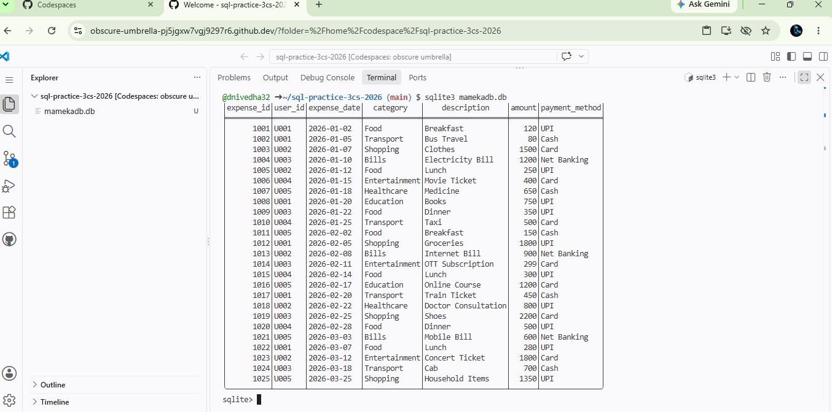

SQL Query 1: Display All Expenses

SELECT user_id, expense_date ,category, description,amount, payment_method
FROM personal_expenses ORDER BY expense_date;0 OUTPUT:

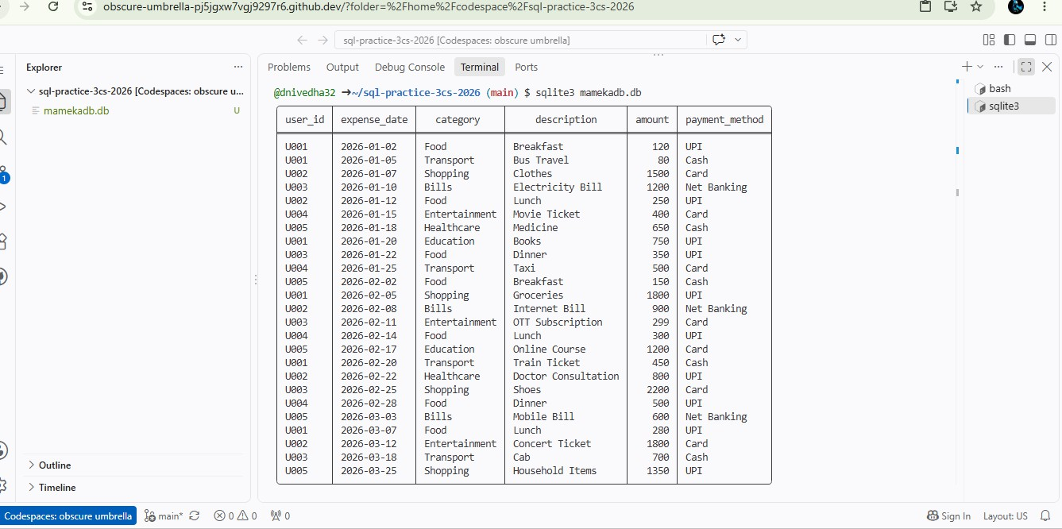
SELECT strftime('%Y-%m', expense_date) AS expense_month, SUM(amount) AS total_monthly_expenses
FROM personal_expenses

GROUP BY strftime('%Y-%m', expense_date) ORDER BY expense_month;

OUTPUT:
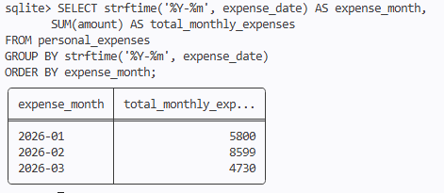

SELECT category,

SUM(amount) AS total_spending

FROM personal_expenses GROUP BY category
ORDER BY total_spending DESC; OUTPUT:
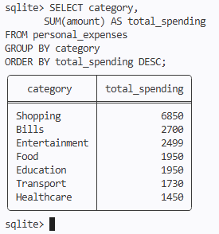

SELECT expense_id, user_id, expense_date, category, description, amount, payment_method
FROM personal_expenses ORDER BY amount DESC LIMIT 5;

OUTPUT:

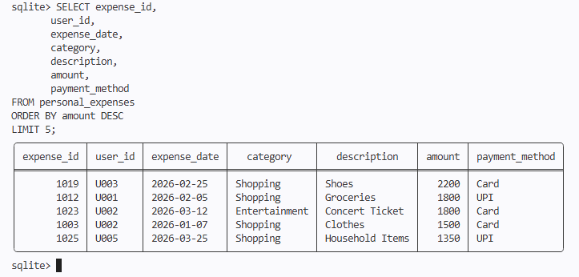

SELECT payment_method, COUNT(*) AS transaction_count, SUM(amount) AS total_spending
FROM personal_expenses GROUP BY payment_method ORDER BY total_spending DESC; OUTPUT:
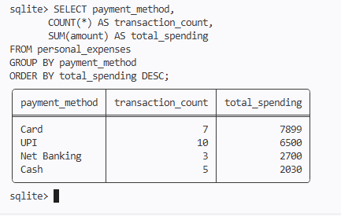

INSERT INTO personal_expenses (expense_id, user_id, expense_date, category,

description, amount, payment_method) SELECT 1026,

'U001', '2026-03-28',
'Food',

'Dinner', 450, 'UPI'
WHERE 450 > 0 AND 'Food' IN (
'Food', 'Transport', 'Bills', 'Shopping', 'Entertainment', 'Healthcare', 'Education'

); OUTPUT:

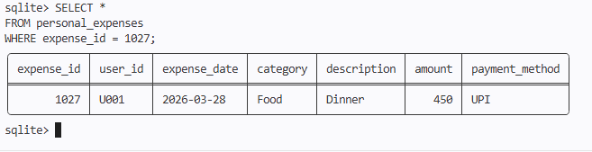

SELECT user_id,

SUM(amount) AS total_monthly_expense FROM personal_expenses
WHERE user_id = 'U001'

AND strftime('%Y-%m', expense_date) = '2026-03' GROUP BY user_id;

OUTPUT:
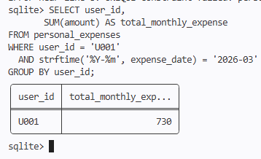

SELECT

'U001' AS user_id,

'2026-03' AS expense_month,

1000 AS budget,

COALESCE(SUM(amount), 0) AS total_expense, 1000 - COALESCE(SUM(amount), 0) AS balance, CASE
WHEN COALESCE(SUM(amount), 0) > 1000 THEN 'BUDGET EXCEEDED'

ELSE 'WITHIN BUDGET'

END AS status

FROM personal_expenses WHERE user_id = 'U001'
AND strftime('%Y-%m', expense_date) = '2026-03'; OUTPUT:
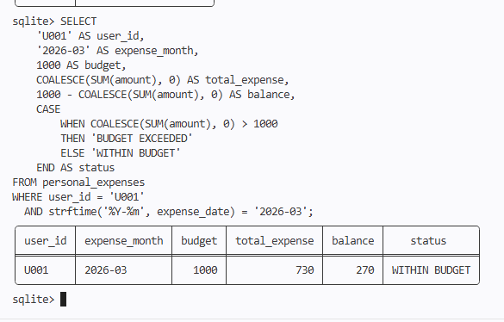

EXCEPTION HANDLING:

Test Case 1: Actual INSERT with validation SELECT

CASE

WHEN 450 <= 0

THEN 'ERROR: Amount must be greater than zero'

WHEN 'Food' NOT IN (

'Food', 'Transport', 'Bills', 'Shopping', 'Entertainment', 'Healthcare', 'Education'
)

THEN 'ERROR: Invalid category'

WHEN EXISTS ( SELECT 1
FROM personal_expenses WHERE expense_id = 1027
)

THEN 'ERROR: Expense ID already exists'

ELSE 'SUCCESS: Expense can be added'

END AS result;

OUTPUT:
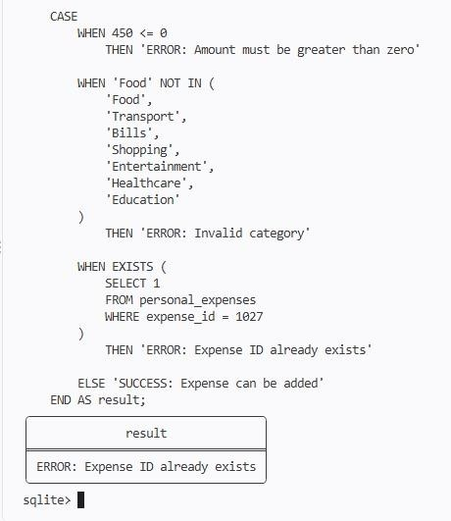

Test Case 2: Check result SELECT
CASE

WHEN EXISTS ( SELECT 1
FROM personal_expenses WHERE expense_id = 1027
)

THEN 'Expense inserted successfully' ELSE 'Expense was not inserted'
END AS result;

OUTPUT:

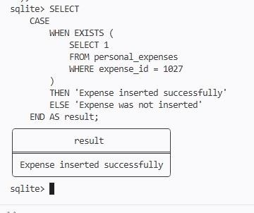
Dataset Insights
- The dataset contains 25 personal expense records.
- The expenses belong to categories such as Food, Transport, Shopping, Bills, Entertainment, Healthcare, and Education.
- The payment methods include UPI, Cash, Card, and Net Banking.
- Monthly expenses can be analyzed using the expense date and amount.
- The highest individual expenses can be identified using SQL.
- Category-wise aggregation helps analyze the total spending for each expense category.
- Payment-method-wise analysis helps identify the number of transactions and total spending.

Result
Thus, the Personal Finance and Expense Management system was successfully implemented using SQLite. The required PERSONAL_EXPENSES table was created, 25 expense records were inserted, SQL queries were executed successfully, monthly and category-wise expenses were analyzed, highest expenses were identified, and payment-method-wise spending was calculated. Validation and error handling were also implemented using SQLite queries.

Book list database
What are your favorite books? You can make a database table to store them in! In this first step, create a table to store your list of books. It should have columns for id, name, and rating.

INPUT:
CREATE TABLE BOOKS(
id INTEGER PRIMARY KEY,
name TEXT, rating INTEGER
);
INSERT INTO BOOKS(id,name,rating) VALUES
(1, 'C programing language',10),
(2, 'Java programming language',9), (3, 'python programming language',7);

OUTPUT:
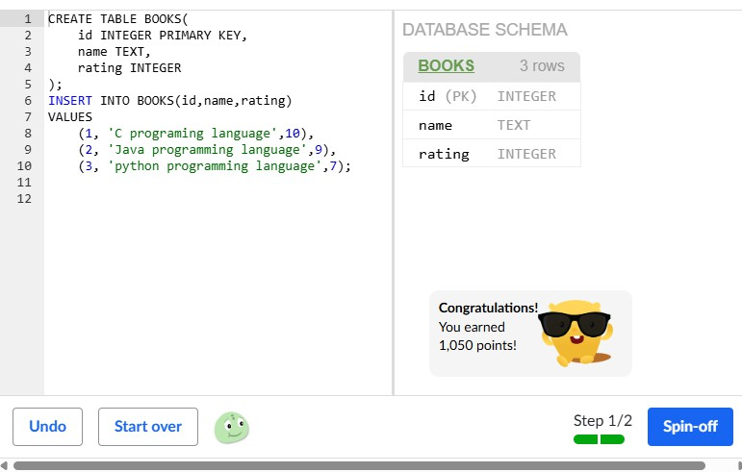

Box office hits database
This database contains an incomplete list of box office hits and their release year. In this challenge, you're going to get the results back out of the database in different ways! In this first step, just select all the movies.

INPUT:
CREATE TABLE movies (id INTEGER PRIMARY KEY, name TEXT, release_year INTEGER);
INSERT INTO movies VALUES (1, "Avatar", 2009); INSERT INTO movies VALUES (2, "Titanic", 1997);
INSERT INTO movies VALUES (3, "Star Wars: Episode IV - A New Hope", 1977); INSERT INTO movies VALUES (4, "Shrek 2", 2004);
INSERT INTO movies VALUES (5, "The Lion King", 1994); INSERT INTO movies VALUES (6, "Disney's Up", 2009);
SELECT*FROM movies;

SELECT *FROM movies WHERE release_year >= 2000 ORDER BY release_year ASC; OUTPUT:
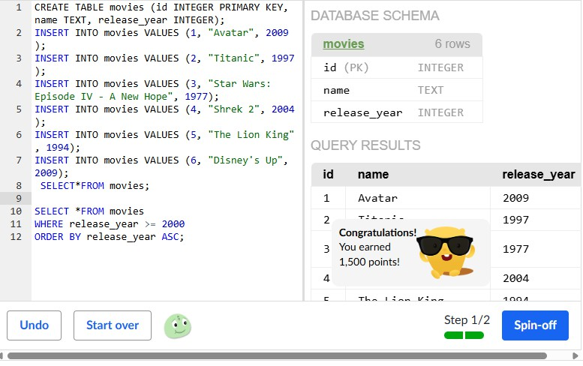

TODO list database stats

Here's a table containing a TODO list with the number of minutes it will take to complete each item. Insert another item to your todo list with the estimated minutes it will take.

INPUT:
CREATE TABLE todo_list (id INTEGER PRIMARY KEY, item TEXT, minutes INTEGER); INSERT INTO todo_list VALUES (1, "Wash the dishes", 15);
INSERT INTO todo_list VALUES (2, "vacuuming", 20);
INSERT INTO todo_list VALUES (3, "Learn some stuff on KA", 30); INSERT INTO todo_list VALUES (4,"Do homework", 45);
SELECT SUM(MINUTES) FROM todo_list;

OUTPUT:
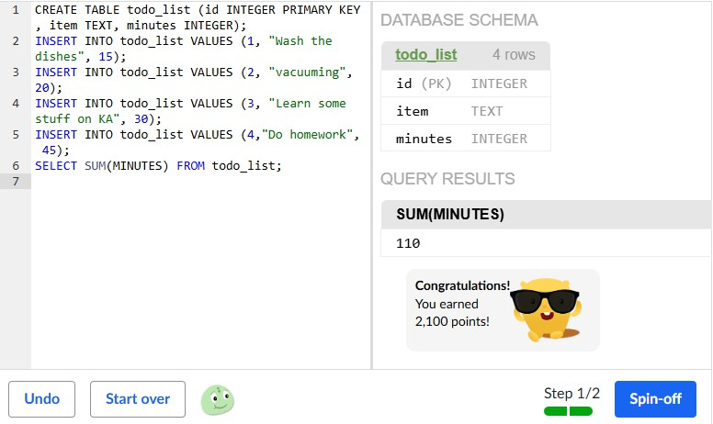

Design a store database
Create your own store! Your store should sell one type of things, like clothing or bikes, whatever you want your store to specialize in. You should have a table for all the items in your store, and at least 5 columns for the kind of data you think you'd need to store. You should sell at least 15 items, and use select statements to order your items by price and show at least one statistic about the items.

INPUT:
-- Create the database table CREATE TABLE store (
id INTEGER PRIMARY KEY,
item_name TEXT, category TEXT, brand TEXT, price REAL,
stock_quantity INTEGER
);

-- Insert 15 items
INSERT INTO store VALUES (1, 'Classic T-Shirt', 'Shirt', 'UrbanWear', 19.99, 40); INSERT INTO store VALUES (2, 'Hoodie', 'Sweatshirt', 'CozyFit', 39.99, 25); INSERT INTO store VALUES (3, 'Jeans', 'Pants', 'DenimPro', 49.99, 30);
INSERT INTO store VALUES (4, 'Sneakers', 'Shoes', 'FastStep', 69.99, 20);
INSERT INTO store VALUES (5, 'Baseball Cap', 'Accessories', 'CapZone', 14.99, 50); INSERT INTO store VALUES (6, 'Leather Jacket', 'Outerwear', 'StyleMax', 99.99, 10); INSERT INTO store VALUES (7, 'Shorts', 'Pants', 'SummerFit', 24.99, 35);
INSERT INTO store VALUES (8, 'Dress Shirt', 'Shirt', 'FormalLine', 44.99, 18); INSERT INTO store VALUES (9, 'Running Shoes', 'Shoes', 'SpeedRun', 79.99, 15);
INSERT INTO store VALUES (10, 'Socks (3-Pack)', 'Accessories', 'ComfyFeet', 9.99, 60); INSERT INTO store VALUES (11, 'Beanie', 'Accessories', 'WarmStyle', 12.99, 45);

INSERT INTO store VALUES (12, 'Polo Shirt', 'Shirt', 'ClassicWear', 29.99, 22); INSERT INTO store VALUES (13, 'Sweatpants', 'Pants', 'CozyFit', 34.99, 28); INSERT INTO store VALUES (14, 'Winter Coat', 'Outerwear', 'StyleMax', 129.99, 8); INSERT INTO store VALUES (15, 'Sandals', 'Shoes', 'BeachWalk', 24.99, 32);
-- Show all items ordered by price (lowest to highest) SELECT * FROM store
ORDER BY price ASC;
-- Show statistics about the items SELECT
COUNT(*) AS total_items, AVG(price) AS average_price, MIN(price) AS cheapest_item, MAX(price) AS most_expensive_item, SUM(stock_quantity) AS total_stock
FROM store;

OUTPUT:
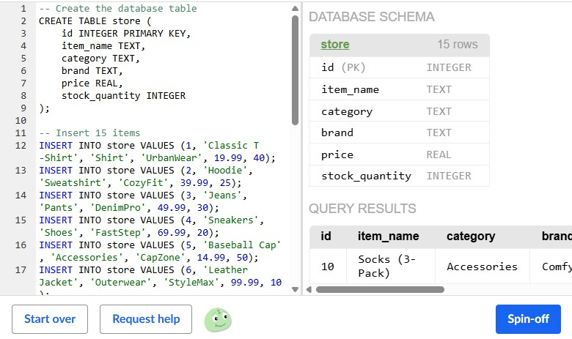

Karaoke song selector
Ever sung karaoke? It's a place where you sing songs with your friends, and it's a lot of fun. We've created a table with songs, and in this challenge, you'll use queries to decide what songs to sing. For the first step, select all the song titles.

INPUT:
CREATE TABLE songs (
id INTEGER PRIMARY KEY,
title TEXT, artist TEXT, mood TEXT,
duration INTEGER, released INTEGER);

INSERT INTO songs (title, artist, mood, duration, released) VALUES ("Bohemian Rhapsody", "Queen", "epic", 60, 1975);
INSERT INTO songs (title, artist, mood, duration, released) VALUES ("Let it go", "Idina Menzel", "epic", 227, 2013);
INSERT INTO songs (title, artist, mood, duration, released) VALUES ("I will survive", "Gloria Gaynor", "epic", 198, 1978);
INSERT INTO songs (title, artist, mood, duration, released) VALUES ("Twist and Shout", "The Beatles", "happy", 152, 1963);
INSERT INTO songs (title, artist, mood, duration, released) VALUES ("La Bamba", "Ritchie Valens", "happy", 166, 1958);
INSERT INTO songs (title, artist, mood, duration, released)
VALUES ("I will always love you", "Whitney Houston", "epic", 273, 1992); INSERT INTO songs (title, artist, mood, duration, released)
VALUES ("Sweet Caroline", "Neil Diamond", "happy", 201, 1969); INSERT INTO songs (title, artist, mood, duration, released)
VALUES ("Call me maybe", "Carly Rae Jepsen", "happy", 193, 2011);

SELECT title FROM songs; SELECT title FROM songs
WHERE mood = 'epic' OR released > 1990; SELECT title
FROM songs
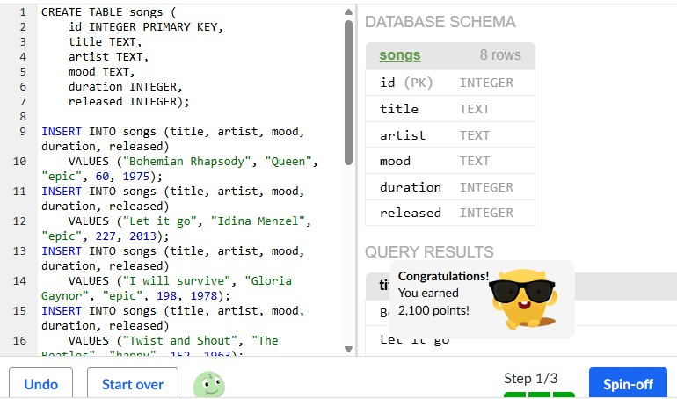
WHERE mood = "epic" AND released > 1990 AND duration < 240; OUTPUT:

Playlist maker
We've created a database of songs and artists, and you'll make playlists from them in this challenge. In this first step, select the title of all the songs by the artist named 'Queen'.

INPUT:
CREATE TABLE artists (
id INTEGER PRIMARY KEY AUTOINCREMENT,
name TEXT, country TEXT, genre TEXT);

INSERT INTO artists (name, country, genre) VALUES ("Taylor Swift", "US", "Pop"); INSERT INTO artists (name, country, genre)
VALUES ("Led Zeppelin", "US", "Hard rock"); INSERT INTO artists (name, country, genre)
VALUES ("ABBA", "Sweden", "Disco");
INSERT INTO artists (name, country, genre) VALUES ("Queen", "UK", "Rock");
INSERT INTO artists (name, country, genre) VALUES ("Celine Dion", "Canada", "Pop");
INSERT INTO artists (name, country, genre) VALUES ("Meatloaf", "US", "Hard rock");
INSERT INTO artists (name, country, genre) VALUES ("Garth Brooks", "US", "Country");
INSERT INTO artists (name, country, genre) VALUES ("Shania Twain", "Canada", "Country");
INSERT INTO artists (name, country, genre) VALUES ("Rihanna", "US", "Pop");
INSERT INTO artists (name, country, genre)

VALUES ("Guns N' Roses", "US", "Hard rock"); INSERT INTO artists (name, country, genre)
VALUES ("Gloria Estefan", "US", "Pop"); INSERT INTO artists (name, country, genre)
VALUES ("Bob Marley", "Jamaica", "Reggae");

CREATE TABLE songs (
id INTEGER PRIMARY KEY AUTOINCREMENT,
artist TEXT, title TEXT);

INSERT INTO songs (artist, title)
VALUES ("Taylor Swift", "Shake it off"); INSERT INTO songs (artist, title)
VALUES ("Rihanna", "Stay"); INSERT INTO songs (artist, title)
VALUES ("Celine Dion", "My heart will go on"); INSERT INTO songs (artist, title)
VALUES ("Celine Dion", "A new day has come"); INSERT INTO songs (artist, title)
VALUES ("Shania Twain", "Party for two"); INSERT INTO songs (artist, title)
VALUES ("Gloria Estefan", "Conga"); INSERT INTO songs (artist, title)
VALUES ("Led Zeppelin", "Stairway to heaven"); INSERT INTO songs (artist, title)
VALUES ("ABBA", "Mamma mia");
INSERT INTO songs (artist, title) VALUES ("Queen", "Bicycle Race");

INSERT INTO songs (artist, title)
VALUES ("Queen", "Bohemian Rhapsody"); INSERT INTO songs (artist, title)
VALUES ("Guns N' Roses", "Don't cry"); SELECT title
FROM songs
WHERE artist = "Queen"; SELECT name
FROM artists
WHERE genre = "Pop"; SELECT title
FROM songs WHERE artist IN (
SELECT name FROM artists
WHERE genre = "Pop"
);

OUTPUT:
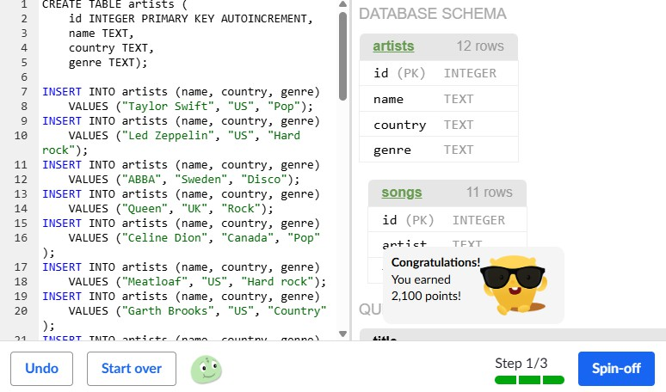

The wordiest author
We've created a database of a few popular authors and their books, with word counts for each book. In this first step, select all the authors who have written more than 1 million words, using GROUP BY and HAVING. Your results table should include the 'author' and their total word count as a 'total_words' column.

INPUT:
CREATE TABLE books (
id INTEGER PRIMARY KEY AUTOINCREMENT,
author TEXT, title TEXT,
words INTEGER);

INSERT INTO books (author, title, words)
VALUES ("J.K. Rowling", "Harry Potter and the Philosopher's Stone", 79944); INSERT INTO books (author, title, words)
VALUES ("J.K. Rowling", "Harry Potter and the Chamber of Secrets", 85141); INSERT INTO books (author, title, words)
VALUES ("J.K. Rowling", "Harry Potter and the Prisoner of Azkaban", 107253); INSERT INTO books (author, title, words)
VALUES ("J.K. Rowling", "Harry Potter and the Goblet of Fire", 190637); INSERT INTO books (author, title, words)
VALUES ("J.K. Rowling", "Harry Potter and the Order of the Phoenix", 257045); INSERT INTO books (author, title, words)
VALUES ("J.K. Rowling", "Harry Potter and the Half-Blood Prince", 168923); INSERT INTO books (author, title, words)
VALUES ("J.K. Rowling", "Harry Potter and the Deathly Hallows", 197651);

INSERT INTO books (author, title, words)
VALUES ("Stephenie Meyer", "Twilight", 118501); INSERT INTO books (author, title, words)

VALUES ("Stephenie Meyer", "New Moon", 132807); INSERT INTO books (author, title, words)
VALUES ("Stephenie Meyer", "Eclipse", 147930); INSERT INTO books (author, title, words)
VALUES ("Stephenie Meyer", "Breaking Dawn", 192196);

INSERT INTO books (author, title, words)
VALUES ("J.R.R. Tolkien", "The Hobbit", 95022); INSERT INTO books (author, title, words)
VALUES ("J.R.R. Tolkien", "Fellowship of the Ring", 177227); INSERT INTO books (author, title, words)
VALUES ("J.R.R. Tolkien", "Two Towers", 143436); INSERT INTO books (author, title, words)
VALUES ("J.R.R. Tolkien", "Return of the King", 134462); SELECT
author,
SUM(words) AS total_words FROM books
GROUP BY author
HAVING SUM(words) > 1000000;

SELECT
author,
AVG(words) AS avg_words FROM books
GROUP BY author
HAVING AVG(words) > 150000;

OUTPUT:
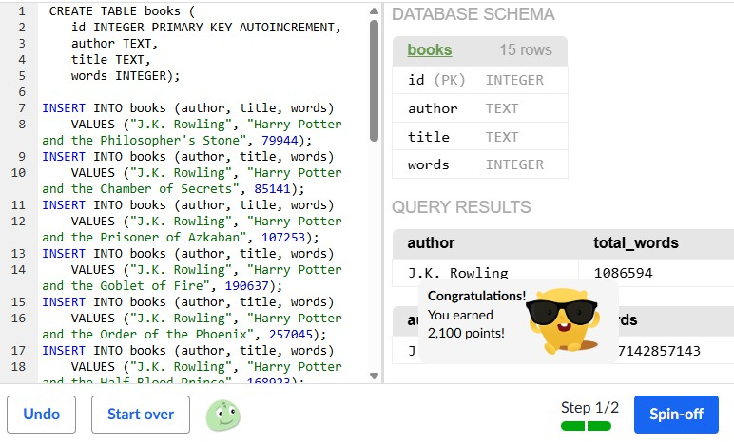

Gradebook
We've created a database to track student grades, with their name, number grade, and what percent of activities they've completed. In this first step, select all of the rows, and display
the name, number_grade, and percent_completed, which you can compute by multiplying and rounding the fraction_completed column.

INPUT:
CREATE TABLE student_grades (
id INTEGER PRIMARY KEY AUTOINCREMENT,
name TEXT, number_grade INTEGER,
fraction_completed REAL);

INSERT INTO student_grades (name, number_grade, fraction_completed) VALUES ("Winston", 90, 0.805);
INSERT INTO student_grades (name, number_grade, fraction_completed) VALUES ("Winnefer", 95, 0.901);
INSERT INTO student_grades (name, number_grade, fraction_completed) VALUES ("Winsteen", 85, 0.906);
INSERT INTO student_grades (name, number_grade, fraction_completed) VALUES ("Wincifer", 66, 0.7054);
INSERT INTO student_grades (name, number_grade, fraction_completed) VALUES ("Winster", 76, 0.5013);
INSERT INTO student_grades (name, number_grade, fraction_completed) VALUES ("Winstonia", 82, 0.9045);

SELECT name, number_grade,
ROUND(fraction_completed * 100) AS percent_completed FROM student_grades;
SELECT COUNT(*),

CASE
WHEN number_grade > 90 THEN 'A' WHEN number_grade > 80 THEN 'B' WHEN number_grade > 70 THEN 'C' ELSE 'F'
END AS "letter_grade" FROM student_grades GROUP BY
CASE
WHEN number_grade > 90 THEN 'A' WHEN number_grade > 80 THEN 'B' WHEN number_grade > 70 THEN 'C' ELSE 'F'
END;

OUTPUT:

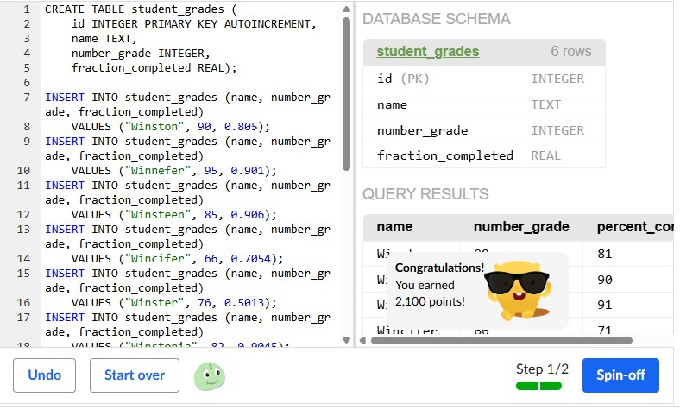

Data dig
Pick one of those data sets or create a data set like that, and use advanced SELECT queries to discover things about the data. What sort of questions might one have about that data, like if they were using it for an app or a business idea? Here are some ideas:
- What are average, max, and min values in the data?
- What about those numbers per category in the data (using HAVING)?
- What ways are there to group the data values that don’t exist yet (using CASE)?
- What interesting ways are there to filter the data (using AND/OR)?

INPUT:
CREATE TABLE students (
id INTEGER PRIMARY KEY,
name TEXT, department TEXT, gender TEXT,
age INTEGER,
marks INTEGER, attendance REAL
);
INSERT INTO students VALUES
(1, 'Alice', 'Computer Science', 'Female', 20, 88, 95.5),
(2, 'Bob', 'Computer Science', 'Male', 21, 76, 90.0),
(3, 'Charlie', 'Mathematics', 'Male', 22, 91, 98.0),
(4, 'David', 'Physics', 'Male', 20, 67, 82.5),
(5, 'Emma', 'Computer Science', 'Female', 21, 95, 99.0),
(6, 'Frank', 'Physics', 'Male', 23, 72, 85.0),
(7, 'Grace', 'Mathematics', 'Female', 20, 84, 93.0),
(8, 'Henry', 'Physics', 'Male', 22, 58, 75.5),
(9, 'Ivy', 'Computer Science', 'Female', 19, 81, 91.5),
(10, 'Jack', 'Mathematics', 'Male', 21, 89, 96.0);/* Put your data in here and query it! */

OUTPUT:
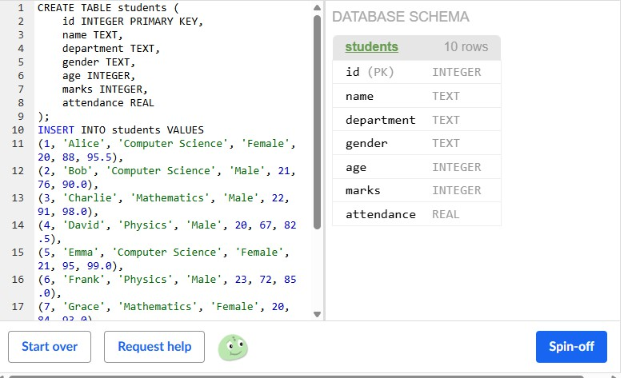

Bobby's Hobbies
We've created a database of people and hobbies, and each row in hobbies is related to a row in persons via the person_id column. In this first step, insert one more row in persons and then one more row in hobbies that is related to the newly inserted person.

INPUT:
CREATE TABLE persons (
id INTEGER PRIMARY KEY AUTOINCREMENT,
name TEXT, age INTEGER);

INSERT INTO persons (name, age) VALUES ("Bobby McBobbyFace", 12); INSERT INTO persons (name, age) VALUES ("Lucy BoBucie", 25); INSERT INTO persons (name, age) VALUES ("Banana FoFanna", 14); INSERT INTO persons (name, age) VALUES ("Shish Kabob", 20); INSERT INTO persons (name, age) VALUES ("Fluffy Sparkles", 8);

CREATE table hobbies (
id INTEGER PRIMARY KEY AUTOINCREMENT,
person_id INTEGER, name TEXT);

INSERT INTO hobbies (person_id, name) VALUES (1, "drawing"); INSERT INTO hobbies (person_id, name) VALUES (1, "coding"); INSERT INTO hobbies (person_id, name) VALUES (2, "dancing"); INSERT INTO hobbies (person_id, name) VALUES (2, "coding"); INSERT INTO hobbies (person_id, name) VALUES (3, "skating"); INSERT INTO hobbies (person_id, name) VALUES (3, "rowing"); INSERT INTO hobbies (person_id, name) VALUES (3, "drawing"); INSERT INTO hobbies (person_id, name) VALUES (4, "coding");

INSERT INTO hobbies (person_id, name) VALUES (4, "dilly-dallying"); INSERT INTO hobbies (person_id, name) VALUES (4, "meowing");

INSERT INTO persons (name, age) VALUES ("Alice", 25);

INSERT INTO hobbies (person_id,name) VALUES (4, "Painting");
SELECT
persons.name, hobbies.name
FROM persons JOIN hobbies
ON persons.id = hobbies.person_id; SELECT
persons.name, hobbies.name
FROM persons JOIN hobbies
ON persons.id = hobbies.person_id
WHERE persons.name = 'Bobby McBobbyFace';

OUTPUT:

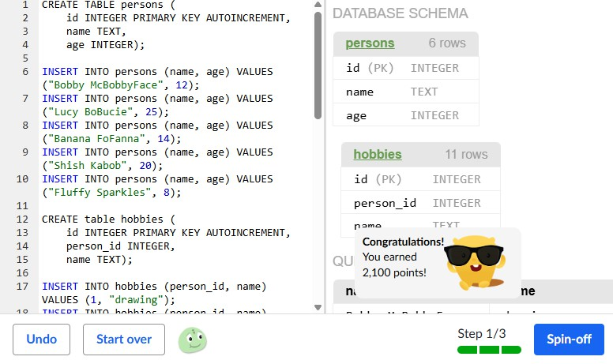

Customer's orders
We've created a database for customers and their orders. Not all of the customers have made orders, however. Come up with a query that lists the name and email of every customer followed by the item and price of orders they've made. Use a LEFT OUTER JOIN so that a customer is listed even if they've made no orders, and don't add any ORDER BY.

INPUT:
CREATE TABLE customers (
id INTEGER PRIMARY KEY AUTOINCREMENT,
name TEXT, email TEXT);

INSERT INTO customers (name, email) VALUES ("Doctor Who", "doctorwho@timelords.com");
INSERT INTO customers (name, email) VALUES ("Harry Potter", "harry@potter.com");
INSERT INTO customers (name, email) VALUES ("Captain Awesome", "captain@awesome.com");

CREATE TABLE orders (
id INTEGER PRIMARY KEY AUTOINCREMENT,
customer_id INTEGER, item TEXT,
price REAL);

INSERT INTO orders (customer_id, item, price) VALUES (1, "Sonic Screwdriver", 1000.00); INSERT INTO orders (customer_id, item, price)
VALUES (2, "High Quality Broomstick", 40.00); INSERT INTO orders (customer_id, item, price)
VALUES (1, "TARDIS", 1000000.00); SELECT

customers.name, customers.email, orders.item, orders.price
FROM customers
LEFT OUTER JOIN orders
ON customers.id = orders.customer_id; SELECT
customers.name, customers.email,
SUM(orders.price) AS total_spent FROM customers
LEFT OUTER JOIN orders
ON customers.id = orders.customer_id GROUP BY customers.id
ORDER BY total_spent DESC;

OUTPUT:
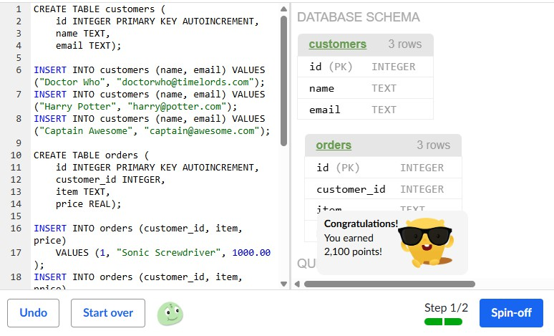

Sequels in SQL
We've created a table with all the 'Harry Potter' movies, with a sequel_id column that matches the id of the sequel for each movie. Issue a SELECT that will show the title of each movie next to its sequel's title (or NULL if it doesn't have a sequel).

INPUT:
CREATE TABLE movies (id INTEGER PRIMARY KEY AUTOINCREMENT,
title TEXT,
released INTEGER, sequel_id INTEGER);

INSERT INTO movies
VALUES (1, "Harry Potter and the Philosopher's Stone", 2001, 2); INSERT INTO movies
VALUES (2, "Harry Potter and the Chamber of Secrets", 2002, 3); INSERT INTO movies
VALUES (3, "Harry Potter and the Prisoner of Azkaban", 2004, 4); INSERT INTO movies
VALUES (4, "Harry Potter and the Goblet of Fire", 2005, 5); INSERT INTO movies
VALUES (5, "Harry Potter and the Order of the Phoenix ", 2007, 6); INSERT INTO movies
VALUES (6, "Harry Potter and the Half-Blood Prince", 2009, 7); INSERT INTO movies
VALUES (7, "Harry Potter and the Deathly Hallows – Part 1", 2010, 8); INSERT INTO movies
VALUES (8, "Harry Potter and the Deathly Hallows – Part 2", 2011, NULL); SELECT
m1.title,

m2.title AS sequel_title FROM movies AS m1
LEFT OUTER JOIN movies AS m2 ON m1.sequel_id = m2.id;

OUTPUT:
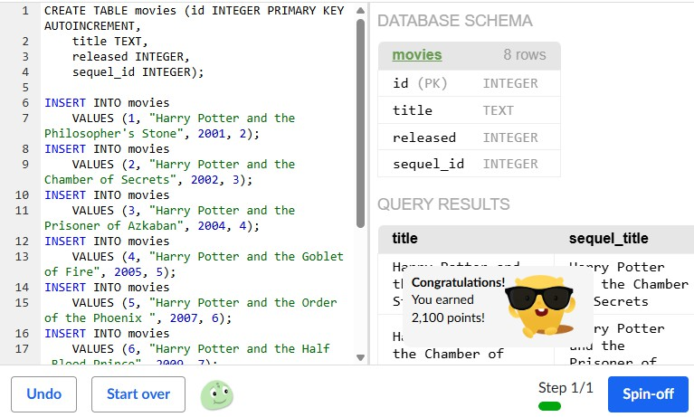

FriendBook
We've created a database for a friend networking site, with a table storing data on each person, a table on each person's hobbies, and a table of friend connections between the people. In this first step, use a JOIN to display a table showing people's names with their hobbies.

INPUT:
CREATE TABLE persons (
id INTEGER PRIMARY KEY AUTOINCREMENT,
fullname TEXT, age INTEGER);

INSERT INTO persons (fullname, age) VALUES ("Bobby McBobbyFace", "12"); INSERT INTO persons (fullname, age) VALUES ("Lucy BoBucie", "25"); INSERT INTO persons (fullname, age) VALUES ("Banana FoFanna", "14"); INSERT INTO persons (fullname, age) VALUES ("Shish Kabob", "20"); INSERT INTO persons (fullname, age) VALUES ("Fluffy Sparkles", "8");

CREATE table hobbies (
id INTEGER PRIMARY KEY AUTOINCREMENT,
person_id INTEGER, name TEXT);

INSERT INTO hobbies (person_id, name) VALUES (1, "drawing"); INSERT INTO hobbies (person_id, name) VALUES (1, "coding"); INSERT INTO hobbies (person_id, name) VALUES (2, "dancing"); INSERT INTO hobbies (person_id, name) VALUES (2, "coding"); INSERT INTO hobbies (person_id, name) VALUES (3, "skating"); INSERT INTO hobbies (person_id, name) VALUES (3, "rowing"); INSERT INTO hobbies (person_id, name) VALUES (3, "drawing"); INSERT INTO hobbies (person_id, name) VALUES (4, "coding");

INSERT INTO hobbies (person_id, name) VALUES (4, "dilly-dallying"); INSERT INTO hobbies (person_id, name) VALUES (4, "meowing");

CREATE table friends (
id INTEGER PRIMARY KEY AUTOINCREMENT,
person1_id INTEGER, person2_id INTEGER);

INSERT INTO friends (person1_id, person2_id) VALUES (1, 4);
INSERT INTO friends (person1_id, person2_id) VALUES (2, 3);

SELECT persons.fullname, hobbies.name
FROM persons JOIN hobbies
ON persons.id = hobbies.person_id;

SELECT p1.fullname AS person1, p2.fullname AS person2
FROM friends JOIN persons AS p1
ON friends.person1_id = p1.id JOIN persons AS p2
ON friends.person2_id = p2.id;

OUTPUT:

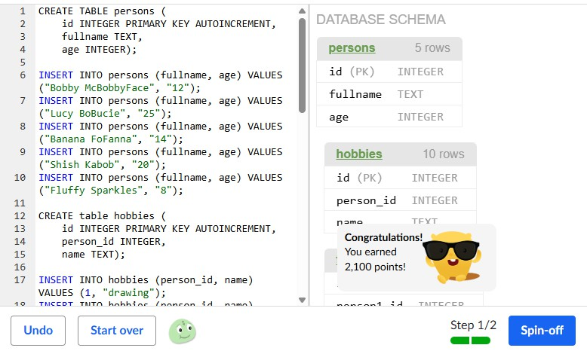

Famous people
In this project, you’re going to make your own table with some small set of “famous people”, then make more tables about things they do and join those to create nice human readable lists.

INPUT:
-- Create Authors table CREATE TABLE authors (
id INTEGER PRIMARY KEY,
name TEXT, country TEXT
);

INSERT INTO authors VALUES
(1, 'J.K. Rowling', 'United Kingdom'), (2, 'George Orwell', 'United Kingdom'), (3, 'Chetan Bhagat', 'India');

-- Create Books table CREATE TABLE books (
id INTEGER PRIMARY KEY,
title TEXT,
author_id INTEGER, year_published INTEGER
);

INSERT INTO books VALUES
(1, 'Harry Potter and the Philosopher''s Stone', 1, 1997), (2, 'Harry Potter and the Chamber of Secrets', 1, 1998), (3, '1984', 2, 1949),
(4, 'Animal Farm', 2, 1945),

(5, 'Five Point Someone', 3, 2004);

-- Create Awards table CREATE TABLE awards (
id INTEGER PRIMARY KEY,
award_name TEXT, author_id INTEGER
);

INSERT INTO awards VALUES
(1, 'British Book Awards', 1),
(2, 'Prometheus Hall of Fame Award', 2), (3, 'CNN-IBN Indian of the Year', 3);

-- Query 1: Authors and their books SELECT
authors.name, authors.country, books.title, books.year_published
FROM authors JOIN books
ON authors.id = books.author_id;

-- Query 2: Authors and their awards SELECT
authors.name, awards.award_name
FROM authors

JOIN awards
ON authors.id = awards.author_id;/* Create table about the people and what they do here */

OUTPUT:

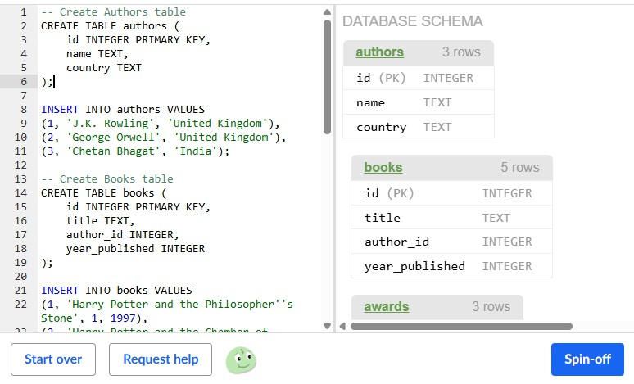

Dynamic Documents
We've created a database for a documents app, with rows for each document with it's title, content, and author. In this first step, use UPDATE to change the author to 'Jackie Draper' for all rows where it's currently 'Jackie Paper'. Then re-select all the rows to make sure the table changed like you expected.

INPUT:
CREATE table documents (
id INTEGER PRIMARY KEY AUTOINCREMENT,
title TEXT, content TEXT, author TEXT);

INSERT INTO documents (author, title, content)
VALUES ("Puff T.M. Dragon", "Fancy Stuff", "Ceiling wax, dragon wings, etc."); INSERT INTO documents (author, title, content)
VALUES ("Puff T.M. Dragon", "Living Things", "They're located in the left ear, you know.");
INSERT INTO documents (author, title, content)
VALUES ("Jackie Paper", "Pirate Recipes", "Cherry pie, apple pie, blueberry pie."); INSERT INTO documents (author, title, content)
VALUES ("Jackie Paper", "Boat Supplies", "Rudder - guitar. Main mast - bed post."); INSERT INTO documents (author, title, content)
VALUES ("Jackie Paper", "Things I'm Afraid Of", "Talking to my parents, the sea, giant pirates, heights.");

SELECT * FROM documents;

UPDATE documents
SET author = 'Jackie Draper' WHERE author = 'Jackie Paper';

SELECT *
FROM documents; DELETE FROM documents
WHERE title = "Things I'm Afraid Of"; SELECT *
FROM documents;

OUTPUT:

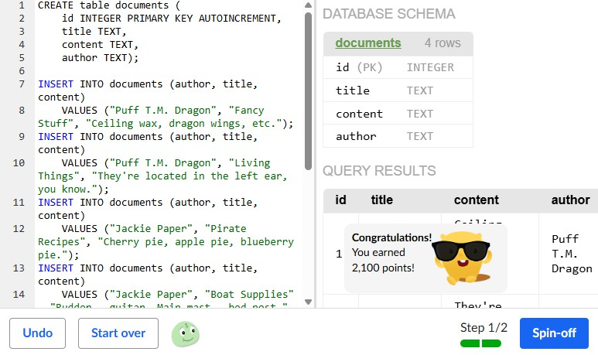

Clothing alterations
We've created a database of clothes, and decided we need a price column. Use ALTER to add a 'price' column to the table. Then select all the columns in each row to see what your table looks like now.

INPUT:
CREATE TABLE clothes (
id INTEGER PRIMARY KEY AUTOINCREMENT,
type TEXT, design TEXT);

INSERT INTO clothes (type, design) VALUES ("dress", "pink polka dots");
INSERT INTO clothes (type, design) VALUES ("pants", "rainbow tie-dye");
INSERT INTO clothes (type, design) VALUES ("blazer", "black sequin"); ALTER TABLE clothes
ADD COLUMN price REAL;

SELECT *
FROM clothes; UPDATE clothes SET price = 10 WHERE id = 1;

UPDATE clothes SET price = 20 WHERE id = 2;

UPDATE clothes SET price = 30 WHERE id = 3; SELECT *
FROM clothes;

INSERT INTO clothes (id, TYPE, price) VALUES (4, 'Jacket', 40);
SELECT *
FROM clothes;

OUTPUT:

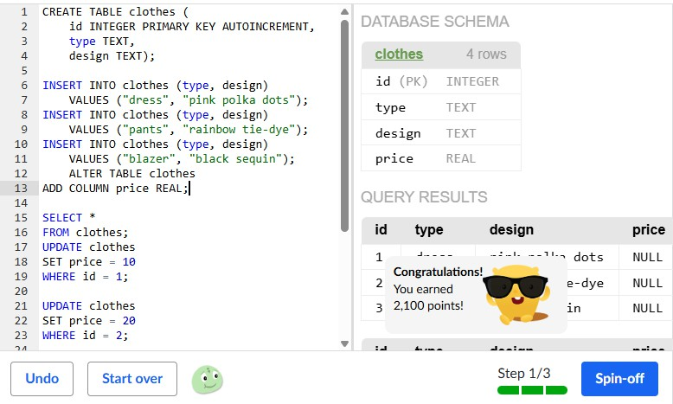

App impersonator

Think about your favorite apps, and pick one that stores your data- like a game that stores scores, an app that lets you post updates, etc. Now in this project, you're going to imagine that the app stores your data in a SQL database (which is pretty likely!), and write SQL statements that might look like their own SQL.
- CREATE a table to store the data.
- INSERT a few example rows in the table.
- Use an UPDATE to emulate what happens when you edit data in the app.
- Use a DELETE to emulate what happens when you delete data in the app.

INPUT:

-- Create table
CREATE TABLE posts (
id INTEGER PRIMARY KEY,
username TEXT, content TEXT, likes INTEGER
);

-- Insert example rows INSERT INTO posts VALUES
(1, 'alice', 'Hello everyone!', 15),
(2, 'bob', 'Enjoying my vacation.', 30), (3, 'charlie', 'Learning SQL is fun!', 20);

-- Update a post (user edits their post) UPDATE posts
SET content = 'Learning SQL is really fun!'

WHERE id = 3;

-- Delete a post (user deletes their post) DELETE FROM posts
WHERE id = 2;

-- View remaining posts SELECT * FROM posts;

OUTPUT:

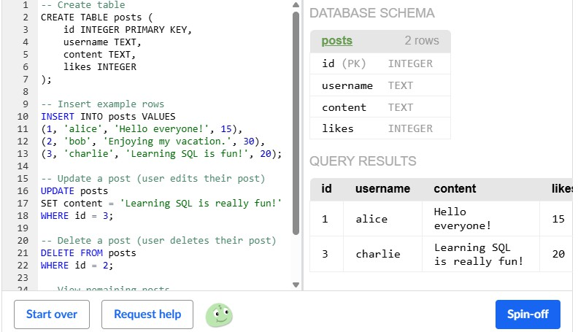

Revising the Select Query I
Query all columns for all American cities in the CITY table with populations larger than 100000. The CountryCode for America is USA.
The CITY table is described as follows:
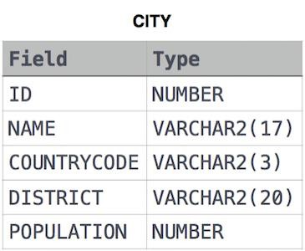

INPUT:
SELECT NAME FROM CITY
WHERE COUNTRYCODE = 'USA' AND POPULATION > 100000;

OUTPUT:
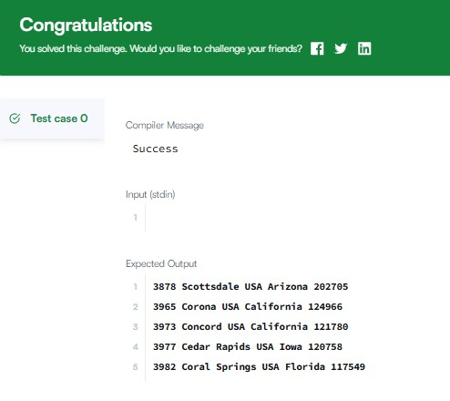

Revising the Select Query II

Query the NAME field for all American cities in the CITY table with populations larger than 120000. The CountryCode for America is USA.
The CITY table is described as follows:

INPUT:
SELECT NAME FROM CITY
WHERE COUNTRYCODE = 'USA' AND POPULATION > 120000;

OUTPUT:
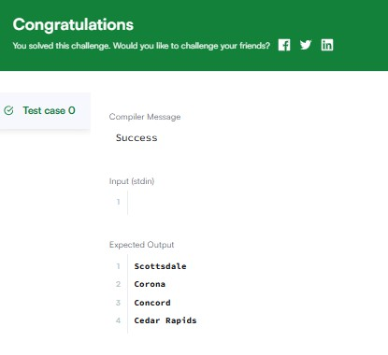

Select All
Query all columns (attributes) for every row in the CITY table. The CITY table is described as follows:

INPUT:
SELECT * FROM CITY;

OUTPUT:
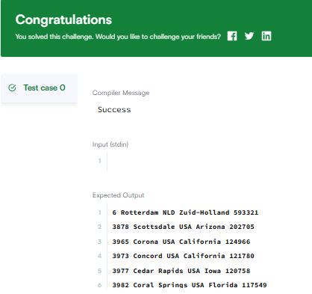

Select By ID
Query all columns for a city in CITY with the ID 1661. The CITY table is described as follows:

INPUT:
SELECT *FROM CITY WHERE ID = 1661;

OUTPUT:
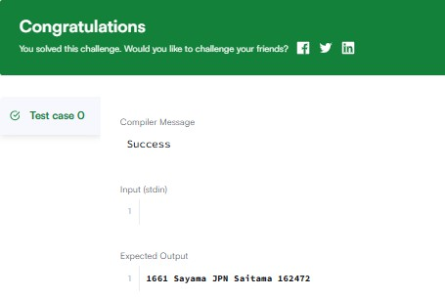

Japanese Cities' Attributes
Query all attributes of every Japanese city in the CITY table. The COUNTRYCODE for Japan is JPN.
The CITY table is described as follows:

INPUT:
SELECT * FROM CITY
WHERE COUNTRYCODE = 'JPN';

OUTPUT:
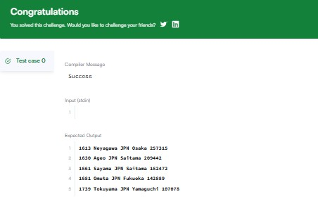

Japanese Cities' Names
Query the names of all the Japanese cities in the CITY table. The COUNTRYCODE for Japan is JPN.
The CITY table is described as follows:

INPUT:
select Name from City where CountryCode ='JPN';

OUTPUT:
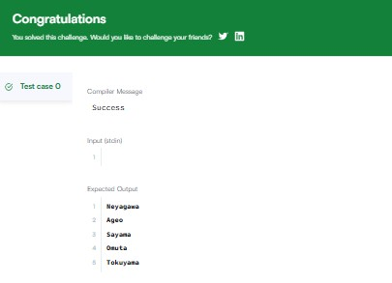

Weather Observation Station 1
Query a list of CITY and STATE from the STATION table. The STATION table is described as follows:
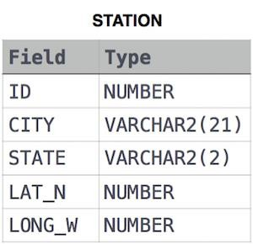

INPUT:
SELECT CITY, STATE FROM STATION;

OUTPUT:
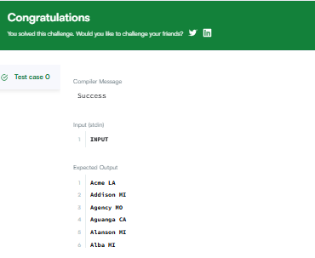

Weather Observation Station 3
Query a list of CITY names from STATION for cities that have an even ID number. Print the results in any order, but exclude duplicates from the answer.
The STATION table is described as follows:

INPUT:
SELECT DISTINCT CITY FROM STATION
WHERE ID % 2 = 0

OUTPUT:
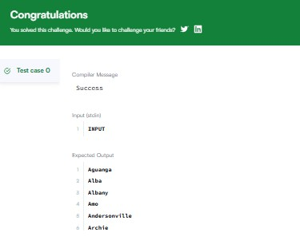

Weather Observation Station 4

Find the difference between the total number of CITY entries in the table and the number of distinct CITY entries in the table.
The STATION table is described as follows:

INPUT:
SELECT COUNT(CITY) - COUNT(DISTINCT CITY) FROM STATION

OUTPUT:
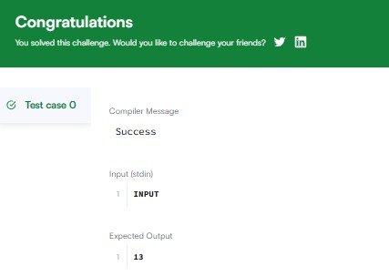

Weather Observation Station 5
Query the two cities in STATION with the shortest and longest CITY names, as well as their respective lengths (i.e.: number of characters in the name). If there is more than one smallest or largest city, choose the one that comes first when ordered
alphabetically.
The STATION table is described as follows:

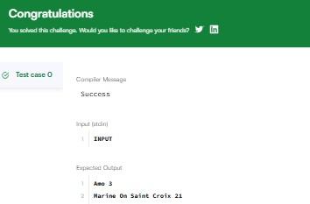
INPUT:
SELECT CITY, LENGTH(CITY) FROM STATION
ORDER BY LENGTH(CITY) ASC, CITY ASC LIMIT 1;
OUTPUT:

Weather Observation Station 6
Query the list of CITY names starting with vowels (i.e., a, e, i, o, or u) from STATION. Your result cannot contain duplicates.

Input Format
The STATION table is described as follows:

INPUT:
select distinct(city) from station where city like "a%" or
city like "e%" or city like "i%" or city like "o%" or city like "u%";
select distinct city from station where left(city,1) in('a','e','i','o','u') OUTPUT:

Weather Observation Station 7
Query the list of CITY names ending with vowels (a, e, i, o, u) from STATION. Your result cannot contain duplicates.

Input Format
The STATION table is described as follows:

INPUT:
select distinct city from station where right(city,1) in('a','e','i','o','u')

OUTPUT:
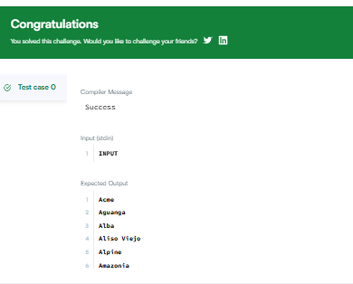

Weather Observation Station 8
Query the list of CITY names from STATION which have vowels (i.e., a, e, i, o, and u) as both their first and last characters. Your result cannot contain duplicates.

Input Format
The STATION table is described as follows:
INPUT:
select distinct city from station where left(city,1) in('a','e','i','o','u') and right(city,1) in('a','e','i','o','u')
OUTPUT:
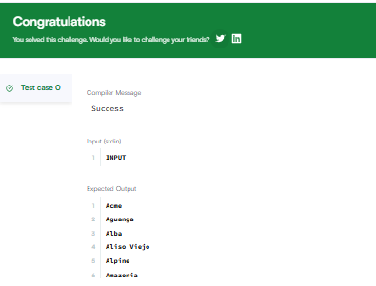

Weather Observation Station 9

. Query the list of CITY names ending with vowels (a, e, i, o, u) from STATION. Your result cannot contain duplicates.

Input Format
The STATION table is described as follows:
INPUT:
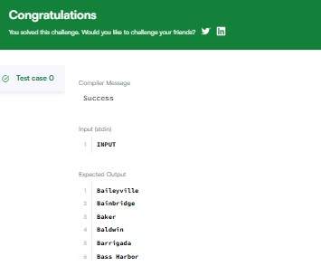
select distinct city from station where left(city,1) not in('a','e','i','o','u') OUTPUT:

Weather Observation Station 10
Query the list of CITY names from STATION that do not end with vowels. Your result cannot contain duplicates.
Input Format
The STATION table is described as follows:

INPUT:
select distinct(city) from station where city not like "%a" and
city not like "%e" and city not like "%i" and city not like "%o" and city not like "%u";

OUTPUT:
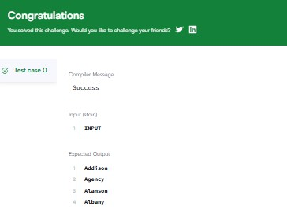

Weather Observation Station 11
Query the list of CITY names from STATION that either do not start with vowels or do not end with vowels. Your result cannot contain duplicates.
Input Format
The STATION table is described as follows:

INPUT:
select distinct city from station where left(city,1) not in('a','e','i','o','u') or right(city,1) not in('a','e','i','o','u');

OUTPUT:
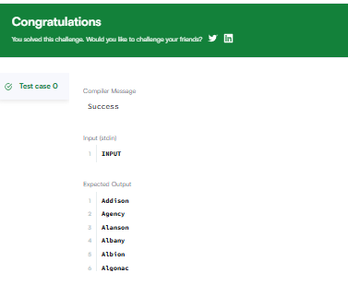

Weather Observation Station 12
Query the list of CITY names from STATION that do not start with vowels and do not end with vowels. Your result cannot contain duplicates.
Input Format
The STATION table is described as follows:

INPUT:
select distinct city from station where left(city,1) not in('a','e','i','o','u') and right(city,1) not in('a','e','i','o','u');

OUTPUT:
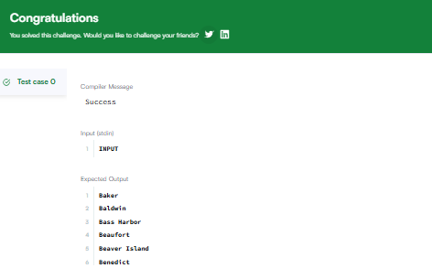

Higher Than 75 Marks
Query the Name of any student in STUDENTS who scored higher than Marks. Order your output by the last three characters of each name. If two or more students both have names ending in the same last three characters (i.e.: Bobby, Robby, etc.), secondary sort them by ascending ID.
Input Format
The STUDENTS table is described as
follows: 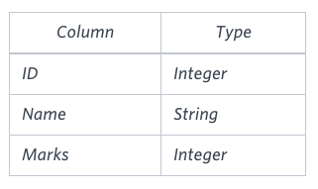

INPUT:
select name from students where marks > 75 order by right(name,3),id asc;

OUTPUT:
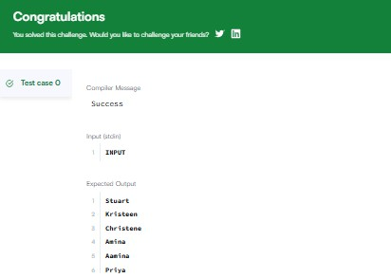

Employee Names
Write a query that prints a list of employee names (i.e.: the name attribute) from the Employee table in alphabetical order.
Input Format
The Employee table containing employee data for a company is described as follows:
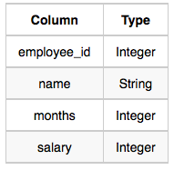

INPUT:
select name from employee order by name;

OUTPUT:
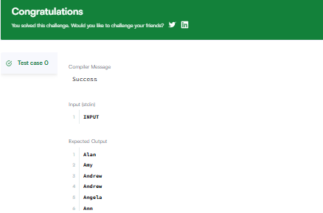

Employee Salaries
Write a query that prints a list of employee names (i.e.: the name attribute) for employees in Employee having a salary greater than per month who have been employees for less than months. Sort your result by ascending employee_id.
Input Format
The Employee table containing employee data for a company is described as follows:

INPUT:
select name from employee where salary > 2000 and months <10 order By employee_id;

OUTPUT:
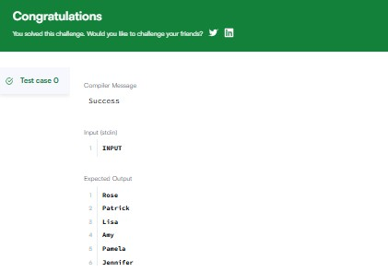

Type of Triangle
Write a query identifying the type of each record in the TRIANGLES table using its three side lengths. Output one of the following statements for each record in the table:
  - Equilateral: It's a triangle with sides of equal length.
  - Isosceles: It's a triangle with sides of equal length.
  - Scalene: It's a triangle with sides of differing lengths.
  - Not A Triangle: The given values of A, B, and C don't form a triangle.

Input Format
The TRIANGLES table is described as follows:
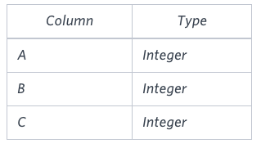
Each row in the table denotes the lengths of each of a triangle's three sides.

INPUT:
Select CASE
when A + B <= C or A + C <= B or B + C <= A then "Not A Triangle" when A = B and B = C then "Equilateral"
when A = B or A = C or B = C then "Isosceles" else "Scalene"
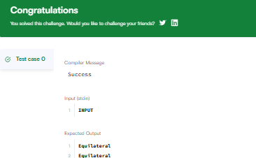
end as triangle_sides from TRIANGLES OUTPUT:

The PADS
Generate the following two result sets:
- Query an alphabetically ordered list of all names in OCCUPATIONS, immediately followed by the first letter of each profession as a parenthetical (i.e.: enclosed in parentheses). For
example: AnActorName(A), ADoctorName(D), AProfessorName(P), and ASingerName(S).
- Query the number of ocurrences of each occupation in OCCUPATIONS. Sort the occurrences in ascending order, and output them in the following format:
- There are a total of [occupation_count] [occupation]s.
where [occupation_count] is the number of occurrences of an occupation
in OCCUPATIONS and [occupation] is the lowercase occupation name. If more than one Occupation has the same [occupation_count], they should be ordered alphabetically.
Note: There will be at least two entries in the table for each type of occupation. Input Format
The OCCUPATIONS table is described as
follows: 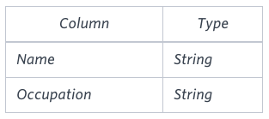 Occupation will only contain one
of the following values: Doctor, Professor, Singer or Actor.

INPUT:
SELECT CONCAT(NAME, "(", LEFT(Occupation , 1), ")") FROM OCCUPATIONS
ORDER BY NAME ASC;

SELECT CONCAT("There are a total of ", COUNT(Occupation), ' ', LOWER(Occupation), "s.")
FROM OCCUPATIONS
GROUP BY Occupation
ORDER BY COUNT(Occupation), Occupation ASC;

OUTPUT:

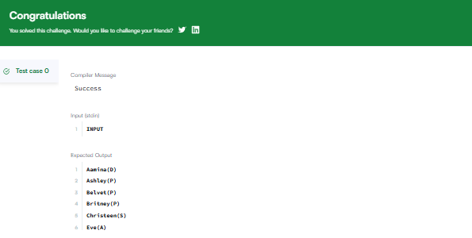

Occupations

Pivot the Occupation column in OCCUPATIONS so that each Name is sorted alphabetically and displayed underneath its corresponding Occupation. The output should consist of four columns (Doctor, Professor, Singer, and Actor) in that specific order, with their respective names listed alphabetically under each column.
Note: Print NULL when there are no more names corresponding to an occupation. Input Format
The OCCUPATIONS table is described as follows:
Occupation will only contain one of the following values: Doctor, Professor, Singer or Actor.

INPUT:
SELECT
MAX(CASE WHEN Occupation = 'Doctor' THEN Name END) AS Doctor, MAX(CASE WHEN Occupation = 'Professor' THEN Name END) AS Professor, MAX(CASE WHEN Occupation = 'Singer' THEN Name END) AS Singer, MAX(CASE WHEN Occupation = 'Actor' THEN Name END) AS Actor
FROM ( SELECT
Name, Occupation,
ROW_NUMBER() OVER (PARTITION BY Occupation ORDER BY Name) AS rn FROM OCCUPATIONS
) AS sub GROUP BY rn;

OUTPUT:

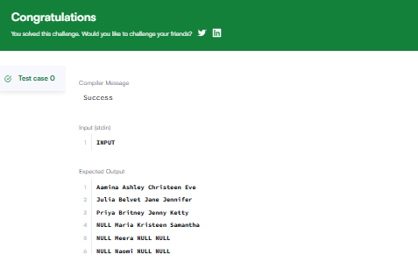

Binary Tree Nodes
You are given a table, BST, containing two columns: N and P, where N represents the value of a node in Binary Tree, and P is the parent of N.
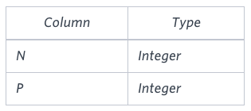
Write a query to find the node type of Binary Tree ordered by the value of the node. Output one of the following for each node:
  - Root: If node is root node.
  - Leaf: If node is leaf node.
  - Inner: If node is neither root nor leaf node.

INPUT:
SELECT BT.N, CASE
WHEN BT.P IS NULL THEN 'Root'
WHEN EXISTS (SELECT B.P FROM BST B WHERE B.P = BT.N) THEN 'Inner' ELSE 'Leaf'
END
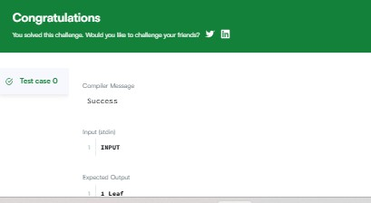
FROM BST AS BT ORDER BY BT.N OUTPUT:

New Companies
Amber's conglomerate corporation just acquired some new companies. Each of the
companies follows this hierarchy: 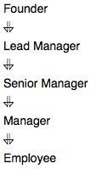
Given the table schemas below, write a query to print
the company_code, founder name, total number of lead managers, total number
of senior managers, total number of managers, and total number of employees. Order your output by ascending company_code.

INPUT:
SELECT c.company_code,c.founder, count(distinct lm.lead_manager_code), count(distinct sm.senior_manager_code), count(distinct m.manager_code),
count(distinct e.employee_code)
FROM Company c, Lead_Manager lm, Senior_Manager sm, Manager m, Employee e WHERE
c.company_code=lm.company_code AND
lm.lead_manager_code=sm.lead_manager_code AND sm.senior_manager_code=m.senior_manager_code AND m.manager_code=e.manager_code
GROUP BY c.company_code,c.founder ORDER BY c.company_code ASC

OUTPUT:

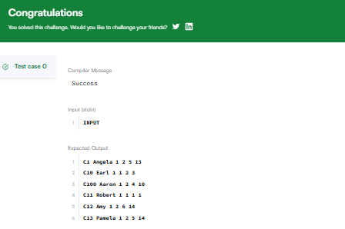

Revising Aggregations - The Count Function
Query a count of the number of cities in CITY having a Population larger than . Input Format
The CITY table is described as
follows:

INPUT:
SELECT COUNT(POPULATION) FROM CITY
WHERE POPULATION > 100000;

OUTPUT:

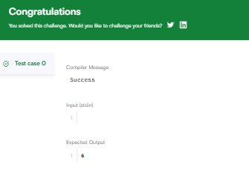

Revising Aggregations - The Sum Function
Query the total population of all cities in CITY where District is California. Input Format
The CITY table is described as
follows:

INPUT:
SELECT SUM(POPULATION) FROM CITY
WHERE DISTRICT = 'California';

OUTPUT:

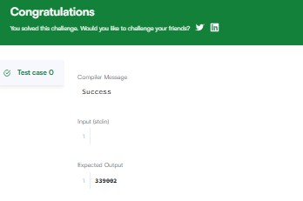

Revising Aggregations – Averages
Query the average population of all cities in CITY where District is California. Input Format
The CITY table is described as
follows:

INPUT:
SELECT AVG(POPULATION) FROM CITY
WHERE DISTRICT = 'California';

OUTPUT:

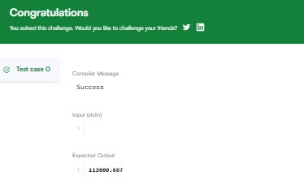

Average Population
Query the average population for all cities in CITY, rounded down to the nearest integer.

Input Format
The CITY table is described as
follows:

INPUT:
SELECT FLOOR(AVG(POPULATION)) FROM CITY;

OUTPUT:
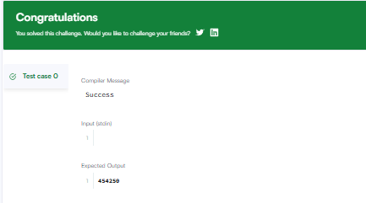

Japan Population
Query the sum of the populations for all Japanese cities in CITY. The COUNTRYCODE for Japan is JPN.
Input Format
The CITY table is described as
follows:

INPUT:
SELECT SUM(POPULATION) FROM CITY
WHERE COUNTRYCODE = 'JPN';

OUTPUT:
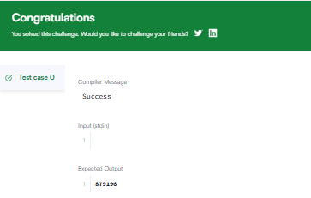

Population Density Difference
Query the difference between the maximum and minimum populations in CITY. Input Format
The CITY table is described as
follows:

INPUT:
SELECT MAX(POPULATION)-MIN(POPULATION) FROM CITY;

OUTPUT:

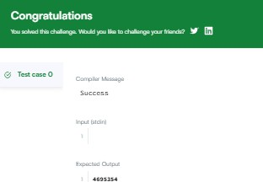

The Blunder
Samantha was tasked with calculating the average monthly salaries for all employees in the EMPLOYEES table, but did not realize her keyboard's key was broken until after completing the calculation. She wants your help finding the difference between her miscalculation (using salaries with any zeros removed), and the actual average salary.
Write a query calculating the amount of error (i.e.: average monthly salaries), and round it up to the next integer.
Input Format
The EMPLOYEES table is described as follows:
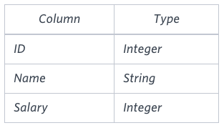
INPUT:
SELECT CEIL(AVG(Salary)-AVG(REPLACE(Salary,'0',''))) FROM EMPLOYEES;

OUTPUT:

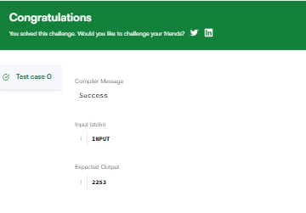

Top Earners
We define an employee's total earnings to be their monthly worked, and the maximum total earnings to be the maximum total earnings for any employee in the Employee table. Write a query to find the maximum total earnings for all employees as well as the total number of employees who have maximum total earnings. Then print these values as space-separated integers.

Input Format
The Employee table containing employee data for a company is described as follows:

INPUT:
SELECT MAX(SALARY*MONTHS), COUNT(*) FROM EMPLOYEE
WHERE (SALARY*MONTHS) = (SELECT MAX(SALARY*MONTHS) FROM EMPLOYEE);

OUTPUT:
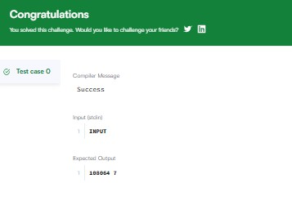

Weather Observation Station 2
Query the following two values from the STATION table:
- The sum of all values in LAT_N rounded to a scale of decimal places.
- The sum of all values in LONG_W rounded to a scale of decimal places.

Input Format
The STATION table is described as follows:

INPUT:
SELECT ROUND(SUM(LAT_N), 2), ROUND(SUM(LONG_W), 2) FROM STATION;

OUTPUT:
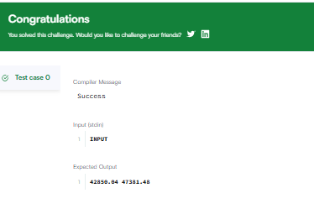

Weather Observation Station 13
Query the sum of Northern Latitudes (LAT_N) from STATION having values greater than and less than . Truncate your answer to decimal places.
Input Format
The STATION table is described as follows:

INPUT:
SELECT TRUNCATE(SUM(LAT_N), 4) FROM STATION
WHERE LAT_N > 38.7880 AND LAT_N < 137.2345;

OUTPUT:
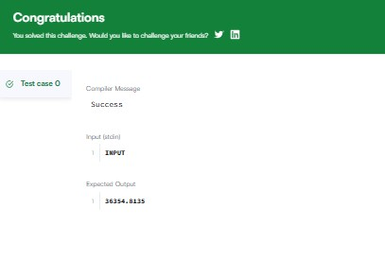

Weather Observation Station 14
Query the greatest value of the Northern Latitudes (LAT_N) from STATION that is less than . Truncate your answer to decimal places.

Input Format
The STATION table is described as follows:

INPUT:
SELECT ROUND(MAX(LAT_N), 4) FROM STATION
WHERE LAT_N < 137.2345;

OUTPUT:
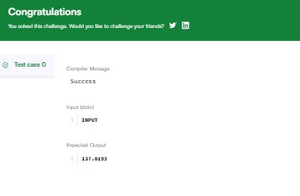

Weather Observation Station 15
Query the Western Longitude (LONG_W) for the largest Northern Latitude (LAT_N) in STATION that is less than . Round your answer to decimal places.
Input Format
The STATION table is described as follows:
INPUT:
SELECT ROUND(LONG_W, 4) FROM STATION
WHERE LAT_N = (

SELECT MAX(LAT_N)
FROM STATION

WHERE LAT_N < 137.2345

);

OUTPUT:

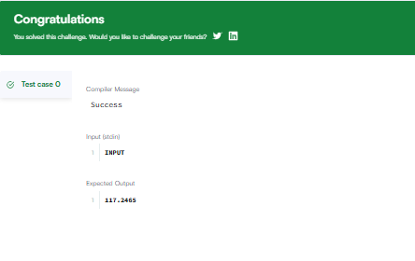

Weather Observation Station 16
Query the smallest Northern Latitude (LAT_N) from STATION that is greater than . Round your answer to decimal places.

Input Format
The STATION table is described as follows:
INPUT:
SELECT ROUND(MIN(LAT_N), 4) FROM STATION
WHERE LAT_N > 38.7780; OUTPUT:
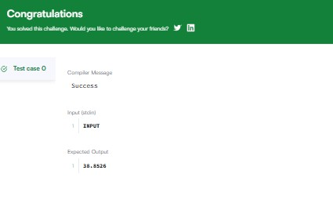

Weather Observation Station 17
Query the Western Longitude (LONG_W)where the smallest Northern Latitude (LAT_N) in STATION is greater than . Round your answer to decimal places.

Input Format
The STATION table is described as follows:

INPUT:
SELECT ROUND(LONG_W, 4) FROM STATION
WHERE LAT_N = ( SELECT MIN(LAT_N) FROM STATION
WHERE LAT_N > 38.7780
);

OUTPUT:
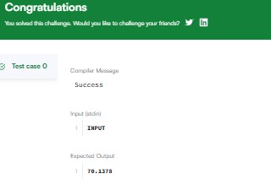

Weather Observation Station 18
Consider and to be two points on a 2D plane.
  - happens to equal the minimum value in Northern Latitude (LAT_N in STATION).
  - happens to equal the minimum value in Western Longitude (LONG_W in STATION).
  - happens to equal the maximum value in Northern Latitude (LAT_N in STATION).
  - happens to equal the maximum value in Western Longitude (LONG_W in STATION).
Query the Manhattan Distance between points and and round it to a scale of decimal places.

Input Format
The STATION table is described as follows:

INPUT:
SELECT ROUND(ABS(MAX(LAT_N) - MIN(LAT_N)) + ABS(MAX(LONG_W) - MIN(LONG_W)), 4)
FROM STATION;

OUTPUT:
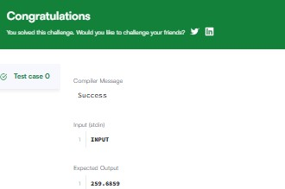

Weather Observation Station 19
Consider and to be two points on a 2D plane where are the respective minimum and maximum values of Northern Latitude (LAT_N) and are the respective minimum and maximum values of Western Longitude (LONG_W) in STATION.
Query the Euclidean Distance between points and format your answer to display decimal digits.

Input Format
The STATION table is described as follows:

INPUT:
SELECT ROUND(SQRT(POWER(MAX(LAT_N) - MIN(LAT_N), 2) + POWER(MAX(LONG_W) - MIN(LONG_W), 2)), 4)
FROM STATION;

OUTPUT:
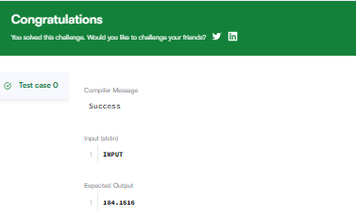

Weather Observation Station 20
A median is defined as a number separating the higher half of a data set from the lower half. Query the median of the Northern Latitudes (LAT_N) from STATION and round your answer to decimal places.

Input Format
The STATION table is described as follows:

INPUT:
SELECT ROUND(S.LAT_N, 4) FROM STATION S WHERE
(SELECT COUNT(LAT_N) FROM STATION WHERE LAT_N > S.LAT_N)
= (SELECT COUNT(LAT_N) FROM STATION WHERE LAT_N < S.LAT_N);

OUTPUT:
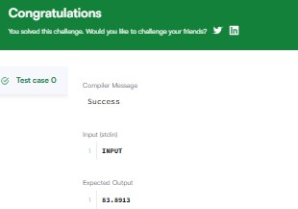

Population Census

Given the CITY and COUNTRY tables, query the sum of the populations of all cities where the CONTINENT is 'Asia'.
Note: CITY.CountryCode and COUNTRY.Code are matching key columns. Input Format

The CITY and COUNTRY tables are described as

follows:
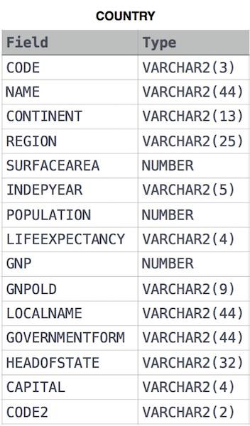

INPUT:
SELECT SUM(CITY.POPULATION) FROM CITY
JOIN COUNTRY ON CITY.COUNTRYCODE = COUNTRY.CODE WHERE COUNTRY.CONTINENT = 'Asia';

OUTPUT:
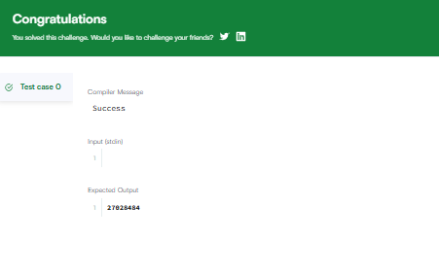

African Cities
Given the CITY and COUNTRY tables, query the names of all cities where the CONTINENT is 'Africa'.

Note: CITY.CountryCode and COUNTRY.Code are matching key columns.

Input Format
The CITY and COUNTRY tables are described as
follows:

INPUT:
SELECT CITY.NAME FROM CITY
INNER JOIN COUNTRY
ON CITY.COUNTRYCODE = COUNTRY.CODE WHERE COUNTRY.CONTINENT = 'Africa';

OUTPUT:
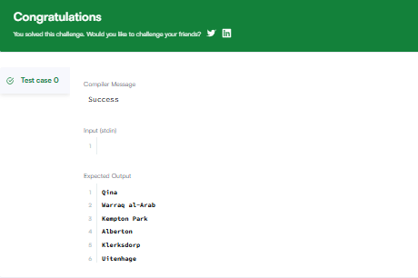

Average Population of Each Continent
Given the CITY and COUNTRY tables, query the names of all the continents (COUNTRY.Continent) and their respective average city populations (CITY.Population) rounded down to the nearest integer.
Note: CITY.CountryCode and COUNTRY.Code are matching key columns.

Input Format
The CITY and COUNTRY tables are described as

follows:

INPUT:
SELECT COUNTRY.CONTINENT, FLOOR(AVG (CITY.POPULATION)) FROM CITY
INNER JOIN COUNTRY
ON CITY.COUNTRYCODE = COUNTRY.CODE GROUP BY COUNTRY.CONTINENT;

OUTPUT:
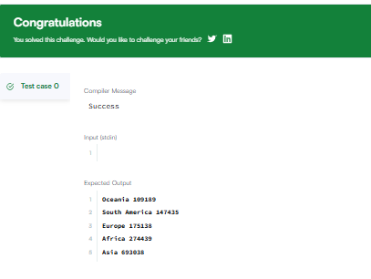

The Report
You are given two tables: Students and Grades. Students contains three columns ID, Name and Marks.
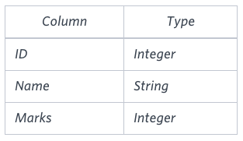
Grades contains the following data:
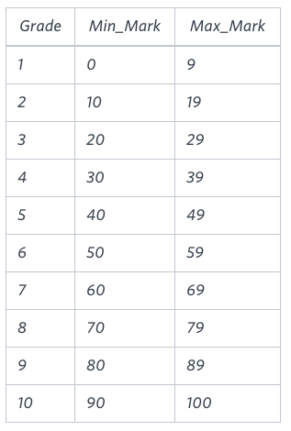

INPUT:
SELECT IF(GRADES.GRADE>=8, STUDENTS.NAME, NULL),GRADES.GRADE, STUDENTS.MARKS
FROM GRADES, STUDENTS
WHERE STUDENTS.MARKS BETWEEN GRADES.MIN_MARK AND GRADES.MAX_MARK
ORDER BY GRADES.GRADE DESC, STUDENTS.NAME;

OUTPUT:
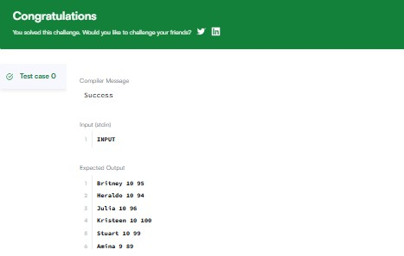

Top Competitors
Julia just finished conducting a coding contest, and she needs your help assembling the leaderboard! Write a query to print the respective hacker_id and name of hackers who achieved full scores for more than one challenge. Order your output in descending order by the total number of challenges in which the hacker earned a full score. If more than one hacker received full scores in same number of challenges, then sort them by
ascending hacker_id.

INPUT:
SELECT H.HACKER_ID, H.NAME FROM HACKERS H
INNER JOIN SUBMISSIONS S
ON H.HACKER_ID = S.HACKER_ID INNER JOIN CHALLENGES C
ON S.CHALLENGE_ID = C.CHALLENGE_ID INNER JOIN DIFFICULTY D
ON C.DIFFICULTY_LEVEL = D.DIFFICULTY_LEVEL WHERE S.SCORE = D.SCORE
GROUP BY H.HACKER_ID, H.NAME HAVING COUNT(S.HACKER_ID) > 1
ORDER BY COUNT(S.HACKER_ID) DESC, S.HACKER_ID ASC; OUTPUT:
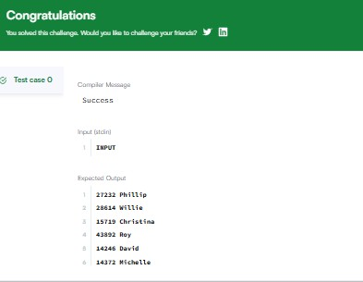

Ollivander's Inventory
Harry Potter and his friends are at Ollivander's with Ron, finally replacing Charlie's old broken wand.
Hermione decides the best way to choose is by determining the minimum number of gold galleons needed to buy each non-evil wand of high power and age. Write a query to print
the id, age, coins_needed, and power of the wands that Ron's interested in, sorted in order of descending power. If more than one wand has same power, sort the result in order of descending age.

INPUT:
SELECT W.ID, P.AGE, W.COINS_NEEDED, W.POWER FROM WANDS AS W
JOIN WANDS_PROPERTY AS P ON (W.CODE = P.CODE)
WHERE P.IS_EVIL = 0 AND W.COINS_NEEDED = (SELECT MIN(COINS_NEEDED) FROM WANDS AS X
JOIN WANDS_PROPERTY AS Y ON (X.CODE = Y.CODE)
WHERE X.POWER = W.POWER AND Y.AGE = P.AGE) ORDER BY W.POWER DESC, P.AGE DESC;

OUTPUT:
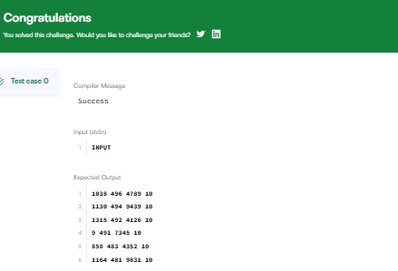

Challenges
Julia asked her students to create some coding challenges. Write a query to print
the hacker_id, name, and the total number of challenges created by each student. Sort your results by the total number of challenges in descending order. If more than one student created the same number of challenges, then sort the result by hacker_id. If more than one student created the same number of challenges and the count is less than the maximum number of challenges created, then exclude those students from the result.

INPUT:
WITH challenge_counts AS ( SELECT
h.hacker_id, h.name,
COUNT(c.challenge_id) AS total_challenges FROM hackers h
JOIN challenges c ON h.hacker_id = c.hacker_id GROUP BY h.hacker_id, h.name
),
max_count AS (
SELECT MAX(total_challenges) FROM challenge_counts
),
unique_counts AS ( SELECT total_challenges FROM challenge_counts
GROUP BY total_challenges
HAVING COUNT(total_challenges) = 1
) SELECT
cc.hacker_id, cc.name, cc.total_challenges

FROM challenge_counts cc
WHERE cc.total_challenges = (SELECT * FROM max_count)
OR cc.total_challenges IN (SELECT total_challenges FROM unique_counts) ORDER BY cc.total_challenges DESC, cc.hacker_id ASC;

OUTPUT:
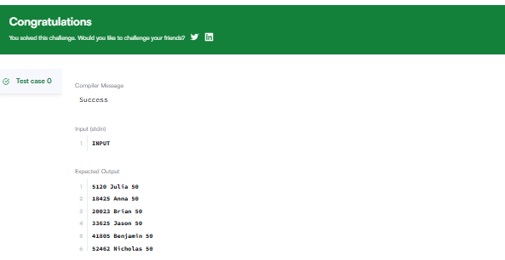

Contest Leaderboard
You did such a great job helping Julia with her last coding contest challenge that she wants you to work on this one, too!
The total score of a hacker is the sum of their maximum scores for all of the challenges. Write a query to print the hacker_id, name, and total score of the hackers ordered by the descending score. If more than one hacker achieved the same total score, then sort the result by
ascending hacker_id. Exclude all hackers with a total score of from your result

INPUT:
SELECT h.hacker_id, h.name, SUM(s.max_score) AS total_score FROM Hackers h
JOIN (
SELECT hacker_id, challenge_id, MAX(score) AS max_score FROM Submissions
GROUP BY hacker_id, challenge_id
) s ON h.hacker_id = s.hacker_id GROUP BY h.hacker_id, h.name HAVING total_score > 0
ORDER BY total_score DESC, h.hacker_id ASC;

OUTPUT:
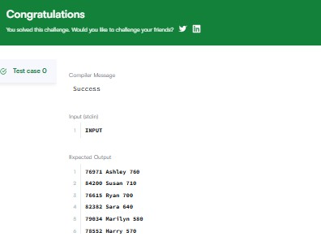

SQL Project Planning

You are given a table, Projects, containing three
columns: Task_ID, Start_Date and End_Date. It is guaranteed that the difference between the End_Date and the Start_Date is equal to 1 day for each row in the table.
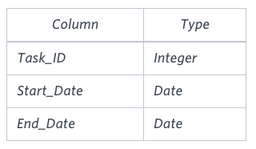
If the End_Date of the tasks are consecutive, then they are part of the same project. Samantha is interested in finding the total number of different projects completed.
Write a query to output the start and end dates of projects listed by the number of days it took to complete the project in ascending order. If there is more than one project that have the same number of completion days, then order by the start date of the project.

INPUT:

SELECT Start_Date, MIN(End_Date) FROM
(SELECT Start_Date FROM Projects WHERE Start_Date NOT IN (SELECT End_Date FROM Projects)) AS S,
(SELECT End_Date FROM Projects WHERE End_Date NOT IN (SELECT Start_Date FROM Projects)) AS E
WHERE Start_Date < End_Date GROUP BY Start_Date
ORDER BY DATEDIFF(MIN(End_Date), Start_Date) ASC, Start_Date ASC;

OUTPUT:

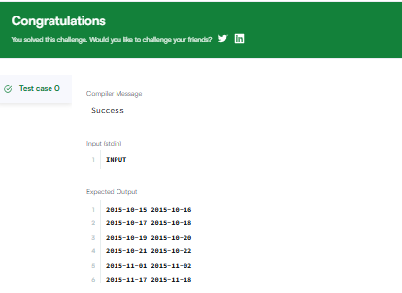

Placements
You are given three tables: Students, Friends and Packages. Students contains two columns: ID and Name. Friends contains two columns: ID and Friend_ID (ID of the ONLY best friend). Packages contains two columns: ID and Salary (offered salary in
$ thousands per month).
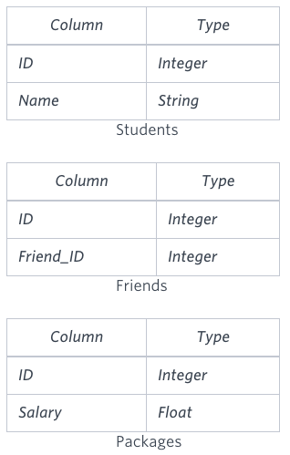

INPUT:
SELECT S.NAME FROM STUDENTS S
JOIN FRIENDS F ON S.ID = F.ID JOIN PACKAGES P1 ON S.ID = P1.ID
JOIN PACKAGES P2 ON F.FRIEND_ID = P2.ID WHERE P2.SALARY > P1.SALARY
ORDER BY P2.SALARY;

OUTPUT:

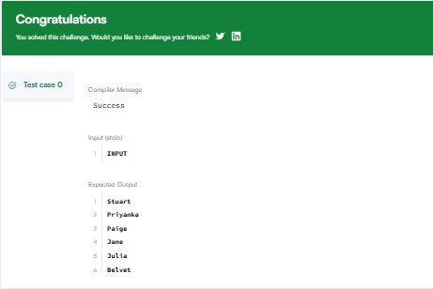

Symmetric Pairs
You are given a table, Functions, containing two columns: X and Y.
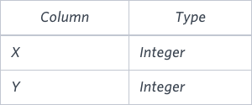

Two pairs (X1, Y1) and (X2, Y2) are said to be symmetric pairs if X1 = Y2 and X2 = Y1.
Write a query to output all such symmetric pairs in ascending order by the value of X. List the rows such that X1 ≤ Y1.
INPUT:
SELECT X, Y FROM FUNCTIONS F1
WHERE EXISTS(SELECT * FROM FUNCTIONS F2 WHERE F2.Y = F1.X AND F2.X = F1.Y AND F2.X > F1.X) AND (X != Y)
UNION
SELECT X,Y FROM FUNCTIONS F1 WHERE X = Y AND
((SELECT COUNT(*) FROM FUNCTIONS WHERE X = F1.X AND Y = F1.X) > 1) ORDER BY X;

OUTPUT:
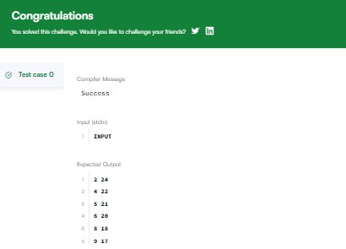

Interviews
Samantha interviews many candidates from different colleges using coding challenges and contests. Write a query to print the contest_id, hacker_id, name, and the sums
of total_submissions, total_accepted_submissions, total_views, and total_unique_views for each contest sorted by contest_id. Exclude the contest from the result if all four sums are .
Note: A specific contest can be used to screen candidates at more than one college, but each college only holds screening contest.

INPUT:

SELECT A.CONTEST_ID, A.HACKER_ID, A.NAME,
SUM(TOTAL_SUBMISSIONS) AS TOTAL_SUBMISSIONS, SUM(TOTAL_ACCEPTED_SUBMISSIONS) AS
TOTAL_ACCEPTED_SUBMISSIONS, SUM(TOTAL_VIEWS) AS TOTAL_VIEWS,
SUM(TOTAL_UNIQUE_VIEWS) AS TOTAL_UNIQUE_VIEWS FROM CONTESTS AS A
LEFT JOIN COLLEGES AS B
ON A.CONTEST_ID = B.CONTEST_ID LEFT JOIN CHALLENGES AS C
ON B.COLLEGE_ID = C.COLLEGE_ID
LEFT JOIN (SELECT CHALLENGE_ID, SUM(TOTAL_VIEWS) AS TOTAL_VIEWS, SUM(TOTAL_UNIQUE_VIEWS) AS TOTAL_UNIQUE_VIEWS
FROM VIEW_STATS
GROUP BY CHALLENGE_ID) AS D
ON C.CHALLENGE_ID = D.CHALLENGE_ID
LEFT JOIN (SELECT CHALLENGE_ID, SUM(TOTAL_SUBMISSIONS) AS TOTAL_SUBMISSIONS,
SUM(TOTAL_ACCEPTED_SUBMISSIONS) AS TOTAL_ACCEPTED_SUBMISSIONS
FROM SUBMISSION_STATS GROUP BY CHALLENGE_ID) AS E

ON C.CHALLENGE_ID = E.CHALLENGE_ID GROUP BY A.CONTEST_ID, A.HACKER_ID, A.NAME
HAVING (TOTAL_SUBMISSIONS + TOTAL_ACCEPTED_SUBMISSIONS + TOTAL_VIEWS + TOTAL_UNIQUE_VIEWS) > 0
ORDER BY A.CONTEST_ID;

OUTPUT:

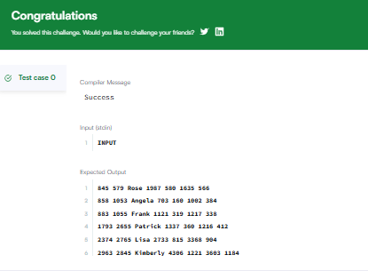

15 Days of Learning SQL
Julia conducted a days of learning SQL contest. The start date of the contest was March 01, 2016 and the end date was March 15, 2016.
Write a query to print total number of unique hackers who made at least submission each day (starting on the first day of the contest), and find the hacker_id and name of the hacker who made maximum number of submissions each day. If more than one such hacker has a maximum number of submissions, print the lowest hacker_id. The query should print this information for each day of the contest, sorted by the date.

INPUT:

SELECT SUBMISSION_DATE,
(SELECT COUNT(DISTINCT HACKER_ID) FROM SUBMISSIONS S2
WHERE S2.SUBMISSION_DATE = S1.SUBMISSION_DATE AND (SELECT COUNT(DISTINCT S3.SUBMISSION_DATE)
FROM SUBMISSIONS S3 WHERE S3.HACKER_ID = S2.HACKER_ID AND S3.SUBMISSION_DATE < S1.SUBMISSION_DATE) = DATEDIFF(S1.SUBMISSION_DATE , '2016-03-01')),
(SELECT HACKER_ID FROM SUBMISSIONS S2 WHERE S2.SUBMISSION_DATE = S1.SUBMISSION_DATE
GROUP BY HACKER_ID ORDER BY COUNT(SUBMISSION_ID) DESC, HACKER_ID LIMIT 1) AS TMP,
(SELECT NAME FROM HACKERS WHERE HACKER_ID = TMP) FROM
(SELECT DISTINCT SUBMISSION_DATE FROM SUBMISSIONS) S1 GROUP BY SUBMISSION_DATE;

OUTPUT:
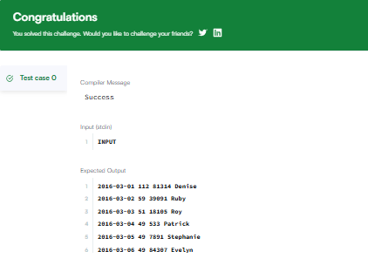

Draw The Triangle 1

P(R) represents a pattern drawn by Julia in R rows. The following pattern represents P(5):
* * * * *
* * * *
* * *
* *
*
Write a query to print the pattern P(20).

INPUT:
SET @NUMBER := 21;
SELECT REPEAT('* ', @NUMBER := @NUMBER - 1)
FROM information_schema.tables LIMIT 20;

OUTPUT:

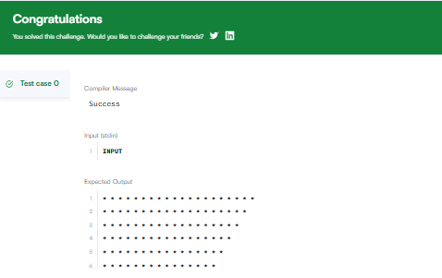

Draw The Triangle 2
P(R) represents a pattern drawn by Julia in R rows. The following pattern represents P(5):
*
* *
* * *
* * * *
* * * * *
Write a query to print the pattern P(20).

INPUT:
SET @number = 0;
SELECT REPEAT('* ', @number := @number + 1) FROM information_schema.tables
WHERE @number < 20;

OUTPUT:
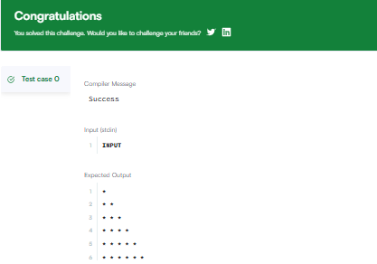

Print Prime Numbers
Write a query to print all prime numbers less than or equal to . Print your result on a single line, and use the ampersand () character as your separator (instead of a space).
For example, the output for all prime numbers would be: 2&3&5&7
INPUT:
WITH RECURSIVE Numbers AS ( SELECT 2 AS L
UNION ALL
SELECT L + 1 FROM Numbers WHERE L < 1000
)
SELECT GROUP_CONCAT(L SEPARATOR '&')
FROM Numbers num WHERE NOT EXISTS (
SELECT 1
FROM Numbers div_num WHERE div_num.L > 1 AND div_num.L < num.L
AND num.L % div_num.L = 0
); OUTPUT:
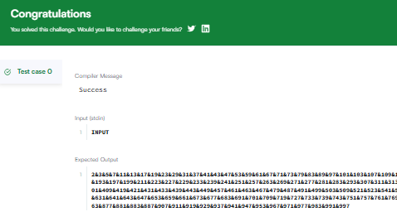

1.Basic Commands

All Products Task
Write a query to output Products table.

Table name: Products

product_id product_name price category

1 | Laptop | 999.99 | Electronics
2 | Desk Chair | 149.99 | Furniture
3 | Smartphone | 599.99 | Electronics
4 | Notebook | 2.99 | Stationery
5 | Headphones | 89.99 | Electronics
6 | Coffee Maker | 49.99 | Appliances
7 | Standing Desk | 249.99 | Furniture
8 | Tablet | 399.99 | Electronics
9 | Mouse | 19.99 | Electronics
10 | Water Bottle | 12.99 | Stationery

INPUT:

SELECT * FROM Products;

OUTPUT:
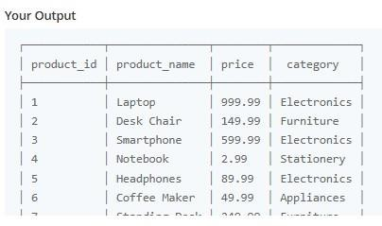

High Price of Products

Task

Write a query to find all product_name and category that have a price greater than 100.00 from the Products table.
Table name: Products

product_id product_name price category

1 | Laptop | 999.99 | Electronics
2 | Desk Chair | 149.99 | Furniture
3 | Smartphone | 599.99 | Electronics
4 | Notebook | 2.99 | Stationery

5 | Headphones | 89.99 | Electronics
6 | Coffee Maker | 49.99 | Appliances
7 | Standing Desk | 249.99 | Furniture
8 | Tablet | 399.99 | Electronics
9 | Mouse | 19.99 | Electronics
10 | Water Bottle | 12.99 | Stationery
Expected columns

- product_name
- category

INPUT:
SELECT product_name, category FROM Products WHERE price > 100.00;

OUTPUT:
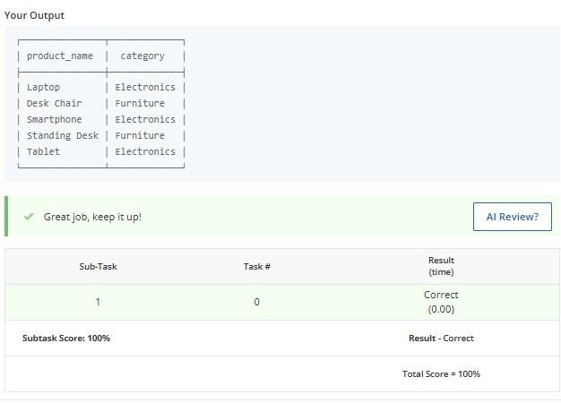
Average Salary

Task

- Write a query to calculate the average salary across all companies combined. Rename the column as avg_salary.
Table name: Works

employee_id company_name salary
1 | TechCorp |  | 75000.00
2 | InnovateLtd |  | 62000.50
3 | HealthPlus |  | 54000.75
4 | EduWorks | 48000.00
5 | GreenTech |  | 68000.00
6 | TechCorp |  | 80000.00
7 | InnovateLtd |  | 66000.20
8 | HealthPlus |  | 50000.10
9 | EduWorks |  | 51000.00
10 | GreenTech |  | 72000.00
Expected column

- avg_salary

INPUT:
SELECT AVG(salary) AS avg_salary FROM Works;

OUTPUT:
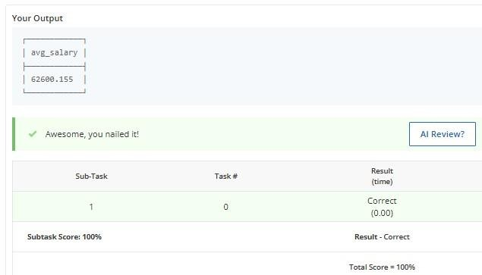

Locate People

Task

- Write a query to retrieve the department_name and location of departments located in a city that starts with 'S'.
Table name: departments

department_id department_name location
1 | Human Resources | New York
2 | Research and Development | San Francisco
3 | Sales | Los Angeles
4 | Marketing | New York

5 | Customer Support |  | Boston
6 | Finance |  | Austin
7 | IT Support |  | Seattle
8 | Product Management |  | San Francisco
9 | Quality Assurance |  | Los Angeles
10 | Legal |  | Boston
Expected column

- department_name
- location

INPUT:
SELECT department_name, location FROM departments WHERE location LIKE 'S%';

OUTPUT:
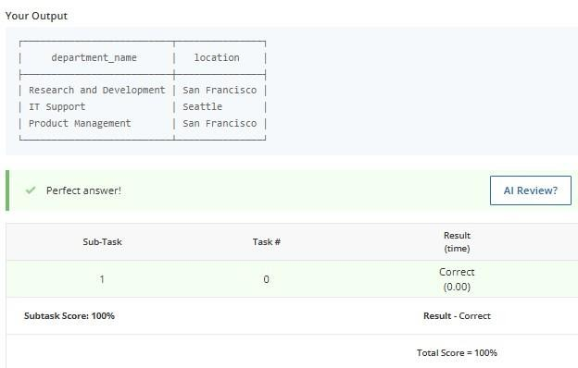
Write a query to select all the distinct companies (company_name) in the Works table.

Table name: Works
employee_id company_name salary
1 | TechCorp |  | 75000.00
2 | InnovateLtd |  | 62000.50
3 | HealthPlus |  | 54000.75
4 | EduWorks |  | 48000.00
5 | GreenTech | 68000.00
6 | TechCorp |  | 80000.00
7 | InnovateLtd |  | 66000.20
8 | HealthPlus |  | 50000.10
9 | EduWorks | 51000.00

GreenTech
72000.00
10 Distinct Companies

Task

Expected Column

- company_name

INPUT:
SELECT DISTINCT company_name FROM Works;

OUTPUT:
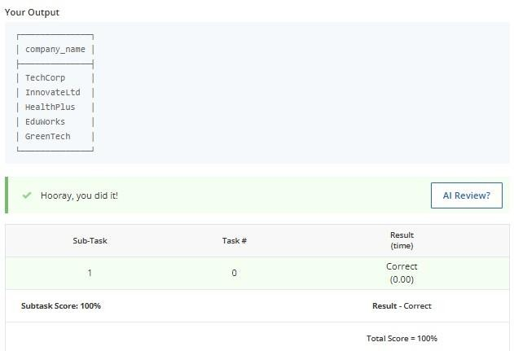

Fiction Collection Size

Task

Write a query to find the total count of books whose genre is Fiction.

Note: Output column name should be fiction_count.

Table name: Books

id title author genre price published_year
1 | The Great | F. Scott  Fitzgerald | Fiction | 10.99 | 1925
 | Gatsby | F. Scott  Fitzgerald
2 | 1984 | George | Dystopian | 15.99 | 1949
 |  | Orwell
3 | To Kill a Mockingbird | Harper Lee | Fiction | 12.99 | 1960

4 | The Catcher in the Rye | J.D.  Salinger | Fiction | 14.99 | 1951
5 | Brave New World | Aldous Huxley | Dystopian | 13.99 | 1932
6 | The Hobbit | J.R.R.  Tolkien | Fantasy | 9.99 | 1937
7 | Moby Dick | Herman Melville | Fiction | 18.50 | 1851
8 | War and Peace | Leo Tolstoy | Historical | 20.00 | 1869

9 | The Picture of Dorian  Gray | Oscar Wilde | Fiction | 11.50 | 1890
10 | The  Alchemist | Paulo Coelho | Fiction | 16.00 | 1988
11 | Fahrenheit 451 | Ray Bradbury | Dystopian | 12.50 | 1953
12 | The  Chronicles of Narnia | C.S. Lewis | Fantasy | 14.00 | 1950
13 | The  Handmaid's Tale | Margaret Atwood | Dystopian | 15.50 | 1985
14 | A Tale of Two Cities | Charles Dickens | Historical | 13.00 | 1859
15 | Little Women | Louisa May Alcott | Fiction | 9.50 | 1868
Expected column

- fiction_count INPUT:
SELECT COUNT(*) AS fiction_count FROM Books WHERE genre = 'Fiction';
OUTPUT:

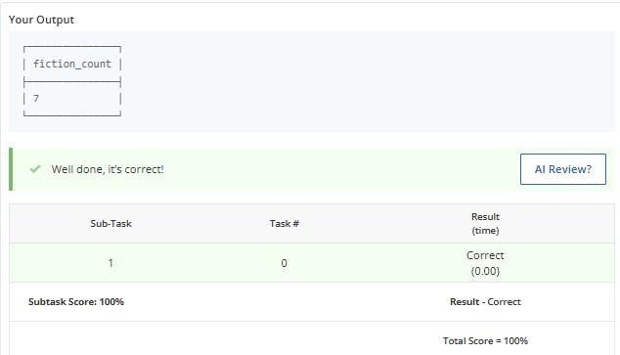

List of Movies with Ratings

Task

Write a query to select only the movie names where the ratings are greater than 7 but less than 9.
Table: Cinema

Movie_id Movie_name Description Rating

1 | War | great 3D | 8.9
2 | Science | fiction | 8.5
3 | Irish | boring | 6.2
4 | Ice Song | Fantasy | 8.6
5 | House Card | Interesting | 9.1
6 | The Escape | Thriller | 7.8

7 | Solar Flare | Sci-Fi | 8.3
8 | The Joker | Drama | 9.0
9 | Lost Dreams | Mystery | 7.5
10 | Galaxy War | Action | 8.7
Expected column

- Movie_name

INPUT:
SELECT Movie_name FROM Cinema WHERE Rating > 7.0 AND Rating < 9.0;

OUTPUT:
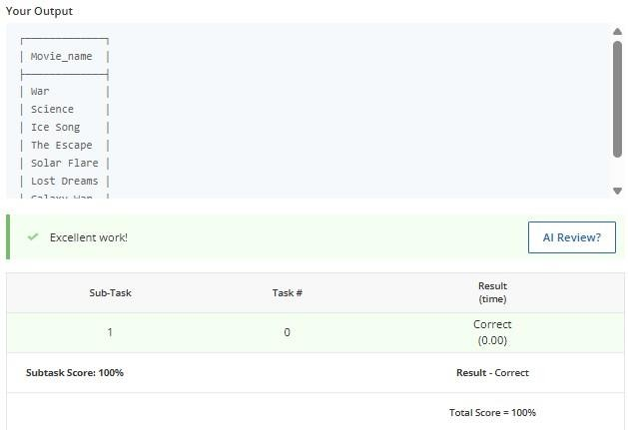
Handling NULL Values

Task

Write a query to retrieve book_id, title, author and published_year of the books which have NULL rating for their books. Table name: Library
book_id title author published_year rating

1 | The Great Gatsby | F. Scott  Fitzgerald | 1925 | 4.2
2 | To Kill a Mockingbird | Harper Lee | 1960 | NULL
3 | 1984 | George Orwell | 1949 | 4.8
4 | The Catcher in the Rye | J.D. Salinger | 1951 | NULL
5 | Brave New World | Aldous Huxley | 1932 | 4.3
Expected column

- book_id
- title
- author
- published_year

INPUT:
SELECT book_id, title, author, published_year FROM Library WHERE rating IS NULL;

OUTPUT:

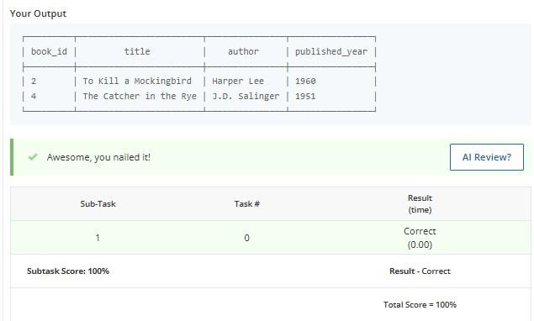

Salary of Employees

Task

Create a query to retrieve the employee_name, company, and salary for employees in the full-time category, ordered by salary in descending order
Table name: Employees employee_id employee_name company category department salary
1 | John Smith | TechCorp | Full-Time | Engineering | 80000
2 | Alice Johnson | TechCorp | Part-Time | HR | 30000
3 | Bob Brown | FinServ | Full-Time | Finance | 90000
4 | Carol White | HealthPlus | Contract | IT | 75000
5 | David Green | TechCorp | Full-Time | Engineering | 85000

6 | Emma Blue | FinServ | Part-Time | Finance | 32000
7 | Frank Black | HealthPlus | Full-Time | HR | 60000
8 | Grace Grey | TechCorp | Full-Time | Marketing | 70000
9 | Henry Red | FinServ | Contract | IT | 95000
10 | Ivy Yellow | HealthPlus | Part-Time | Marketing | 28000
Expected column

- employee_name
- company
- salary

INPUT:
SELECT employee_name, company, salary FROM Employees WHERE category = 'Full-Time' ORDER BY salary DESC;

OUTPUT:
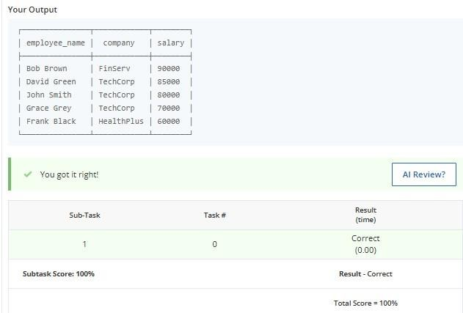
Department of Each Employee

Task

Write a query to group the employees by their department and display the total number of employees (as total_employees) in each department.
Table name: Employees employee_id employee_name company category department salary
1 | John Smith | TechCorp | Full-Time | Engineering | 80000
2 | Alice Johnson | TechCorp | Part-Time | HR | 30000
3 | Bob Brown | FinServ | Full-Time | Finance | 90000
4 | Carol White | HealthPlus | Contract | IT | 75000
5 | David Green | TechCorp | Full-Time | Engineering | 85000
6 | Emma Blue | FinServ | Part-Time | Finance | 32000
7 | Frank Black | HealthPlus | Full-Time | HR | 60000
8 | Grace Grey | TechCorp | Full-Time | Marketing | 70000
9 | Henry Red | FinServ | Contract | Sales | 95000
10 | Ivy Yellow | HealthPlus | Part-Time | Marketing | 28000

Expected Column

- department
- total_employees

INPUT:
SELECT department, COUNT(*) AS total_employees FROM Employees GROUP BY department;

OUTPUT:
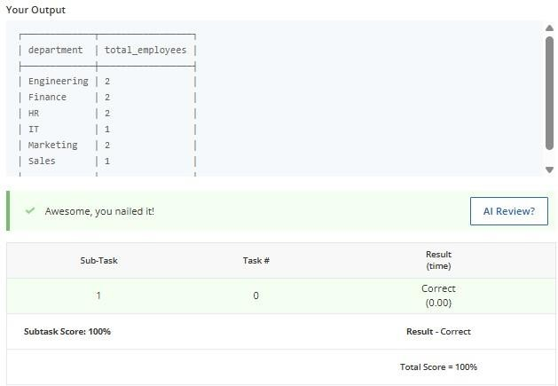

Article views

Task

Write a query to retrieve the author_id, author_name, and publication_name for authors whose articles got zero views. The result should be sorted by author_id in ascending order.
Return the result table sorted by id in ascending order.

Table name: Views article_id author_id author_name viewer_id view_count publication_name

101 | 1 | John Doe | 1 | 3 | The Daily Times
102 | 2 | Jane Smith | 2 | 1 | Global News
103 | 3 | Emily Clark | 4 | 0 | Tech Monthly
104 | 4 | Mark Lewis | 4 | 2 | Health Digest
105 | 5 | Sara White | 3 | 0 | The Business Journal
106 | 1 | John Doe | 2 | 0 | The Daily Times
107 | 2 | Jane Smith | 2 | 2 | Global News
Expected column

- author_id
- author_name
- publication_name

INPUT:
SELECT DISTINCT author_id, author_name, publication_name FROM Views WHERE view_count = 0 ORDER BY author_id ASC;

OUTPUT:

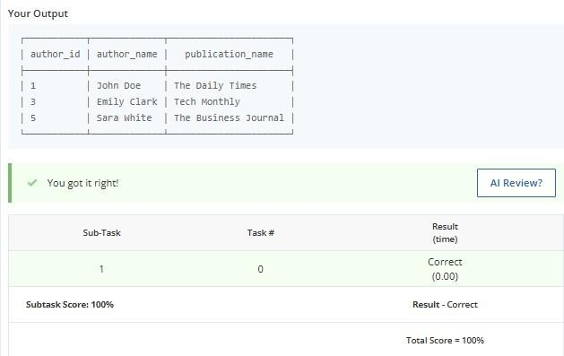
Player Performance Insights

Task

Write a query to find the names of the top 3 distinct players by highest score who have won
matches, including their scores.

Table 1: Players

player_id player_name score rank
1 | Alice | 1200 | 5
2 Bob 1500 2
- Charlie 1300 4
- David 1600 1
5 | Eve | 1100 | 6
Table 2: Matches

match_id player1 player2 winner match_date

101 | Alice | Bob | Bob | 2024-01-15
102 | Charlie | David | David | 2024-01-16
103 | Eve | Bob | Bob | 2024-01-17
104 | Alice | David | David | 2024-01-18
105 | Charlie | Eve | Charlie | 2024-01-19
Expected Output Columns:
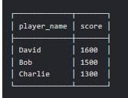

INPUT:
SELECT DISTINCT player_name, score
FROM Players JOIN Matches WHERE winner=player_name ORDER BY score DESC
LIMIT 3;

OUTPUT:
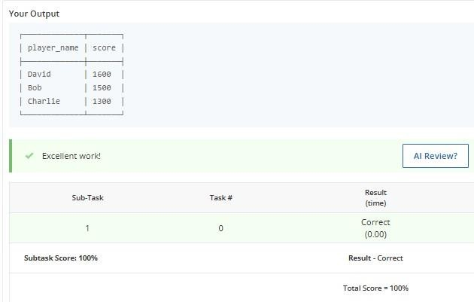

Player Details

Task

Write a query to retrieve the details of the last five matches played, including the match ID, the names of the players who participated, the name of the winning player, match date, and the final score of the winner.
There are two tables named Players and Matches.
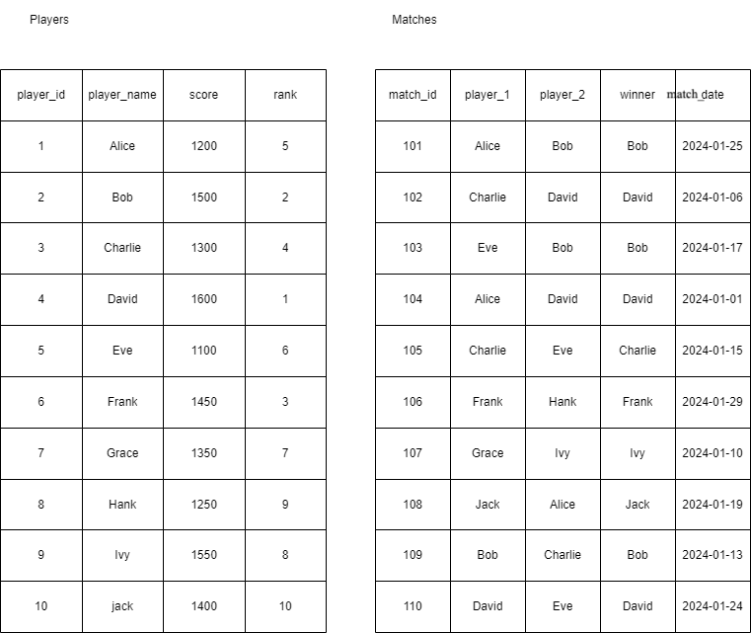

Expected Output Columns:

- match_id

- player_1
- player_2
- winner
- match_date
- score

Expected Output:

┌──────────┬──────────┬──────────┬────────┬────────────┬───────┐
│ match_id │ player_1 │ player_2 │ winner │ match_date │ score │
├──────────┼──────────┼──────────┼────────┼────────────┼───────┤

│ | 106 | │ | Frank | │ | Hank | │ | Frank | │ | 2024-01-29 | │ | 1450 | │
│ | 101 | │ | Alice | │ | Bob | │ | Bob | │ | 2024-01-25 | │ | 1500 | │
│ | 110 | │ | David | │ | Eve | │ | David | │ | 2024-01-24 | │ | 1600 | │
│ | 108 | │ | Jack | │ | Alice | │ | Jack | │ | 2024-01-19 | │ | 1400 | │
│ | 103 | │ | Eve | │ | Bob | │ | Bob | │ | 2024-01-17 | │ | 1500 | │
└──────────┴──────────┴──────────┴────────┴────────────┴───────┘

INPUT:
SELECT m.match_id, m.player_1, m.player_2, m.winner, m.match_date, p.score FROM Matches m
JOIN Players p ON m.winner = p.player_name ORDER BY m.match_date DESC
LIMIT 5;

OUTPUT:

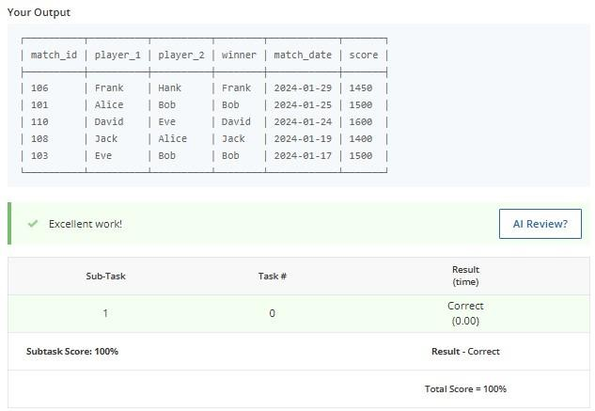

PRACTICAL PROGRAMS:

Consider the following tables CABHUB and CUSTOMER and answer (a) and (b) parts of this question:
  - Write SQL commands for the following statements:

    - To display the names of all the white colored vehicles.
    - To display name of vehicle, make the capacity of vehicles in ascending order of their sitting Capacity.
    - To display the highest charges at which a vehicle can be hired from CABHUB.
    - To display the customer and the corresponding name of the vehicle hired by them.
  - (i) SELECT COUNT (DISTINCT Make) FROM CABHUB;
- SELECT MAX (CHARGES), MIN (Charges) FROM CABHUB;
- SELECT COUNT(*), Make FROM CABHUB;
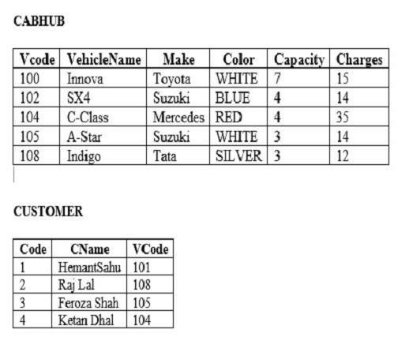
- SELECT VehicleName FROM CABHUB WHERE Capacity = 4;

SYNTAX:
CREATE TABLE CABHUB(Vcode INT PRIMARY KEY,VehicleName VARCHAR(20),Make
VARCHAR(20),Color VARCHAR(10),Capacity INT,Charges INT); INSERT INTO CABHUB VALUES(100,'Innova','Toyota','WHITE',7,15); INSERT INTO CABHUB VALUES(102,'SX4','Suzuki','BLUE',4,14); INSERT INTO CABHUB VALUES(104,'C-Class','Mercedes','RED',4,35); INSERT INTO CABHUB VALUES(105,'A-Star','Suzuki','WHITE',3,14); INSERT INTO CABHUB VALUES(108,'Indigo','Tata','SILVER',3,12);

CREATE TABLE CUSTOMER(Code INT PRIMARY KEY,CName VARCHAR(20),VCode INT);
INSERT INTO CUSTOMER VALUES(1,'Hemant Sahu',101); INSERT INTO CUSTOMER VALUES(2,'Raj Lal',108); INSERT INTO CUSTOMER VALUES(3,'Feroza Shah',105); INSERT INTO CUSTOMER VALUES(4,'Ketan Dhal',104);

QUESTION:
  - Write SQL commands for the following statements:
    - To display the names of all the white colored vehicles.

INPUT:
SELECT VehicleName FROM CABHUB WHERE Color='WHITE';

OUTPUT:
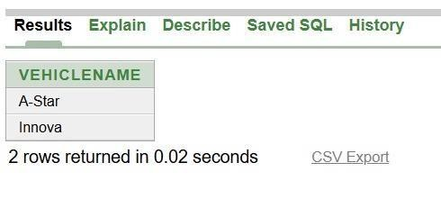

QUESTION:
    - To display name of vehicle, make the capacity of vehicles in ascending order of their sitting Capacity.

INPUT:
SELECT VehicleName,Make,Capacity FROM CABHUB ORDER BY Capacity ASC;

OUTPUT:
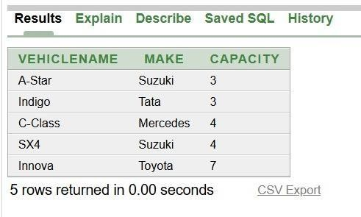

QUESTION:
    - To display the highest charges at which a vehicle can be hired from CABHUB.

INPUT:
SELECT MAX(Charges) FROM CABHUB;

OUTPUT:
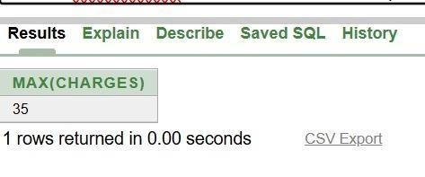

QUESTION:
    - To display the customer and the corresponding name of the vehicle hired by them.

INPUT:
SELECT CUSTOMER.CName,CABHUB.VehicleName FROM CUSTOMER,CABHUB WHERE CUSTOMER.VCode=CABHUB.VCode;

OUTPUT:
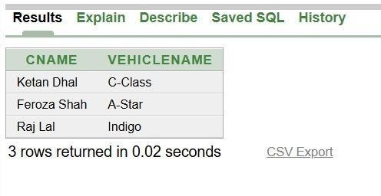

QUESTION:

  - (i) SELECT COUNT (DISTINCT Make) FROM CABHUB;

INPUT:
SELECT COUNT(DISTINCT Make) FROM CABHUB;

OUTPUT:
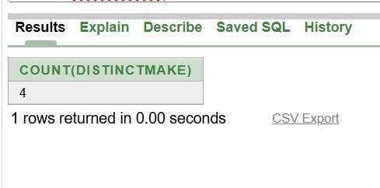

QUESTION:
- SELECT MAX (CHARGES), MIN (Charges) FROM CABHUB;

INPUT:
SELECT MAX(Charges),MIN(Charges) FROM CABHUB;

OUTPUT:
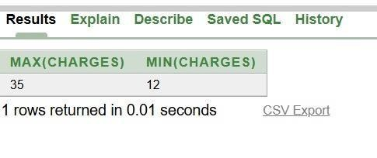

QUESTION:
- SELECT COUNT(*), Make FROM CABHUB;

INPUT:
SELECT COUNT(*),Make FROM CABHUB GROUP BY Make;

OUTPUT:
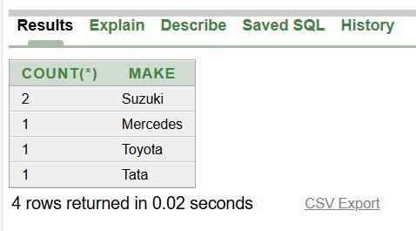

QUESTION:
- SELECT VehicleName FROM CABHUB WHERE Capacity = 4;

INPUT:
SELECT VehicleName FROM CABHUB WHERE Capacity=4;

OUTPUT:
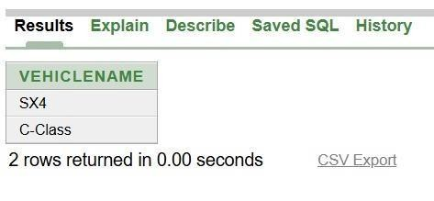
- Given the following CO2_EMISSION relation, write SQL commands for questions (a) to (f).
  - Display all the details of vehicles that use Petrol as the fuel type.
  - Display the Company and Model of vehicles whose EngineSize is greater than 1.5 litres.
  - Display the Company, Model, and CO2Emission in ascending order of CO2Emission.
  - Display the details of vehicles whose CO2Emission is greater than 150 g/km.
  - Count the number of vehicles that use Diesel as the fuel type.
  - Insert the following record into the CO2_EMISSION table. 108, 'MG', 'Hector', 'Petrol', 1.5, 160
  - Write the output of the following SQL commands.
    - SELECT MAX(CO2Emission)FROM CO2_EMISSION;
    - SELECT MIN(EngineSize)FROM CO2_EMISSION;

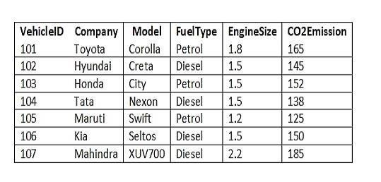
    - SELECT AVG(CO2Emission)FROM CO2_EMISSIONWHERE FuelType='Petrol'; (iv) SELECT COUNT(*)FROM CO2_EMISSIONWHERE EngineSize>=1.5;

SYNTAX:
CREATE TABLE CO2_EMISSION(VehicleID INT PRIMARY KEY,Company
VARCHAR(20),Model VARCHAR(20),FuelType VARCHAR(10),EngineSize DECIMAL(3,1),CO2Emission INT);
INSERT INTO CO2_EMISSION VALUES(101,'Toyota','Corolla','Petrol',1.8,165); INSERT INTO CO2_EMISSION VALUES(102,'Hyundai','Creta','Diesel',1.5,145); INSERT INTO CO2_EMISSION VALUES(103,'Honda','City','Petrol',1.5,152); INSERT INTO CO2_EMISSION VALUES(104,'Tata','Nexon','Diesel',1.5,138); INSERT INTO CO2_EMISSION VALUES(105,'Maruti','Swift','Petrol',1.2,125); INSERT INTO CO2_EMISSION VALUES(106,'Kia','Seltos','Diesel',1.5,150); INSERT INTO CO2_EMISSION VALUES(107,'Mahindra','XUV700','Diesel',2.2,185);

QUESTION:
      - Display all the details of vehicles that use Petrol as the fuel type.

INPUT:
SELECT * FROM CO2_EMISSION WHERE FuelType='Petrol';

OUTPUT:
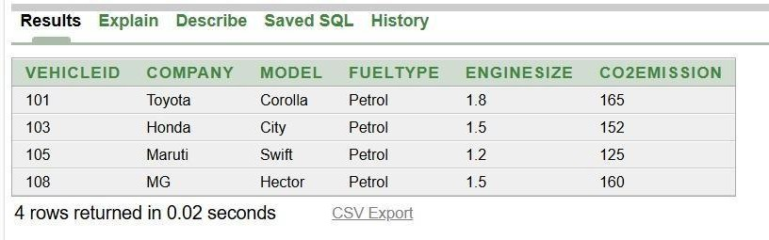

QUESTION:
      - Display the Company and Model of vehicles whose EngineSize is greater than 1.5 litres.

INPUT:
SELECT Company,Model FROM CO2_EMISSION WHERE EngineSize>1.5; OUTPUT:
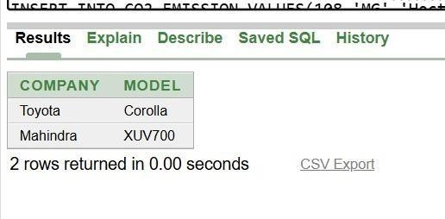

QUESTION:
      - Display the Company, Model, and CO2Emission in ascending order of CO2Emission.

INPUT:
SELECT Company,Model FROM CO2_EMISSION WHERE EngineSize>1.5;

OUTPUT:
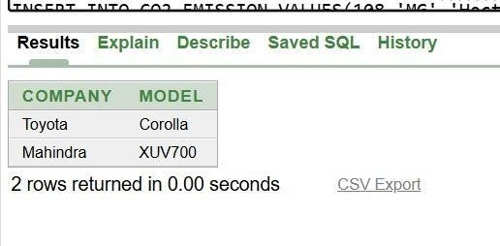

QUESTION:
      - Display the details of vehicles whose CO2Emission is greater than 150 g/km.

INPUT:
SELECT Company,Model,CO2Emission FROM CO2_EMISSION ORDER BY CO2Emission ASC;

OUTPUT:
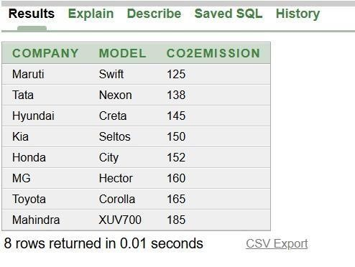

QUESTION:
      - Count the number of vehicles that use Diesel as the fuel type.

INPUT:
SELECT * FROM CO2_EMISSION WHERE CO2Emission>150;

OUTPUT:
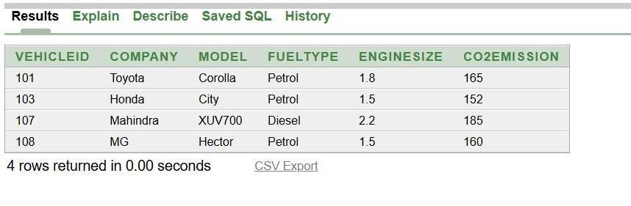

QUESTION:
      - Insert the following record into the CO2_EMISSION table. 108, 'MG', 'Hector', 'Petrol', 1.5, 160

INPUT:
INSERT INTO CO2_EMISSION VALUES(108,'MG','Hector','Petrol',1.5,160);

OUTPUT:
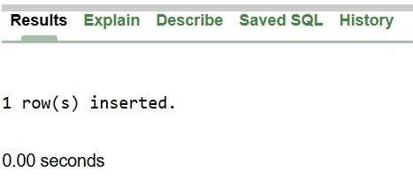

QUESTION:
      - Write the output of the following SQL commands. SELECT MAX(CO2Emission)FROM CO2_EMISSION; INPUT:
SELECT MAX(CO2Emission) FROM CO2_EMISSION;

OUTPUT:
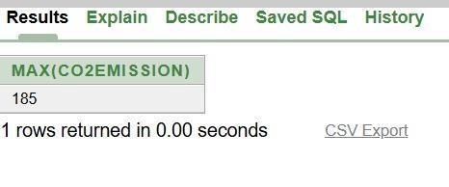

QUESTION:
- SELECT MIN(EngineSize)FROM CO2_EMISSION;

INPUT:
SELECT MIN(EngineSize) FROM CO2_EMISSION;

OUTPUT:

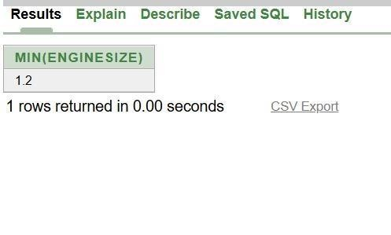

QUESTION:
- SELECT AVG(CO2Emission)FROM CO2_EMISSIONWHERE
FuelType='Petrol';

INPUT:
SELECT AVG(CO2Emission) FROM CO2_EMISSION WHERE FuelType='Petrol';

OUTPUT:
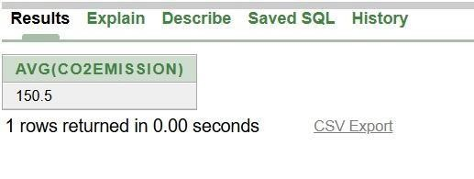

QUESTION:
- SELECT COUNT(*)FROM CO2_EMISSIONWHERE EngineSize>=1.5;

INPUT:
SELECT COUNT(*) FROM CO2_EMISSION WHERE EngineSize>=1.5;

OUTPUT:
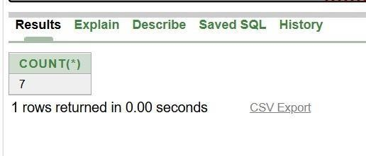

Write SQL queries for (a) to (f) and write the outputs for the SQL queries mentioned shown in (g1) to (g4) parts on the basis of tables APPLICANTS and COURSES.

  - To display name, fee, gender, joinyear about the applicants, who have joined before 2010.
  - display the names of applicants, who are paying fee more than 30000.
  - To display name of all applicants in ascending order of their joinyear.
  - To display the year and the total number of applicants joined in each YEAR from thetable
APPLICANTS.
  - To display the C_ID (i.e. Course ID) and the number of applicants registered in thecourse from the APPLICANTS table.
  - To display the applicant’s name with their respective course’s name from thetables APPLICANTS and COURSES.
  - Give the output of following SQL statements:
(g1) SELECT NAME, JOIN YEAR FROM APPLICANTS WHERE GENDER= ‘F’ AND C_ID= ‘02’;
(g2) SELECT MIN(JOINYEAR) FROM APPLICANTS WHERE Gender= ‘M’;
(g3) SELE CT AVG(FEE) FROM APPLICANTS WHERE C_ID= ‘A01’ OR C_ID= ‘A05’;
(g4) SELECT SUM (FEE), C_ID FROM APPLICATIONS GROUP BY C_ID HAVING COUNT (*)=2;
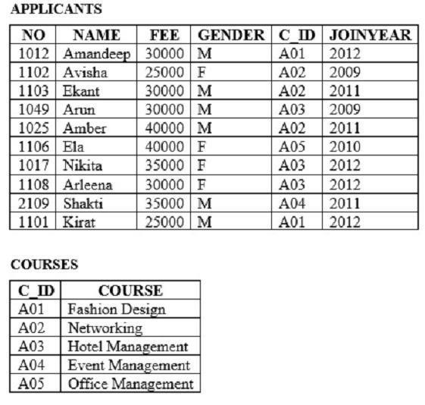

SYNTAX:

CREATE TABLE APPLICANTS(NO INT PRIMARY KEY,NAME VARCHAR(30),FEE INT,GENDER CHAR(1),C_ID VARCHAR(5),JOINYEAR INT);
INSERT INTO APPLICANTS VALUES(1012,'Amandeep',30000,'M','A01',2012); INSERT INTO APPLICANTS VALUES(1102,'Avisha',25000,'F','A02',2009); INSERT INTO APPLICANTS VALUES(1103,'Ekant',30000,'M','A02',2011); INSERT INTO APPLICANTS VALUES(1049,'Arun',30000,'M','A03',2009); INSERT INTO APPLICANTS VALUES(1025,'Amber',40000,'M','A02',2011); INSERT INTO APPLICANTS VALUES(1106,'Ela',40000,'F','A05',2010); INSERT INTO APPLICANTS VALUES(1017,'Nikita',35000,'F','A03',2012); INSERT INTO APPLICANTS VALUES(1108,'Arleena',30000,'F','A03',2012); INSERT INTO APPLICANTS VALUES(2109,'Shakti',35000,'M','A04',2011); INSERT INTO APPLICANTS VALUES(1101,'Kirat',25000,'M','A01',2012);
CREATE TABLE COURSES(C_ID VARCHAR(5) PRIMARY KEY,COURSE VARCHAR(30));
INSERT INTO COURSES VALUES('A01','Fashion Design'); INSERT INTO COURSES VALUES('A02','Networking'); INSERT INTO COURSES VALUES('A03','Hotel Management');
INSERT INTO COURSES VALUES('A04','Event Management'); INSERT
INTO COURSES VALUES('A05','Office Management');

QUESTION:
- To display name, fee, gender, joinyear about the applicants, who have joined before 2010.

INPUT:
SELECT NAME,FEE,GENDER,JOINYEAR FROM APPLICANTS WHERE JOINYEAR<2010;

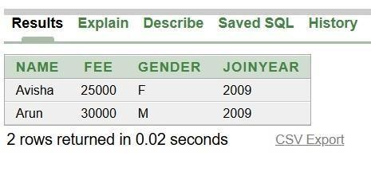

QUESTION:
- display the names of applicants, who are paying fee more than 30000.

INPUT:
SELECT NAME FROM APPLICANTS WHERE FEE>30000;

OUTPUT:
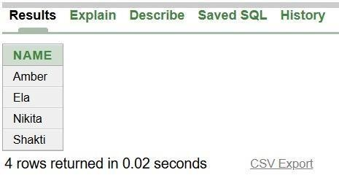

QUESTION:
- To display name of all applicants in ascending order of their joinyear.

INPUT:
SELECT NAME FROM APPLICANTS ORDER BY JOINYEAR ASC;

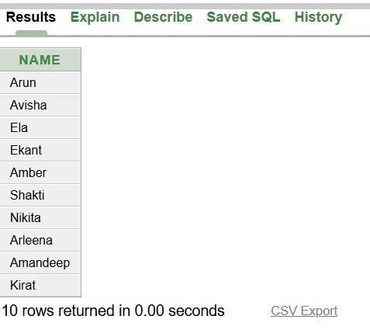
OUTPUT:

QUESTION:
- To display the year and the total number of applicants joined in each YEAR from the table
APPLICANTS.

INPUT:
SELECT JOINYEAR,COUNT(*) FROM APPLICANTS GROUP BY JOINYEAR;

OUTPUT:
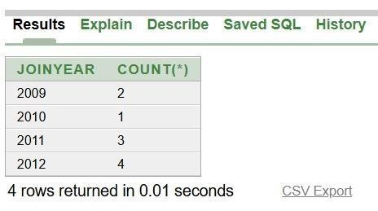

QUESTION:
- To display the C_ID (i.e. Course ID) and the number of applicants registered in the course from the APPLICANTS table.

INPUT:
SELECT C_ID,COUNT(*) FROM APPLICANTS GROUP BY C_ID;

OUTPUT:
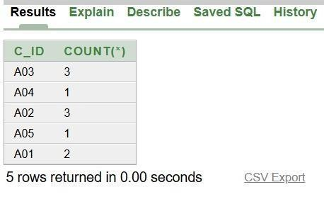

QUESTION:
To display the applicant’s name with their respective course’s name from thetables APPLICANTS and COURSES.

INPUT:
SELECT APPLICANTS.NAME,COURSES.COURSE FROM APPLICANTS,COURSES WHERE APPLICANTS.C_ID=COURSES.C_ID;

OUTPUT:
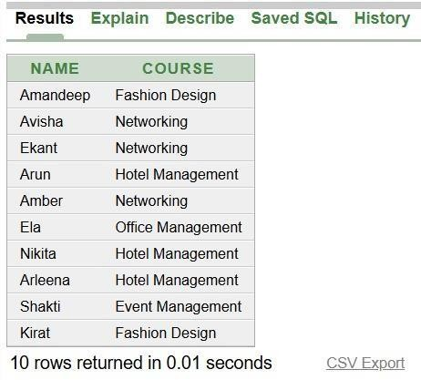

QUESTION:
- Give the output of following SQL statements:
(g1) SELECT NAME, JOIN YEAR FROM APPLICANTS WHERE GENDER= ‘F’ AND C_ID= ‘02’;

INPUT:
SELECT NAME,JOINYEAR FROM APPLICANTS WHERE GENDER='F' AND C_ID='02';

OUTPUT:
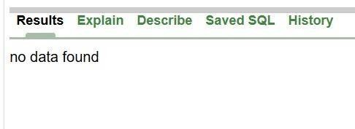

QUESTION:
(g2) SELECT MIN(JOINYEAR) FROM APPLICANTS WHERE Gender= ‘M’;

INPUT:
SELECT MIN(JOINYEAR) FROM APPLICANTS WHERE GENDER='M';

OUTPUT:
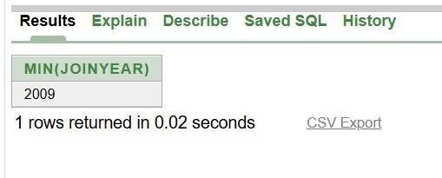

QUESTION:
(g3) SELE CT AVG(FEE) FROM APPLICANTS WHERE C_ID= ‘A01’ OR C_ID= ‘A05’;

INPUT:
SELECT AVG(FEE) FROM APPLICANTS WHERE C_ID='A01' OR C_ID='A05';

OUTPUT:

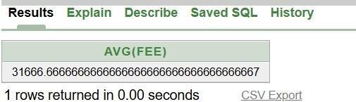

QUESTION:
(g4) SELECT SUM (FEE), C_ID FROM APPLICATIONS GROUP BY C_ID HAVING COUNT (*)=2;

INPUT:
SELECT SUM(FEE),C_ID FROM APPLICANTS GROUP BY C_ID HAVING COUNT(*)=2;

OUTPUT:
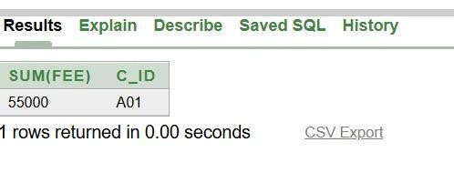

Write SQL queries for (a) to (f) and write the outputs for the SQL queries mentioned shown in (g1) to (g4) parts on the basis of tables PRODUCTS AND SUPPLIERS.
  - To display the details of all the products in ascending order of product names (i.e. PNAME).
  - To display product name and price of all those products, whose price is in the range of 10000 and 15000 (both values inclusive).
  - To display the number of products which are supplied by each supplier i.e. the expected output should be S01 2 S02 2 S03 1
  - To display the price, product name (i.e. PName) and quantity (i.e. QTY) of those which have quantity more than 100.
  - To display the names of those suppliers, who are either from DELHI or from CHENNAI.
  - To display the name of the companies and the name of the products in descending order of company names.
  - Obtain the outputs of the following SQL queries based on the data given in tables PRODUCTS and SUPPLIERS.
(g1) SELECT DISTINCT SUPCODE FROM PRODUCTS;
(g2) SELECT MAX(PRICE), MIN (PRICE) FROM PRODUCTS;
(g3) SELECT PRICE * QTY AMOUNT FROM PRODUCTS WHERE PID = 104;

(g4) SELECT PNAME, SNAME FROM PRODUCTS P, SUPPLIERS S WHERE P. SUPCODE
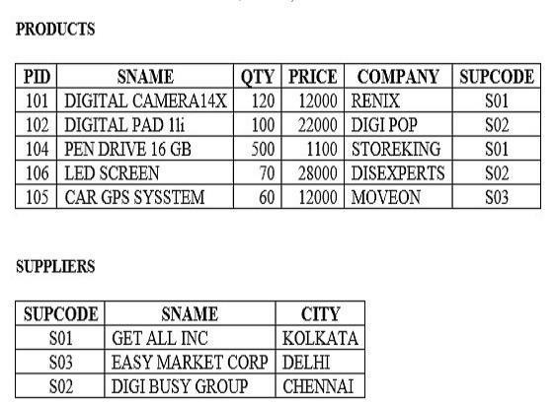
= S. SUPCODE AND QTY>100;

SYNTAX:

CREATE TABLE PRODUCTS(PID INT PRIMARY KEY,SNAME VARCHAR(30),QTY INT,PRICE INT,COMPANY VARCHAR(30),SUPCODE VARCHAR(10));
INSERT INTO PRODUCTS VALUES(101,'DIGITAL CAMERA 14X',120,12000,'RENIX','S01');
INSERT INTO PRODUCTS VALUES(102,'DIGITAL PAD 11i',100,22000,'DIGI POP','S02'); INSERT INTO PRODUCTS VALUES(104,'PEN DRIVE 16 GB',500,1100,'STOREKING','S01');
INSERT INTO PRODUCTS VALUES(106,'LED SCREEN',70,28000,'DISEXPERTS','S02'); INSERT INTO PRODUCTS VALUES(105,'CAR GPS SYSTEM',60,12000,'MOVEON','S03'); CREATE TABLE SUPPLIERS(SUPCODE VARCHAR(10) PRIMARY KEY,SNAME VARCHAR(30),CITY VARCHAR(20));
INSERT INTO SUPPLIERS VALUES('S01','GET ALL INC','KOLKATA');
INSERT INTO SUPPLIERS VALUES('S03','EASY MARKET CORP','DELHI'); INSERT INTO SUPPLIERS VALUES('S02','DIGI BUSY GROUP','CHENNAI');

QUESTION:
- To display the details of all the products in ascending order of product names (i.e. PNAME).

INPUT:
SELECT * FROM PRODUCTS ORDER BY SNAME;

OUTPUT:
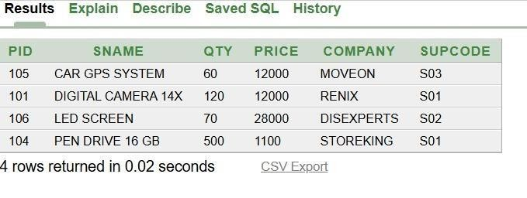

QUESTION:
- To display product name and price of all those products, whose price is in the range of 10000 and 15000 (both values inclusive).

INPUT:
SELECT SNAME,PRICE FROM PRODUCTS WHERE PRICE BETWEEN 10000 AND 15000;

OUTPUT:
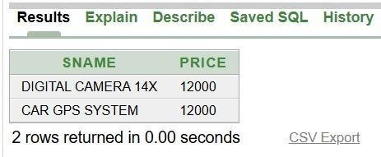

QUESTION:
- To display the number of products which are supplied by each supplier i.e. the expected output should be S01 2 S02 2 S03 1

INPUT:
SELECT SUPCODE,COUNT(*) FROM PRODUCTS GROUP BY SUPCODE;

OUTPUT:
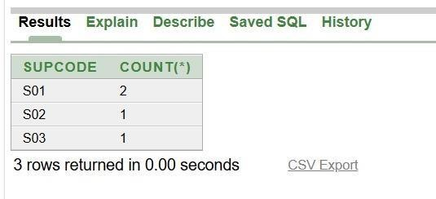

QUESTION:
- To display the price, product name (i.e. PName) and quantity (i.e. QTY) of those which have quantity more than 100.

INPUT:
SELECT PRICE,SNAME,QTY FROM PRODUCTS WHERE QTY>100;

OUTPUT:
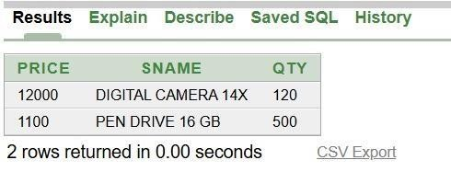

QUESTION:
- To display the names of those suppliers, who are either from DELHI or from CHENNAI.

INPUT:
SELECT SNAME FROM SUPPLIERS WHERE CITY='DELHI' OR CITY='CHENNAI';

OUTPUT:
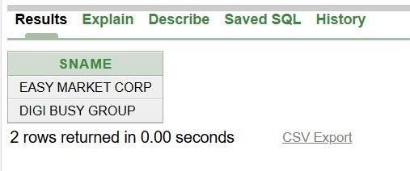

QUESTION:
- To display the name of the companies and the name of the products in descending order of company names.

INPUT:
SELECT P.COMPANY,P.SNAME FROM PRODUCTS P ORDER BY P.COMPANY DESC;

OUTPUT:

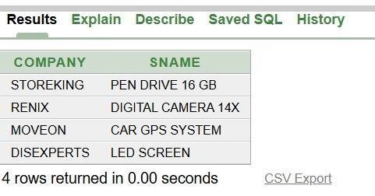

QUESTION:
- Obtain the outputs of the following SQL queries based on the data given in tables PRODUCTS and SUPPLIERS.
(g1) SELECT DISTINCT SUPCODE FROM PRODUCTS;

INPUT:
SELECT DISTINCT SUPCODE FROM PRODUCTS;

OUTPUT:
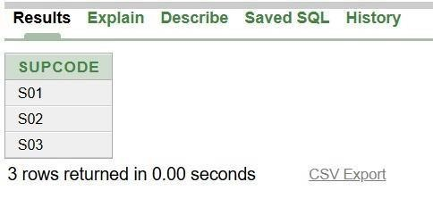

QUESTION:
(g2) SELECT MAX(PRICE), MIN (PRICE) FROM PRODUCTS;

INPUT:
SELECT MAX(PRICE),MIN(PRICE) FROM PRODUCTS; INPUT:

OUTPUT:
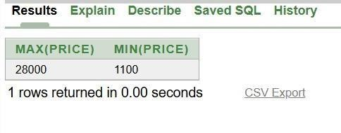

QUESTION:
(g3) SELECT PRICE * QTY AMOUNT FROM PRODUCTS WHERE PID = 104;

INPUT:
SELECT PRICE*QTY AS AMOUNT FROM PRODUCTS WHERE PID=104;

OUTPUT:
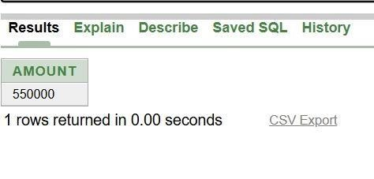

QUESTION:
(g4) SELECT PNAME, SNAME FROM PRODUCTS P, SUPPLIERS S WHERE P. SUPCODE
= S. SUPCODE AND QTY>100;

INPUT:
SELECT P.SNAME,S.SNAME FROM PRODUCTS P,SUPPLIERS S WHERE P.SUPCODE=S.SUPCODE AND QTY>100;

OUTPUT:
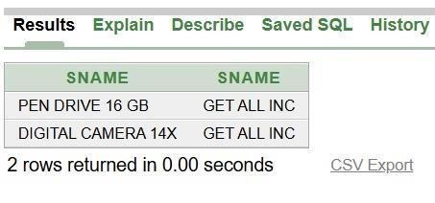

Answer the questions (a) and (b) on the basis of the following tables SHOPPE and ACCESSORIES
  - Write the SQL queries:
    - To display Name and Price of all the accessories in ascending order of their Price.
    - To display Id and SName of all Shoppe in Nehru Place.
    - To display Minimum and Maximum Price of each Name of accessories.
    - To display Name, Price of all accessories and their respective SName where they are available.
  - (i) SELECT DISTINCT Name FROM ACCESSORIES WHERE Price>=500;
- SELECT Area, COUNT () FROM GROUP BY Area;
- SELECT COUNT (DISTINCT Area) FROM SHOPPE;
- SELECT Name, Price0.05 DISCOUNT FROM ACCESSORIES WHERE SNo IN (‘S02,

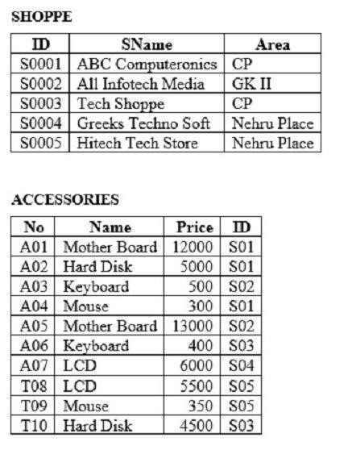
‘S03’);

SYNTAX:
CREATE TABLE SHOPPE(ID VARCHAR(10) PRIMARY KEY,SName VARCHAR(30),Area VARCHAR(20));
INSERT INTO SHOPPE VALUES('S0001','ABC Computeronics','CP'); INSERT INTO SHOPPE VALUES('S0002','All Infotech Media','GK II'); INSERT INTO SHOPPE VALUES('S0003','Tech Shoppe','CP');
INSERT INTO SHOPPE VALUES('S0004','Greeks Techno Soft','Nehru Place'); INSERT INTO SHOPPE VALUES('S0005','Hitech Tech Store','Nehru Place'); CREATE TABLE ACCESSORIES(No VARCHAR(10) PRIMARY KEY,Name VARCHAR(30),Price INT,ID VARCHAR(10));
INSERT INTO ACCESSORIES VALUES('A01','Mother Board',12000,'S01'); INSERT INTO ACCESSORIES VALUES('A02','Hard Disk',5000,'S01'); INSERT INTO ACCESSORIES VALUES('A03','Keyboard',500,'S02'); INSERT INTO ACCESSORIES VALUES('A04','Mouse',300,'S01');
INSERT INTO ACCESSORIES VALUES('A05','Mother Board',13000,'S02'); INSERT INTO ACCESSORIES VALUES('A06','Keyboard',400,'S03'); INSERT INTO ACCESSORIES VALUES('A07','LCD',6000,'S04');
INSERT INTO ACCESSORIES VALUES('T08','LCD',5500,'S05'); INSERT INTO ACCESSORIES VALUES('T09','Mouse',350,'S05'); INSERT INTO ACCESSORIES VALUES('T10','Hard Disk',4500,'S03');

QUESTION:
  - Write the SQL queries:
    - To display Name and Price of all the accessories in ascending order of their Price.

INPUT:
SELECT Name,Price FROM ACCESSORIES ORDER BY Price ASC; OUTPUT:
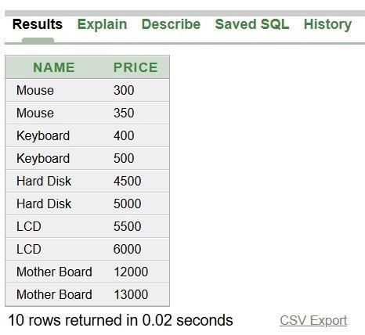

QUESTION:
    - To display Id and SName of all Shoppe in Nehru Place.
INPUT:
SELECT ID,SName FROM SHOPPE WHERE Area='Nehru Place';

OUTPUT:
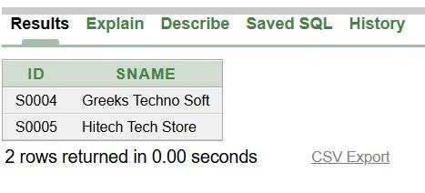

QUESTION:
    - To display Minimum and Maximum Price of each Name of accessories.

INPUT:

SELECT Name,MIN(Price),MAX(Price) FROM ACCESSORIES GROUP BY Name;

OUTPUT:
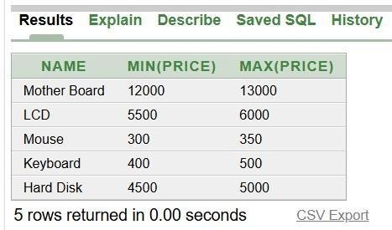

QUESTION:
  - (i) SELECT DISTINCT Name FROM ACCESSORIES WHERE Price>=500;

INPUT:
SELECT DISTINCT Name FROM ACCESSORIES WHERE Price>=500;

OUTPUT:
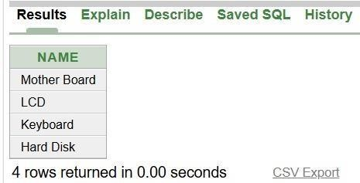

QUESTION:
- SELECT Area, COUNT () FROM GROUP BY Area; INPUT:
SELECT Area,COUNT(*) FROM SHOPPE GROUP BY Area;

OUTPUT:

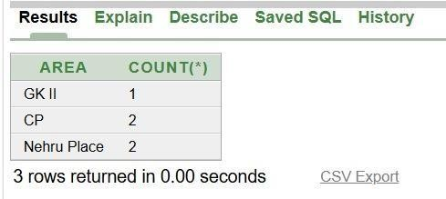

QUESTION:
- SELECT COUNT (DISTINCT Area) FROM SHOPPE;

INPUT:
SELECT COUNT(DISTINCT Area) FROM SHOPPE; OUTPUT:
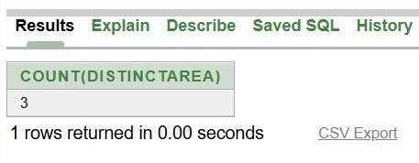

QUESTION:
- SELECT Name, Price0.05 DISCOUNT FROM ACCESSORIES WHERE SNo IN (‘S02,
‘S03’);

INPUT:
SELECT Name,Price*0.05 AS DISCOUNT FROM ACCESSORIES WHERE ID IN('S02','S03');

OUTPUT:
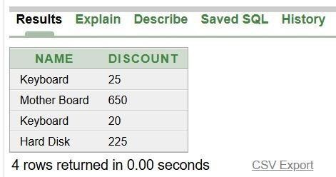

Write SQL commands for (a) to (f) and Write the outputs for (g) on the basis of table HOSPITAL .
  - To select all the information of patients of cardiology department.
  - To list the names of female patients who are in ENT department.
  - To list name of all patients with their date of admission in ascending order.
  - To display Patient’s Name, Charges, Age for only female patients.
  - To count the number of patients with Age<30.
  - To inset in a new row in the HOSPITAL table with the following data: 11, “Aftab”, 24, “Surgery”, {25/02/98}, 300, “M”.
  - Give the output of following SQL statements:
    - Select COUNT (DISTINCT charges) from HOSPITAL;
    - Select MIN (Age) from HOSPITAL where Gender = “F”.
    - Select SUM (Charges) from HOSPITAL where Department = “ENT”.
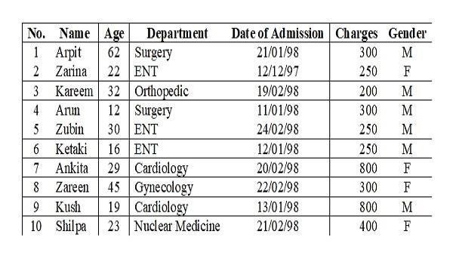
    - Select AVG (Charges) from HOSPITAL where Datofadm< {12/08/98}

SYNTAX:
CREATE TABLE HOSPITAL(No INT PRIMARY KEY,Name VARCHAR(30),Age
INT,Department VARCHAR(30),Datofadm DATE,Charges INT,Gender CHAR(1)); INSERT INTO HOSPITAL VALUES(1,'Arpit',62,'Surgery',DATE '1998-01-21',300,'M'); INSERT INTO HOSPITAL VALUES(2,'Zarina',22,'ENT',DATE '1997-12-12',250,'F');
INSERT INTO HOSPITAL VALUES(3,'Kareem',32,'Orthopedic',DATE '1998-02-19',200,'M'); INSERT INTO HOSPITAL VALUES(4,'Arun',12,'Surgery',DATE '1998-01-11',300,'M'); INSERT INTO HOSPITAL VALUES(5,'Zubin',30,'ENT',DATE '1998-02-24',250,'M'); INSERT INTO HOSPITAL VALUES(6,'Ketaki',16,'ENT',DATE '1998-01-12',250,'M'); INSERT INTO HOSPITAL VALUES(7,'Ankita',29,'Cardiology',DATE '1998-02-20',800,'F');

INSERT INTO HOSPITAL VALUES(8,'Zareen',45,'Gynecology',DATE '1998-02-22',300,'F'); INSERT INTO HOSPITAL VALUES(9,'Kush',19,'Cardiology',DATE '1998-01-13',800,'M'); INSERT INTO HOSPITAL VALUES(10,'Shilpa',23,'Nuclear Medicine',DATE '1998-02-21',400,'F');

QUESTION:
      - To select all the information of patients of cardiology department.

INPUT:
SELECT * FROM HOSPITAL WHERE Department='Cardiology';

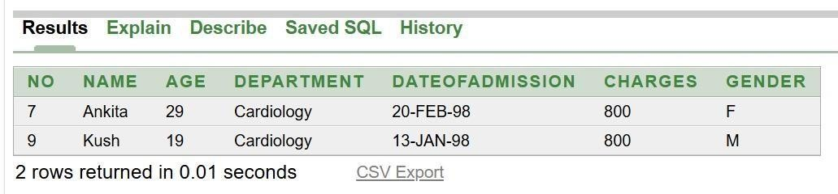
OUTPUT:
QUESTION:
      - To list the names of female patients who are in ENT department.

INPUT:
SELECT Name FROM HOSPITAL WHERE Gender='F' AND Department='ENT';

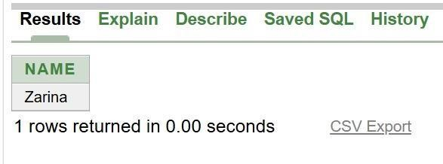
OUTPUT:
QUESTION:
      - To list name of all patients with their date of admission in ascending order.

INPUT:
SELECT Name,DateofAdmission FROM HOSPITAL ORDER BY DateofAdmission ASC;

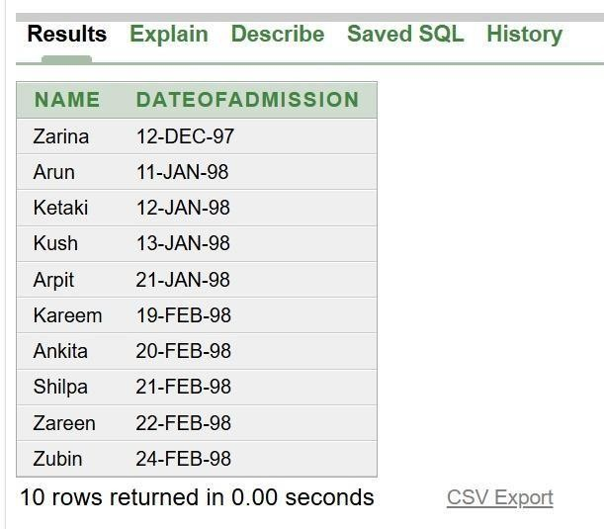
OUTPUT:
QUESTION:
      - To display Patient’s Name, Charges, Age for only female patients.

INPUT:
SELECT Name,Charges,Age FROM HOSPITAL WHERE Gender='F';

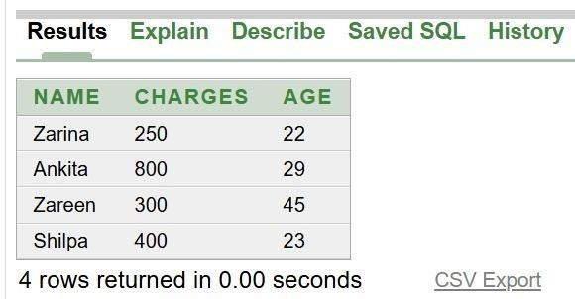
OUTPUT:
QUESTION:
      - To count the number of patients with Age<30.

INPUT:
SELECT COUNT(*) FROM HOSPITAL WHERE Age<30;

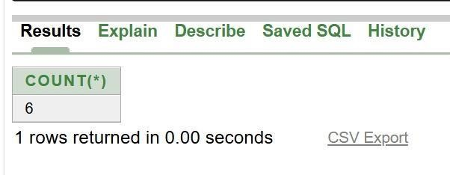
OUTPUT:

QUESTION:
      - To inset in a new row in the HOSPITAL table with the following data: 11, “Aftab”, 24, “Surgery”, {25/02/98}, 300, “M”.

INPUT:
INSERT INTO HOSPITAL VALUES(11,'Aftab',24,'Surgery',DATE '1998-02-25',300,'M');

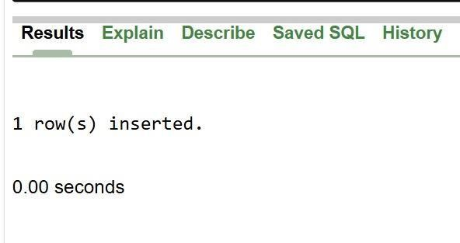
OUTPUT:
QUESTION:
      - Give the output of following SQL statements: (i) Select COUNT (DISTINCT charges) from HOSPITAL;

INPUT:
SELECT COUNT(DISTINCT Charges) FROM HOSPITAL;

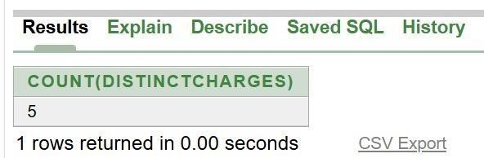
OUTPUT:
QUESTION:
- Select MIN (Age) from HOSPITAL where Gender = “F”.

INPUT:
SELECT MIN(Age) FROM HOSPITAL WHERE Gender='F';

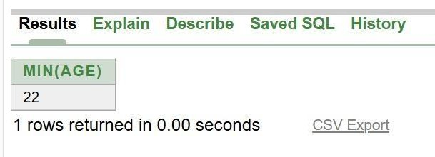
OUTPUT:

QUESTION:
- Select SUM (Charges) from HOSPITAL where Department = “ENT”.

INPUT:
SELECT SUM(Charges) FROM HOSPITAL WHERE Department='ENT';

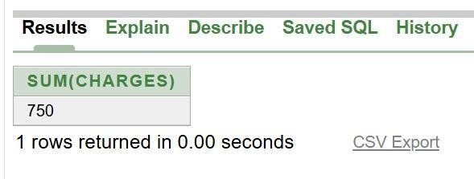
OUTPUT:
QUESTION:
- Select AVG (Charges) from HOSPITAL where Datofadm< {12/08/98}

INPUT:
SELECT AVG(Charges) FROM HOSPITAL WHERE DateofAdmission<TO_DATE('12-AUG1998','DD-MON-YYYY');

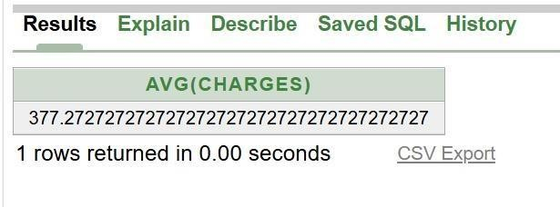
OUTPUT:

Answer the questions (a) and (b) on the basis of the following tables STORE and ITEM
  - Write the SQL queries (i) to (iv):
    - To display IName and Price of all the items in ascending order of their Price.
    - To display SNo and SName of all store location in CP.
    - To display Minimum and maximum Price of each IName from the table ITEM.
    - To display IName, Price of all items and their respective SName where they areavailable.
  - Write the output of the following SQL commands (i) to (iv):
    - SELECT DISTINCT IName FROM ITEM WHERE Price >=5000;
    - SELECT Area, COUNT (*) FROM STORE GROUP BY Area; (iii) SELECT COUNT (DISTINCT Area) FROM STORE:
- SELECT IName, Price * 0.05 DISCOUNT FROM ITEM WHERE SNo IN (‘S02’, ‘S03’);

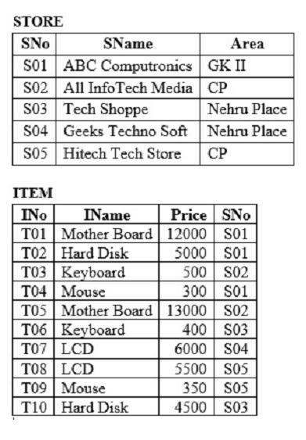

SYNTAX:
CREATE TABLE STORE(SNo VARCHAR(10) PRIMARY KEY,SName VARCHAR(30),Area VARCHAR(20));
INSERT INTO STORE VALUES('S01','ABC Computeronics','GK II'); INSERT INTO STORE VALUES('S02','All InfoTech Media','CP'); INSERT INTO STORE VALUES('S03','Tech Shoppe','Nehru Place');
INSERT INTO STORE VALUES('S04','Geeks Techno Soft','Nehru Place'); INSERT INTO STORE VALUES('S05','Hitech Tech Store','CP');
CREATE TABLE ITEM(INo VARCHAR(10) PRIMARY KEY,IName VARCHAR(30),Price INT,SNo VARCHAR(10));
INSERT INTO ITEM VALUES('T01','Mother Board',12000,'S01'); INSERT INTO ITEM VALUES('T02','Hard Disk',5000,'S01'); INSERT INTO ITEM VALUES('T03','Keyboard',500,'S02'); INSERT INTO ITEM VALUES('T04','Mouse',300,'S01');
INSERT INTO ITEM VALUES('T05','Mother Board',13000,'S02'); INSERT INTO ITEM VALUES('T06','Keyboard',400,'S03');

INSERT INTO ITEM VALUES('T07','LCD',6000,'S04'); INSERT INTO ITEM VALUES('T08','LCD',5500,'S05');
INSERT INTO ITEM VALUES('T09','Mouse',350,'S05'); INSERT INTO ITEM VALUES('T10','Hard Disk',4500,'S03');

QUESTION:
  - Write the SQL queries (i) to (iv):
    - To display IName and Price of all the items in ascending order of their Price.

INPUT:
SELECT IName,Price FROM ITEM ORDER BY Price ASC;

OUTPUT:
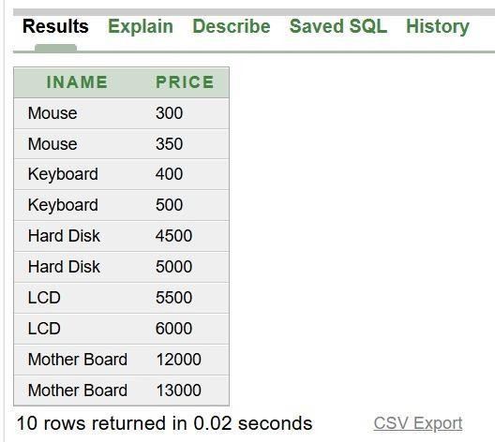

QUESTION:
    - To display SNo and SName of all store location in CP.

INPUT:
SELECT SNo,SName FROM STORE WHERE Area='CP';

OUTPUT:
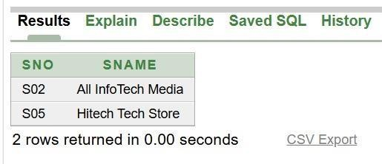

QUESTION:
    - To display Minimum and maximum Price of each IName from the table ITEM.

INPUT:
SELECT IName,MIN(Price),MAX(Price) FROM ITEM GROUP BY IName;

OUTPUT:
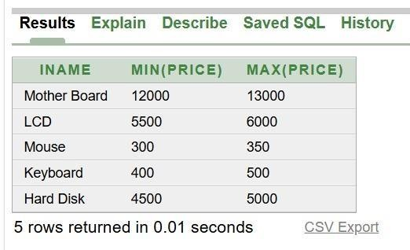

QUESTION:
    - To display IName, Price of all items and their respective SName where they are available.

INPUT:
SELECT I.IName,I.Price,S.SName FROM ITEM I,STORE S WHERE I.SNo=S.SNo;

OUTPUT:
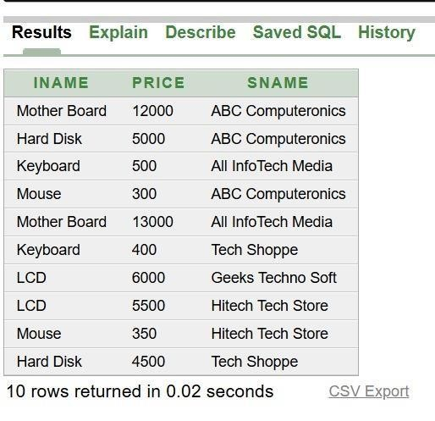

QUESTION:
  - Write the output of the following SQL commands (i) to (iv): (i) SELECT DISTINCT IName FROM ITEM WHERE Price >=5000; INPUT:
SELECT DISTINCT IName FROM ITEM WHERE Price>=5000;

OUTPUT:
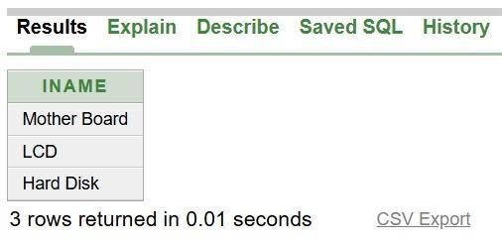

QUESTION:
- SELECT Area, COUNT (*) FROM STORE GROUP BY Area;

INPUT:
SELECT Area,COUNT(*) FROM STORE GROUP BY Area;

OUTPUT:
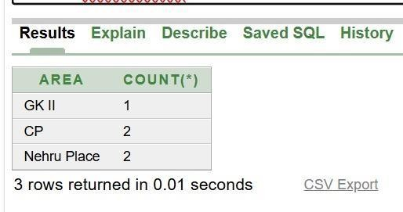

QUESTION:
- SELECT COUNT (DISTINCT Area) FROM STORE:

INPUT:
SELECT COUNT(DISTINCT Area) FROM STORE;

OUTPUT:
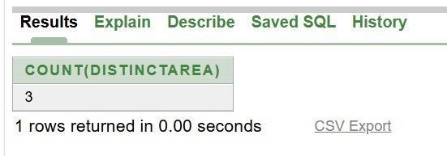

QUESTION:
- SELECT IName, Price * 0.05 DISCOUNT FROM ITEM WHERE SNo IN (‘S02’, ‘S03’);

INPUT:
SELECT IName,Price*0.05 AS DISCOUNT FROM ITEM WHERE SNo IN('S02','S03');

OUTPUT:
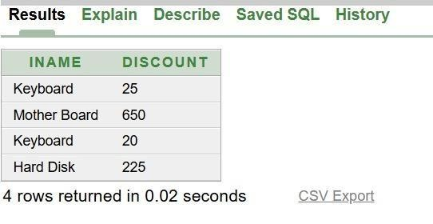

Write SQL commands for (a) to (f) and write output for (g) on the basis of Teacher relation given below:
  - To show all information about the teacher of history department
  - To list the names of female teacher who are in Hindi department
  - To list names of all teachers with their date of joining in ascending order. (d) To display teacher’s Name, Salary, Age for male teacher only (e) To count the number of teachers with Age>23.
- To inset a new row in the TEACHER table with the following data: 9, “Raja”, 26, “Computer”, {13/05/95}, 2300, “M”
- Give the output of following SQL statements:
  - Select COUNT (distinct department) from TEACHER;
(II) Select MAX (Age) from TEACHER where Gender= “F”
- Select AVG (Salary) from TEACHER where Date of join < {12/07/96}; (iv) Select SUM (Salary) from TEACHER where Date of join < {12/07/96};
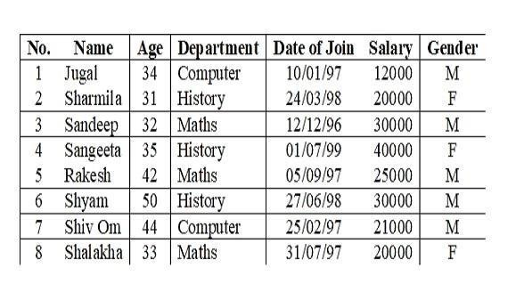

SYNTAX:
CREATE TABLE TEACHER(No INT PRIMARY KEY,Name VARCHAR(20),Age
INT,Department VARCHAR(20),DateofJoin DATE,Salary INT,Gender CHAR(1));

INSERT INTO TEACHER VALUES(1,'Jugal',34,'Computer',TO_DATE('1997-01-10','YYYYMM-DD'),12000,'M');
INSERT INTO TEACHER VALUES(2,'Sharmila',31,'History',TO_DATE('1998-03-24','YYYYMM-DD'),20000,'F');
INSERT INTO TEACHER VALUES(3,'Sandeep',32,'Maths',TO_DATE('1996-12-12','YYYYMM-DD'),30000,'M');
INSERT INTO TEACHER VALUES(4,'Sangeeta',35,'History',TO_DATE('1999-07-01','YYYYMM-DD'),40000,'F');
INSERT INTO TEACHER VALUES(5,'Rakesh',42,'Maths',TO_DATE('1997-09-05','YYYYMM-DD'),25000,'M');
INSERT INTO TEACHER VALUES(6,'Shyam',50,'History',TO_DATE('1998-06-27','YYYYMM-DD'),30000,'M');
INSERT INTO TEACHER VALUES(7,'Shiv Om',44,'Computer',TO_DATE('1997-02-25','YYYY-MM-DD'),21000,'M');
INSERT INTO TEACHER VALUES(8,'Shalakha',33,'Maths',TO_DATE('1997-07-31','YYYYMM-DD'),20000,'F');
INSERT INTO TEACHER VALUES(9,'Raja',26,'Computer',TO_DATE('1995-05-13','YYYYMM-DD'),2300,'M');

QUESTION:
  - To show all information about the teacher of history department

INPUT:
SELECT * FROM TEACHER WHERE Department='History';

OUTPUT:
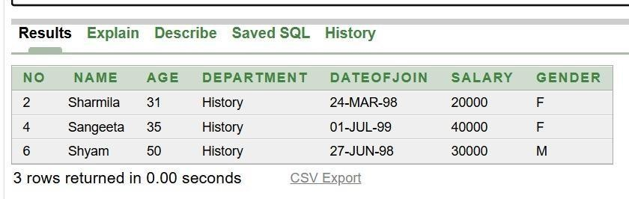

QUESTION:
  - To list the names of female teacher who are in Hindi department

INPUT:
SELECT Name FROM TEACHER WHERE Gender='F' AND Department='Hindi'

OUTPUT:
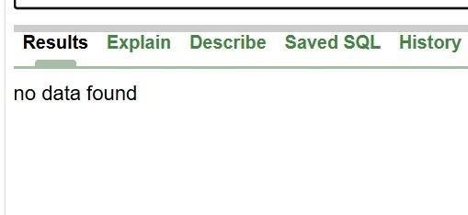

QUESTION:
  - To list names of all teachers with their date of joining in ascending order.

INPUT:
SELECT Name,DateofJoin FROM TEACHER ORDER BY DateofJoin ASC;

OUTPUT:
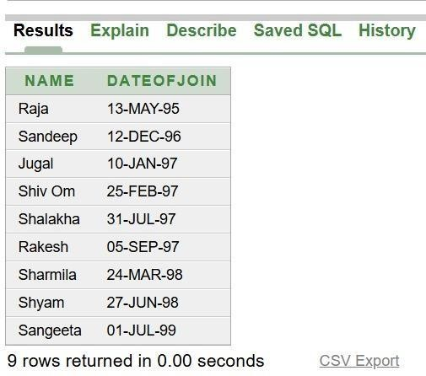

QUESTION:
  - To display teacher’s Name, Salary, Age for male teacher only

INPUT:
SELECT Name,Salary,Age FROM TEACHER WHERE Gender='M';

OUTPUT:
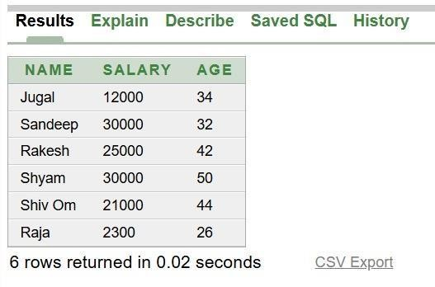

QUESTION:
  - To count the number of teachers with Age>23.

INPUT:
SELECT COUNT(*) FROM TEACHER WHERE Age>23;

OUTPUT:
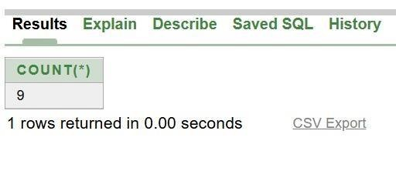

QUESTION:
  - To inset a new row in the TEACHER table with the following data: 9, “Raja”, 26, “Computer”, {13/05/95}, 2300, “M”

INPUT:
SELECT COUNT(DISTINCT Department) FROM TEACHER; OUTPUT:
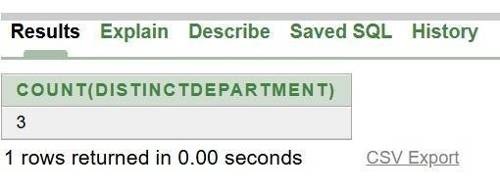

QUESTION:
  - Give the output of following SQL statements: (i) Select COUNT (distinct department) from TEACHER;

INPUT:
SELECT MAX(Age) FROM TEACHER WHERE Gender='F';

OUTPUT:
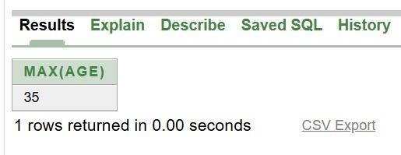

QUESTION:
(II) Select MAX (Age) from TEACHER where Gender= “F”

INPUT:
SELECT MAX(Age) FROM TEACHER WHERE Gender='F';

OUTPUT:

QUESTION:
- Select AVG (Salary) from TEACHER where Date of join < {12/07/96};

INPUT:
SELECT AVG(Salary) FROM TEACHER WHERE DateofJoin<TO_DATE('1996-07-12','YYYY-MM-DD');

OUTPUT:
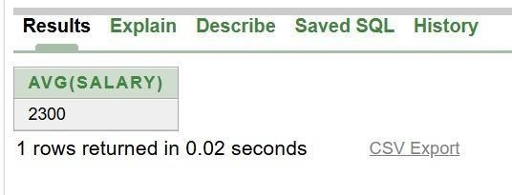

QUESTION:
- Select SUM (Salary) from TEACHER where Date of join < {12/07/96};

INPUT:
SELECT SUM(Salary) FROM TEACHER WHERE DateofJoin<TO_DATE('1996-07-12','YYYY-MM-DD');

OUTPUT:
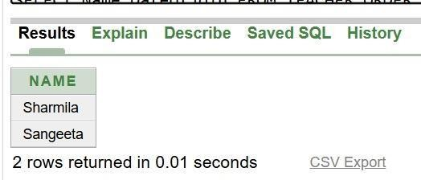

Given the following tables for a database LIBRARY: Write SQL queries for (a) to (f):
  - To show Book name, Author name and Price of books of EPB publishers.
  - To list the names of the books of Fiction Type.
  - To display the names and price of the books in descending order of their price.
  - To increase the price of all books of first publisher by 50.
  - To display the Book_Id, Book_Name and Quantity issued for all books which have been issued. (The query will require contents from both the tables).
  - To insert a new row in the table Issued following the data: “F0002”,4.
  - Give the output of the following queries based on the above tables:
    - SELECT COUNT(DISTINCT Publishers) FROM Books;
    - SELECT SUM(Price) FROM Books WHERE Quantity > 5;
    - SELECT BOOK_NAME,AUTHOR_NAME FROM Books WHERE Price < 500;
    - SELECT COUNT (*) FROM Books;

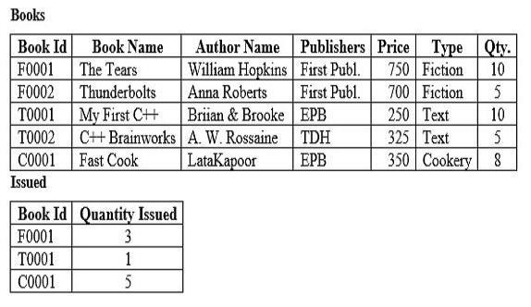

SYNTAX:
CREATE TABLE Books(Book_Id VARCHAR(10) PRIMARY KEY,Book_Name
VARCHAR(30),Author_Name VARCHAR(30),Publishers VARCHAR(20),Price INT,Type VARCHAR(20),Qty INT);
INSERT INTO Books VALUES('F0001','The Tears','William Hopkins','First Publ.',750,'Fiction',10);
INSERT INTO Books VALUES('F0002','Thunderbolts','Anna Roberts','First Publ.',700,'Fiction',5);
INSERT INTO Books VALUES('T0001','My First C++','Brian & Brooke','EPB',250,'Text',10); INSERT INTO Books VALUES('T0002','C++ Brainworks','A. W. Rossaine','TDH',325,'Text',5);
INSERT INTO Books VALUES('C0001','Fast Cook','Lata Kapoor','EPB',350,'Cookery',8); CREATE TABLE Issued(Book_Id VARCHAR(10),Quantity_Issued INT);
INSERT INTO Issued VALUES('F0001',3); INSERT INTO Issued VALUES('T0001',1); INSERT INTO Issued VALUES('C0001',5);
SELECT Book_Name,Author_Name,Price FROM Books WHERE Publishers='EPB'; SELECT Book_Name FROM Books WHERE Type='Fiction';
SELECT Book_Name,Price FROM Books ORDER BY Price DESC; UPDATE Books SET Price=Price+50 WHERE Publishers='First Publ.';
SELECT B.Book_Id,B.Book_Name,I.Quantity_Issued FROM Books B,Issued I WHERE B.Book_Id=I.Book_Id;
INSERT INTO Issued VALUES('F0002',4);
SELECT COUNT(DISTINCT Publishers) FROM Books; SELECT SUM(Price) FROM Books WHERE Qty>5;
SELECT Book_Name,Author_Name FROM Books WHERE Price<500; SELECT COUNT(*) FROM Books; QUESTION:
      - To show Book name, Author name and Price of books of EPB publishers.

INPUT:
SELECT Book_Name,Author_Name,Price FROM Books WHERE Publishers='EPB';

OUTPUT:
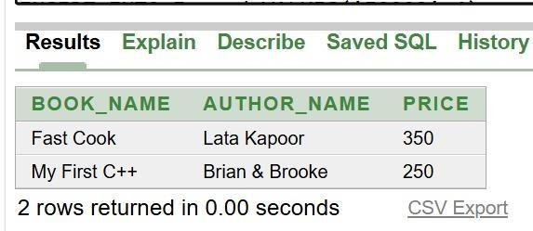

QUESTION:
      - To list the names of the books of Fiction Type.

INPUT:
SELECT Book_Name FROM Books WHERE Type='Fiction';

OUTPUT:
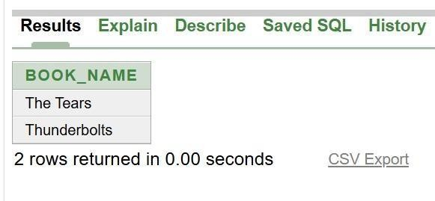

QUESTION:
      - To display the names and price of the books in descending order of their price.

INPUT:
SELECT Book_Name,Price FROM Books ORDER BY Price DESC;

OUTPUT:
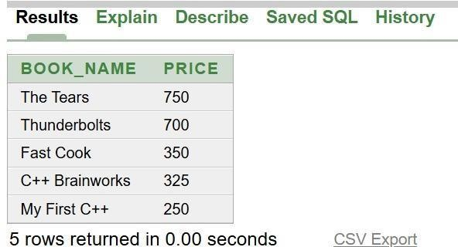

QUESTION:
      - To increase the price of all books of first publisher by 50.

INPUT:
UPDATE Books SET Price=Price+50 WHERE Publishers='First Publ.';

OUTPUT:
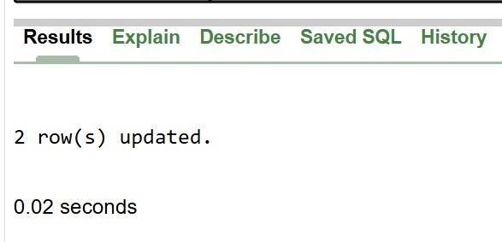

QUESTION:
      - To display the Book_Id, Book_Name and Quantity issued for all books which have been issued. (The query will require contents from both the tables).

INPUT:
SELECT B.Book_Id,B.Book_Name,I.Quantity_Issued FROM Books B,Issued I WHERE B.Book_Id=I.Book_Id;

OUTPUT:
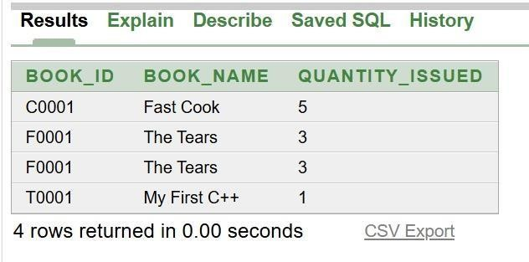

QUESTION:
      - To insert a new row in the table Issued following the data: “F0002”,4.

INPUT:
INSERT INTO Issued VALUES('F0002',4);

OUTPUT:
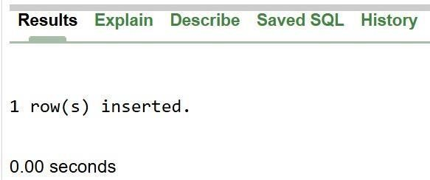

QUESTION:
      - Give the output of the following queries based on the above tables:
        - SELECT COUNT(DISTINCT Publishers) FROM Books;

INPUT:
SELECT COUNT(DISTINCT Publishers) FROM Books;

OUTPUT:
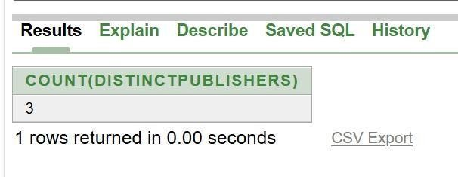

QUESTION:

        - SELECT SUM(Price) FROM Books WHERE Quantity > 5;

INPUT:
SELECT SUM(Price) FROM Books WHERE Qty>5;

OUTPUT:
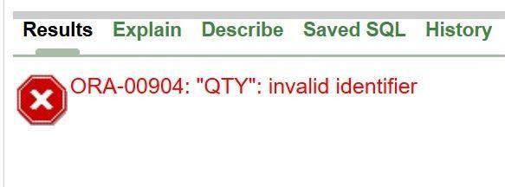

QUESTION:
        - SELECT BOOK_NAME,AUTHOR_NAME FROM Books WHERE Price < 500;

INPUT:
SELECT Book_Name,Author_Name FROM Books WHERE Price<500;

OUTPUT:
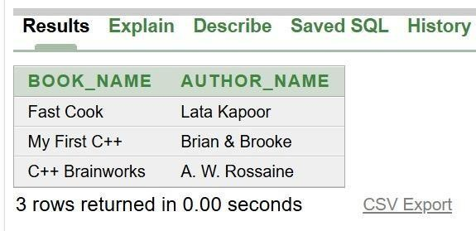

QUESTION:
        - SELECT COUNT (*) FROM Books;

INPUT:
SELECT COUNT(*) FROM Books;

OUTPUT:
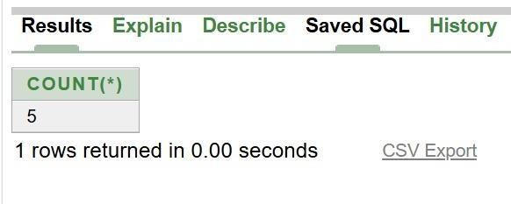

Consider the following tables CARDEN and CUSTOMER and answer (a) and (b) parts of this question:
  - Write SQL commands for the following statements:
    - To display the name of all the SILVER colored cars.
    - To display name of car, make and capacity of cars in descending order of their sitting capacity.
    - To display the highest Charges at which a vehicle can be hired from CARDEN.
    - To display the customer name and the corresponding name of the cards hired by them. (b) Give the output of the following SQL queries:
- SELECT COUNT (DISTINCT Make) FROM CARDEN;
- SELECT MAX (Charges), MIN (Charges) FROM CARDEN;
- SELECT COUNT (*), Make FROM CARDEN;
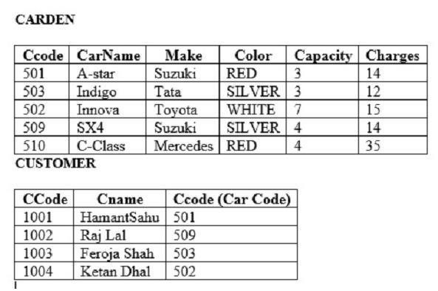
- SELECT CarName FROM CARDEN WHERE Capacity = 4;

SYNTAX:
CREATE TABLE CARDEN (Ccode INT PRIMARY KEY, CarName VARCHAR(20), Make
VARCHAR(20), Color VARCHAR(10), Capacity INT, Charges INT);

INSERT INTO CARDEN VALUES (501, 'A-star', 'Suzuki', 'RED', 3, 14); INSERT INTO CARDEN VALUES (503, 'Indigo', 'Tata', 'SILVER', 3, 12); INSERT INTO CARDEN VALUES (502, 'Innova', 'Toyota', 'WHITE', 7, 15); INSERT INTO CARDEN VALUES (509, 'SX4', 'Suzuki', 'SILVER', 4, 14); INSERT INTO CARDEN VALUES (510, 'C-Class', 'Mercedes', 'RED', 4, 35);
CREATE TABLE CUSTOMER (CCCode INT PRIMARY KEY, CName VARCHAR(30),
Ccode INT);
INSERT INTO CUSTOMER VALUES (1001, 'HemantSahu', 501); INSERT INTO CUSTOMER VALUES (1002, 'Raj Lal', 509); INSERT INTO CUSTOMER VALUES (1003, 'Feroja Shah', 503); INSERT INTO CUSTOMER VALUES (1004, 'Ketan Dhal', 502);

QUESTION:
  - Write SQL commands for the following statements:
    - To display the name of all the SILVER colored cars.

INPUT:
SELECT CarName FROM CARDEN WHERE Color = 'SILVER';

OUTPUT:
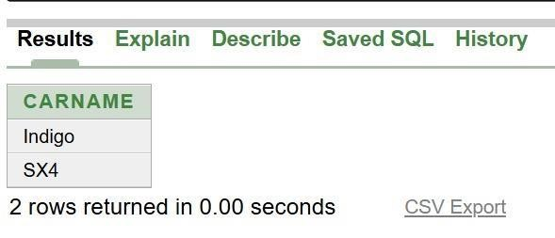

QUESTION:
    - To display name of car, make and capacity of cars in descending order of their sitting capacity.

INPUT:
SELECT CarName, Make, Capacity FROM CARDEN ORDER BY Capacity DESC;

OUTPUT:
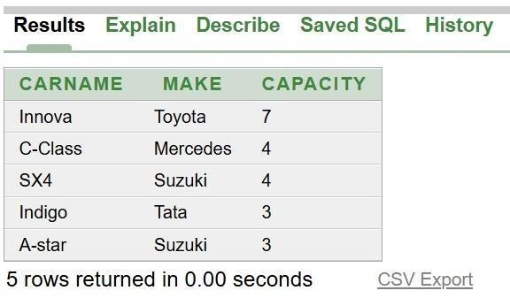

QUESTION:
    - To display the highest Charges at which a vehicle can be hired from CARDEN.

INPUT:
SELECT MAX(Charges) FROM CARDEN;

OUTPUT:
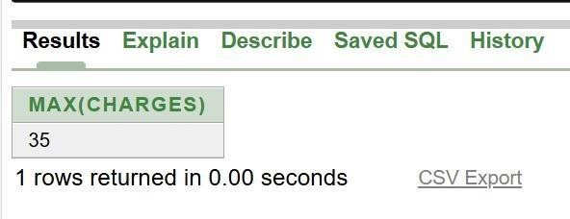

QUESTION:
    - To display the customer name and the corresponding name of the cards hired by them.

INPUT:
SELECT CUSTOMER.CName,CARDEN.CarName FROM CUSTOMER,CARDEN WHERE CUSTOMER.Ccode=CARDEN.Ccode; OUTPUT:
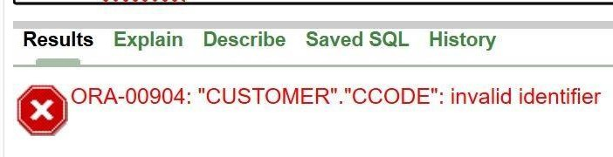

QUESTION:
  - Give the output of the following SQL queries: (i) SELECT COUNT (DISTINCT Make) FROM CARDEN; INPUT:
SELECT COUNT(DISTINCT Make) FROM CARDEN;

OUTPUT:
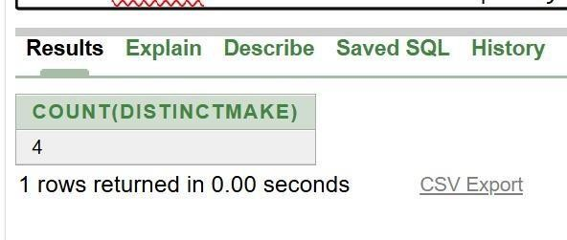

QUESTION:
  - SELECT MAX (Charges), MIN (Charges) FROM CARDEN;

INPUT:
SELECT MAX(Charges),MIN(Charges) FROM CARDEN;

OUTPUT:
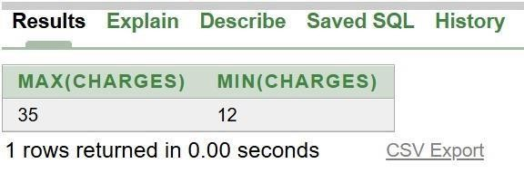

QUESTION:
  - SELECT COUNT (*), Make FROM CARDEN;

INPUT:
SELECT COUNT(*),Make FROM CARDEN GROUP BY Make;

OUTPUT:
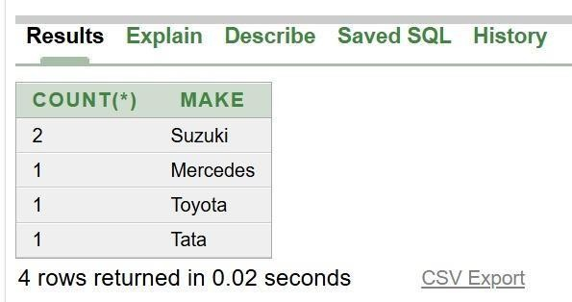

QUESTION:
  - SELECT CarName FROM CARDEN WHERE Capacity = 4;

INPUT:
SELECT CarName FROM CARDEN WHERE Capacity=4;

OUTPUT:
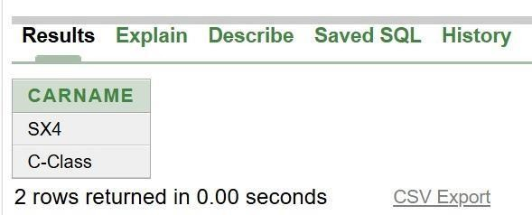

Consider the following tables EMPLOYEE and SALGRADE and answer (a) and (b) parts of this question:
  - Write SQL commands for the following statements:
- To display the detail of all the EMPLOYEE in descending order of DOJ.
- To display name and design of those EMPLOYEE, whose sgrade is either S02 or S03.
- To display the content of all the EMPLOYEE table, whose DOJ is in between ’09-FEB2006’ and ’08-AUG-2009’.
- TO add a new row in the EMPLOYEE table with the following data: 109, ‘Harish Roy’, ‘HEAD-IT’, ‘S02’, ’09-SEP-2007’, ’21-APR-1983’.
  - Give the output of the following SQL queries:
    - SELECT COUNT (SGRADE), SGRADE FROM EMPLOYEE GROUP BY SGRADE;
    - SELECT MIN (DOB), MAX (DOJ) FROM EMPLOYEE;
    - SELECT NAME, SALARY FROM EMPLOYEE E, SALGRADE S WHERE E. SGRADE
= S. SGRADE AND E. ECODE<103;
    - SELECT SGRADE, SALARY+HRA FROM SALGRADE WHERE SGRADE = ‘S02’;

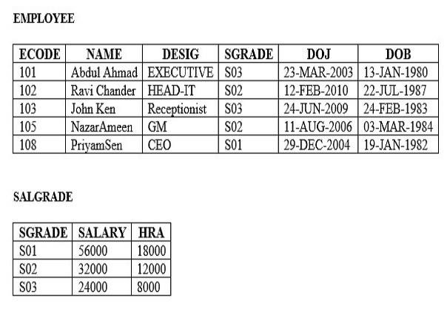

SYNTAX:
CREATE TABLE EMPLOYEE(ECODE INT PRIMARY KEY,NAME VARCHAR(30),DESIG VARCHAR(30),SGRADE VARCHAR(5),DOJ DATE,DOB DATE);

INSERT INTO EMPLOYEE VALUES(101,'Abdul Ahmad','EXECUTIVE','S03',DATE '2003-03-23',DATE '1980-01-13');
INSERT INTO EMPLOYEE VALUES(102,'Ravi Chander','HEAD-IT','S02',DATE '2010-02-12',DATE '1987-07-22');
INSERT INTO EMPLOYEE VALUES(103,'John Ken','RECEPTIONIST','S03',DATE '2009-06-24',DATE '1983-02-24');
INSERT INTO EMPLOYEE VALUES(105,'Nazar Ameen','GM','S02',DATE '2006-08-11',DATE '1984-03-03');
INSERT INTO EMPLOYEE VALUES(108,'Priyam Sen','CEO','S01',DATE '2004-12-29',DATE '1982-01-19');
CREATE TABLE SALGRADE(SGRADE VARCHAR(5) PRIMARY KEY,SALARY INT,HRA INT);
INSERT INTO SALGRADE VALUES('S01',56000,18000); INSERT INTO SALGRADE VALUES('S02',32000,12000); INSERT INTO SALGRADE VALUES('S03',24000,8000); SELECT * FROM EMPLOYEE ORDER BY DOJ DESC;
SELECT NAME,DESIG FROM EMPLOYEE WHERE SGRADE IN('S02','S03');
SELECT * FROM EMPLOYEE WHERE DOJ BETWEEN DATE '2006-02-09' AND DATE '2009-08-08';
SELECT COUNT(SGRADE),SGRADE FROM EMPLOYEE GROUP BY SGRADE;

SELECT MIN(DOB),MAX(DOJ) FROM EMPLOYEE;
SELECT NAME,SALARY FROM EMPLOYEE E,SALGRADE S WHERE E.SGRADE=S.SGRADE AND E.ECODE<103;
SELECT SGRADE,SALARY+HRA FROM SALGRADE WHERE SGRADE='S02'; INSERT INTO EMPLOYEE VALUES(109,'Harish Roy','HEAD-IT','S02',DATE '2007-0909',DATE '1983-04-21');

QUESTION:
      - Write SQL commands for the following statements:
        - To display the detail of all the EMPLOYEE in descending order of DOJ.

INPUT:
SELECT * FROM EMPLOYEE ORDER BY DOJ DESC;

OUTPUT:
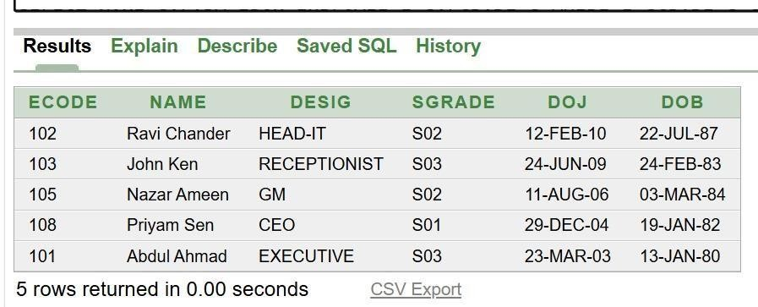

QUESTION:
        - To display name and design of those EMPLOYEE, whose sgrade is either S02 or S03.

INPUT:
SELECT NAME,DESIG FROM EMPLOYEE WHERE SGRADE IN('S02','S03');

OUTPUT:
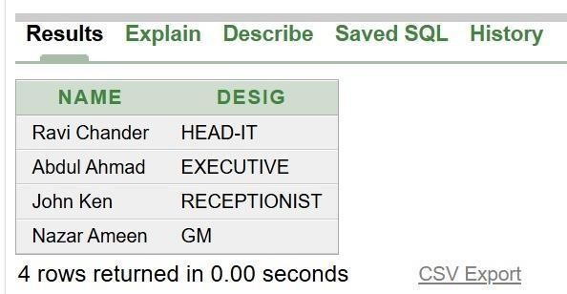

QUESTION:
        - To display the content of all the EMPLOYEE table, whose DOJ is in between ’09-FEB2006’ and ’08-AUG-2009’.

INPUT:
SELECT * FROM EMPLOYEE WHERE DOJ BETWEEN DATE '2006-02-09' AND DATE '2009-08-08';

OUTPUT:
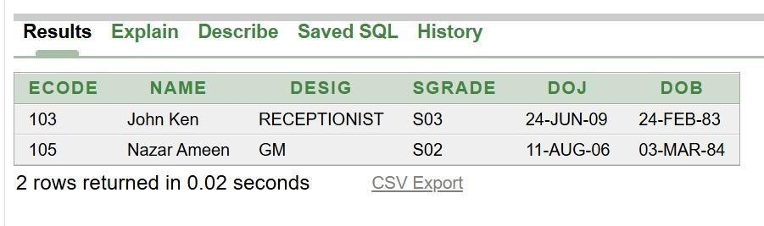

QUESTION:
        - TO add a new row in the EMPLOYEE table with the following data: 109, ‘Harish Roy’, ‘HEAD-IT’, ‘S02’, ’09-SEP-2007’, ’21-APR-1983’.

INPUT:
INSERT INTO EMPLOYEE VALUES(109,'Harish Roy','HEAD-IT','S02',DATE '2007-0909',DATE '1983-04-21');

OUTPUT:
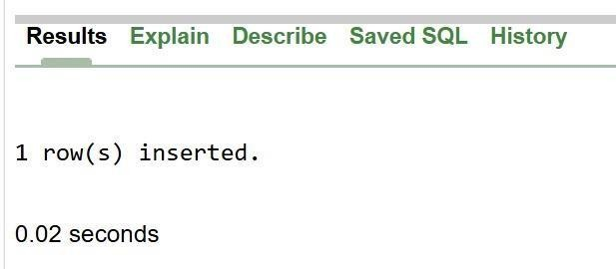

QUESTION:
      - Give the output of the following SQL queries:
        - SELECT COUNT (SGRADE), SGRADE FROM EMPLOYEE GROUP BY SGRADE;

INPUT:
SELECT COUNT(SGRADE),SGRADE FROM EMPLOYEE GROUP BY SGRADE;

OUTPUT:
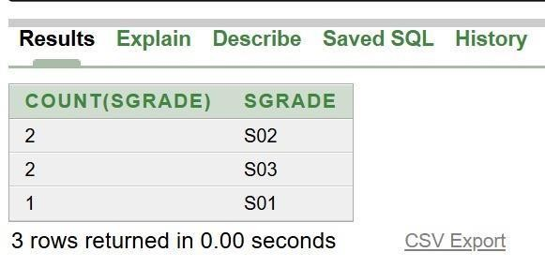

QUESTION:
        - SELECT MIN (DOB), MAX (DOJ) FROM EMPLOYEE;

INPUT:
SELECT MIN(DOB),MAX(DOJ) FROM EMPLOYEE;

OUTPUT:
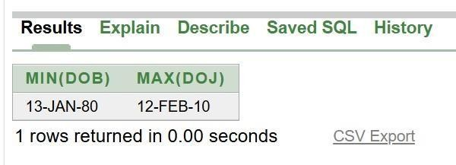

QUESTION:
        - SELECT NAME, SALARY FROM EMPLOYEE E, SALGRADE S WHERE E. SGRADE
= S. SGRADE AND E. ECODE<103; INPUT:
SELECT NAME,SALARY FROM EMPLOYEE E,SALGRADE S WHERE E.SGRADE=S.SGRADE AND E.ECODE<103;

OUTPUT:
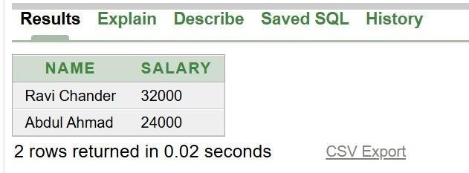

QUESTION:
        - SELECT SGRADE, SALARY+HRA FROM SALGRADE WHERE SGRADE = ‘S02’;

INPUT:
SELECT SGRADE,SALARY+HRA FROM SALGRADE WHERE SGRADE='S02';

OUTPUT:
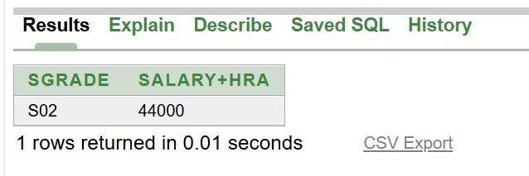

Consider the following tables WORKER and PAYLAVEL and answer (a) and (b) parts of this question
  - Write SQL commands for the following statements:
    - To display the detail of all WORKER in descending order of DOB.
    - To display name and design of those WORKER, whoseplevel is either P001 to P002.
    - To display the content of all the WORKER table, whose DOB is in between ‘19-JAN-1984’ and ‘18-JAN-1987’.
    - To add a new row with the following: 19, ‘Daya Kishore’, ‘Operator’, ‘P003’, ’19-JUN2008’, ’11-JUL-1984’.
  - Give the output of the following SQL queries:
    - SELECT COUNT (PLEVEL), PLEVEL FROM WORKER GROUP BY PLEVEL;
    - SELECT MAX (DOB), MIN (DOJ) FROM WORKER;
    - SELECT NAME, PAY FROM WORKER W, PAYLEVEL P WHERE W. PLEVEL= P.LEVEL AND W. ECODE<13;
    - SELECT PLEVEL, PAY+ALLOWANCE FROM PLEVEL WHERE PLEVEL =‘P003’;

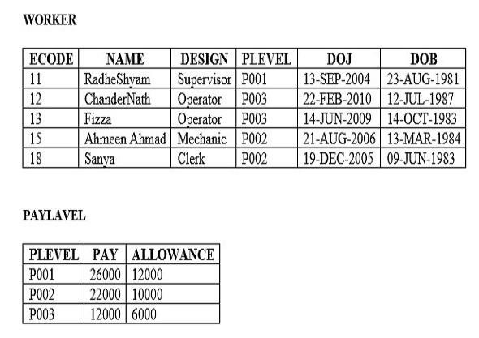

SYNTAX:
CREATE TABLE WORKER(ECODE INT,NAME VARCHAR(20),DESIGN VARCHAR(20),PLEVEL VARCHAR(5),DOJ DATE,DOB DATE);
INSERT INTO WORKER VALUES(11,'RadheShyam','Supervisor','P001','13-SEP-2004','23-AUG-1981');
INSERT INTO WORKER VALUES(12,'ChanderNath','Operator','P003','22-FEB-2010','12-JUL1987');
INSERT INTO WORKER VALUES(13,'Fizza','Operator','P003','14-JUN-2009','14-OCT-1983'); INSERT INTO WORKER VALUES(15,'Ahmeen Ahmad','Mechanic','P002','21-AUG-2006','13MAR-1984');
INSERT INTO WORKER VALUES(18,'Sanya','Clerk','P002','19-DEC-2005','09-JUN-1983'); CREATE TABLE PAYLEVEL(PLEVEL VARCHAR(5),PAY INT,ALLOWANCE INT); INSERT INTO PAYLEVEL VALUES('P001',26000,12000);
INSERT INTO PAYLEVEL VALUES('P002',22000,10000); INSERT INTO PAYLEVEL VALUES('P003',12000,6000);

QUESTION:
      - Write SQL commands for the following statements:
        - To display the detail of all WORKER in descending order of DOB.

INPUT:
SELECT * FROM WORKER ORDER BY DOB DESC;

OUTPUT:
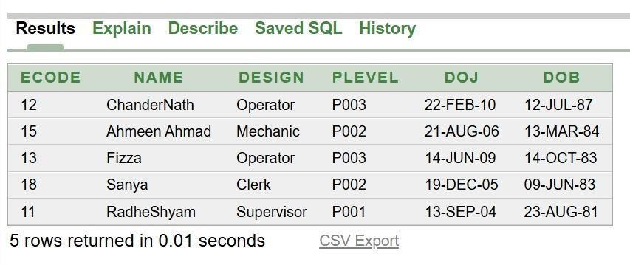

QUESTION:
        - To display name and design of those WORKER, whoseplevel is either P001 to P002.

INPUT:
SELECT NAME,DESIGN FROM WORKER WHERE PLEVEL='P001' OR PLEVEL='P002';

OUTPUT:
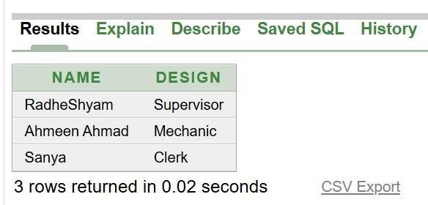

QUESTION:
        - To display the content of all the WORKER table, whose DOB is in between ‘19-JAN-1984’ and ‘18-JAN-1987’.

INPUT:
SELECT * FROM WORKER WHERE DOB BETWEEN '19-JAN-1984' AND '18-JAN-1987';

OUTPUT:
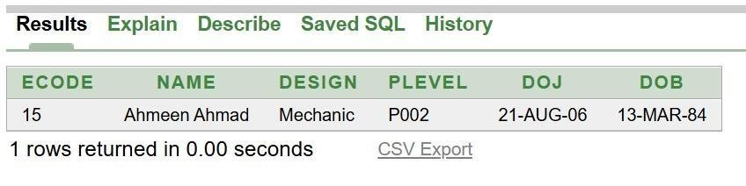

QUESTION:
        - To add a new row with the following: 19, ‘Daya Kishore’, ‘Operator’, ‘P003’, ’19-JUN2008’, ’11-JUL-1984’.

INPUT:
INSERT INTO WORKER VALUES(19,'Daya Kishore','Operator','P003','19-JUN-2008','11JUL-1984');

OUTPUT:
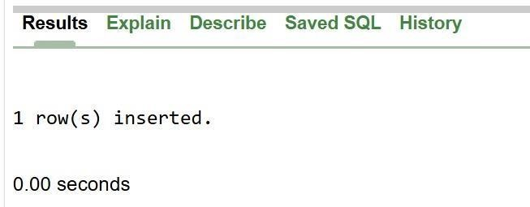

QUESTION:
      - Give the output of the following SQL queries:
        - SELECT COUNT (PLEVEL), PLEVEL FROM WORKER GROUP BY PLEVEL;

INPUT:
SELECT COUNT(PLEVEL),PLEVEL FROM WORKER GROUP BY PLEVEL;

OUTPUT:
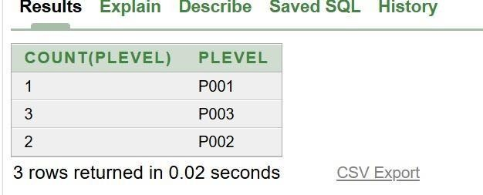

QUESTION:
        - SELECT MAX (DOB), MIN (DOJ) FROM WORKER;

INPUT:
SELECT MAX(DOB),MIN(DOJ) FROM WORKER; OUTPUT:
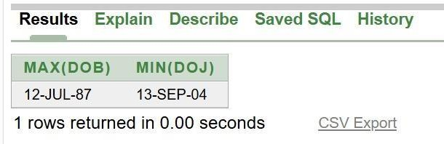

QUESTION:

        - SELECT NAME, PAY FROM WORKER W, PAYLEVEL P WHERE W. PLEVEL= P.LEVEL AND W. ECODE<13;

INPUT:
SELECT NAME,PAY FROM WORKER W,PAYLEVEL P WHERE W.PLEVEL=P.PLEVEL AND W.ECODE<13;

OUTPUT:
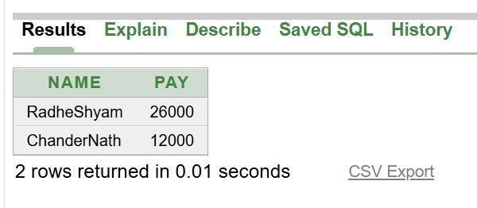

QUESTION:
        - SELECT PLEVEL, PAY+ALLOWANCE FROM PLEVEL WHERE PLEVEL =‘P003’;

INPUT:
SELECT PLEVEL,PAY+ALLOWANCE FROM PAYLEVEL WHERE PLEVEL='P003';

OUTPUT:
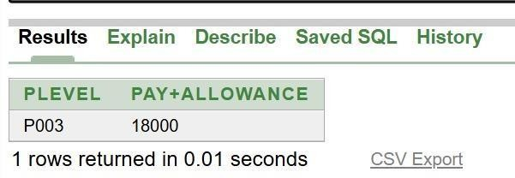

Consider the following tables STORE and SUPPLIERS and answer (a) and (b) parts of this question:
  - Write SQL commands for the following statements:
    - To display details of all the items in the Store table in ascending order of LastBuy. (ii) To display ItemNo and Item name of those items from STORE table whose Rate is more than15 Rupees.
- To display the details of those items whose Supplier code (Scode) is 22 or Quantity in Store (Qty) is more than 110 from the table STORE.

- To display minimum Rate of items for each supplier individually as per Scode from the table STORE.
  - Give the output of the following SQL queries:
    - SELECT COUNT (DISTINCT Scode) FROM STORE;
    - SELECT Rate * Qty FROM STORE WHERE ItemNo=2004;
    - SELECT Item,Sname FROM Store S, SUPPLIERS P WHERE S.Scode=P.ScodeAND ItemNo=2006;
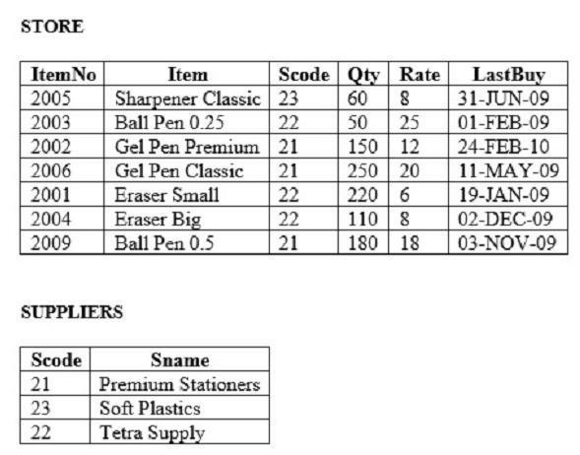
    - SELECT MAX(LastBuy) FROM STORE;

SYNTAX:
DROP TABLE STORE CASCADE CONSTRAINTS; DROP TABLE SUPPLIERS CASCADE CONSTRAINTS;
CREATE TABLE STORE(ItemNo INT PRIMARY KEY,Item VARCHAR(30),Scode INT,Qty
INT,Rate INT,LastBuy DATE);
INSERT INTO STORE VALUES(2001,'Eraser Small',22,220,6,TO_DATE('19-JAN-2009','DD-MON-YYYY'));
INSERT INTO STORE VALUES(2002,'Gel Pen Premium',21,150,12,TO_DATE('24-FEB-2010','DD-MON-YYYY'));
INSERT INTO STORE VALUES(2003,'Ball Pen 0.25',22,50,25,TO_DATE('01-FEB-2010','DD-MON-YYYY'));
INSERT INTO STORE VALUES(2004,'Eraser Big',22,110,8,TO_DATE('02-DEC-2009','DD-MON-YYYY'));
INSERT INTO STORE VALUES(2005,'Sharpener Classic',23,60,8,TO_DATE('30-JUN-

2009','DD-MON-YYYY'));
INSERT INTO STORE VALUES(2006,'Gel Pen Classic',21,250,20,TO_DATE('11-MAR-2009','DD-MON-YYYY'));
INSERT INTO STORE VALUES(2009,'Ball Pen 0.5',21,180,18,TO_DATE('03-NOV-2009','DD-MON-YYYY'));
CREATE TABLE SUPPLIERS(Scode INT PRIMARY KEY,Sname VARCHAR(30)); INSERT INTO SUPPLIERS VALUES(21,'Premium Stationers');
INSERT INTO SUPPLIERS VALUES(22,'Tetra Supply'); INSERT INTO SUPPLIERS VALUES(23,'Soft Plastics'); QUESTION:
      - Write SQL commands for the following statements:
        - To display details of all the items in the Store table in ascending order of LastBuy.

INPUT:
SELECT * FROM STORE ORDER BY LastBuy ASC;

OUTPUT:
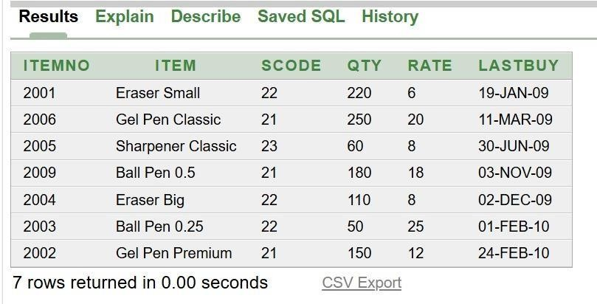

QUESTION:
        - To display ItemNo and Item name of those items from STORE table whose Rate is more than15 Rupees.

INPUT:
SELECT ItemNo,Item FROM STORE WHERE Rate>15;

OUTPUT:
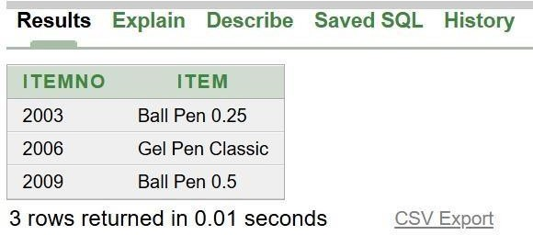

QUESTION:
        - To display the details of those items whose Supplier code (Scode) is 22 or Quantity in Store (Qty) is more than 110 from the table STORE.

INPUT:
SELECT * FROM STORE WHERE Scode=22 OR Qty>110;

OUTPUT:
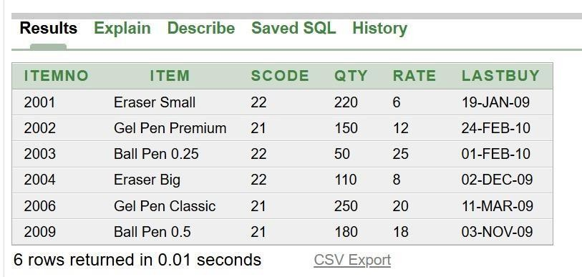

QUESTION:
        - To display minimum Rate of items for each supplier individually as per Scode from the table STORE.

INPUT:
SELECT Scode,MIN(Rate) FROM STORE GROUP BY Scode;

OUTPUT:
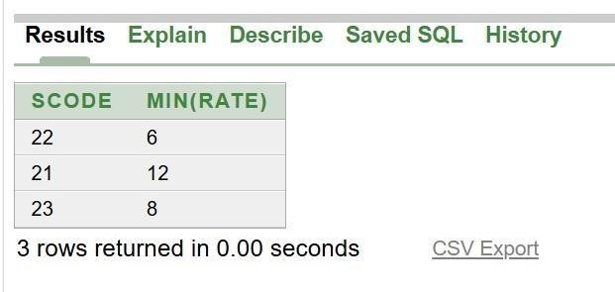

QUESTION:
      - Give the output of the following SQL queries: (i) SELECT COUNT (DISTINCT Scode) FROM STORE; INPUT:
SELECT COUNT(DISTINCT Scode) FROM STORE;

OUTPUT:
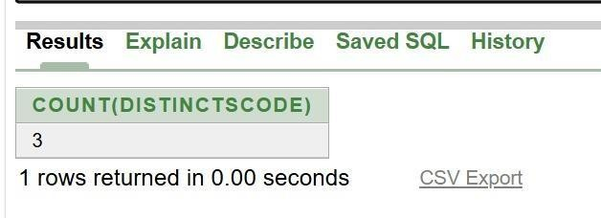

QUESTION:
- SELECT Rate * Qty FROM STORE WHERE ItemNo=2004; INPUT:
SELECT Rate*Qty FROM STORE WHERE ItemNo=2004; OUTPUT:
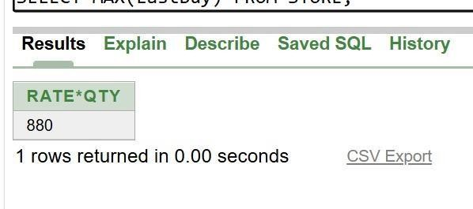

QUESTION:
- SELECT Item,Sname FROM Store S, SUPPLIERS P WHERE S.Scode=P.ScodeAND ItemNo=2006;

INPUT:
SELECT Item,Sname FROM STORE S,SUPPLIERS P WHERE S.Scode=P.Scode AND S.ItemNo=2006;

OUTPUT:
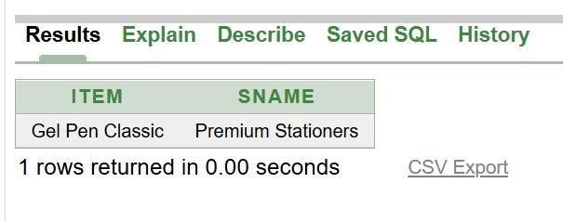

QUESTION:
- SELECT MAX(LastBuy) FROM STORE;

INPUT:
SELECT MAX(LastBuy) FROM STORE;

OUTPUT:
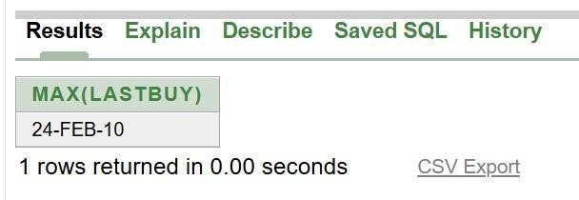

Consider the following table GARMENT and FABRIC, Write SQL commands for the statements (i) to (iv) and give outputs for the SQL queries
- to (viii).
- To display GCODE and DESCRIPTION of each GARMENT in descending order of GCODE.
- To display the details of all the GARMENT, which have READYDATE in between 08DEC-07 and 16-JUN-08 (inclusive if both the dates).
- To display the average PRICE of all the GARMENT, which are made up of fabric with FCODE as F03.
- To display fabric wise highest and lowest price of GARMENT from GARMENT table. (Display FCODE of each GARMENT along with highest and lowest Price).
- SELECT SUM (PRICE) FROM GARMENT WHERE FCODE = ‘F01’;
- SELECT DESCRIPTION, TYPE FROM GARMENT, FABRIC WHERE GARMENT, FCODE = FABRIC.FCODE AND GARMENT.PRICE >=1260;
- SELECT MAX (FCODE) FROM FABRIC;
- SELECT COUNT (DISTINCT PRICE) FROM GARMENT;

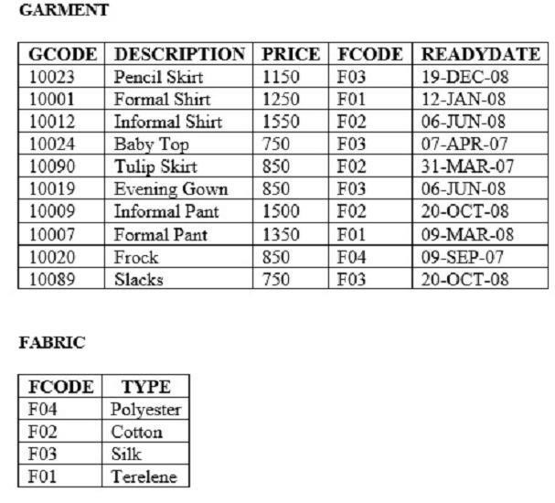

SYNTAX:
CREATE TABLE GARMENT(GCODE INT,DESCRIPTION VARCHAR(30),PRICE INT,FCODE VARCHAR(5),READYDATE DATE);
INSERT INTO GARMENT VALUES(10023,'Pencil Skirt',1150,'F03','19-DEC-08'); INSERT INTO GARMENT VALUES(10001,'Formal Shirt',1250,'F01','12-JAN-08'); INSERT INTO GARMENT VALUES(10012,'Informal Shirt',1550,'F02','06-JUN-08'); INSERT INTO GARMENT VALUES(10024,'Baby Top',750,'F03','07-APR-07'); INSERT INTO GARMENT VALUES(10090,'Tulip Skirt',850,'F02','31-MAR-07'); INSERT INTO GARMENT VALUES(10019,'Evening Gown',850,'F03','06-JUN-08'); INSERT INTO GARMENT VALUES(10009,'Informal Pant',1500,'F02','20-OCT-08'); INSERT INTO GARMENT VALUES(10007,'Formal Pant',1350,'F01','09-MAR-08'); INSERT INTO GARMENT VALUES(10020,'Frock',850,'F04','09-SEP-07');
INSERT INTO GARMENT VALUES(10089,'Slacks',750,'F03','20-OCT-08'); CREATE TABLE FABRIC(FCODE VARCHAR(5),TYPE VARCHAR(20));

INSERT INTO FABRIC VALUES('F04','Polyester'); INSERT INTO FABRIC VALUES('F02','Cotton'); INSERT INTO FABRIC VALUES('F03','Silk'); INSERT INTO FABRIC VALUES('F01','Terelene');

QUESTION:
- To display GCODE and DESCRIPTION of each GARMENT in descending order of GCODE.

INPUT:
SELECT GCODE,DESCRIPTION FROM GARMENT ORDER BY GCODE DESC;

OUTPUT:
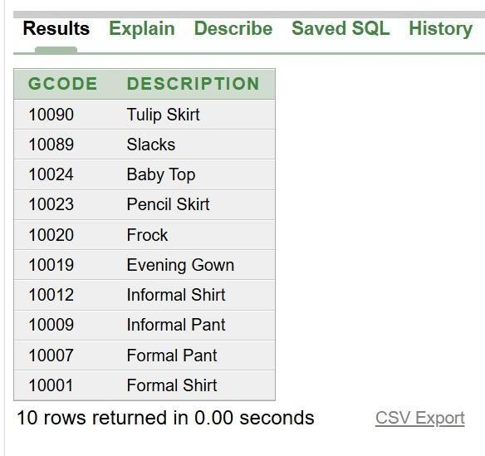

QUESTION:
- To display the details of all the GARMENT, which have READYDATE in between 08DEC-07 and 16-JUN-08 (inclusive if both the dates).

INPUT:
SELECT * FROM GARMENT WHERE READYDATE BETWEEN '08-DEC-07' AND '16-JUN-08';

OUTPUT:
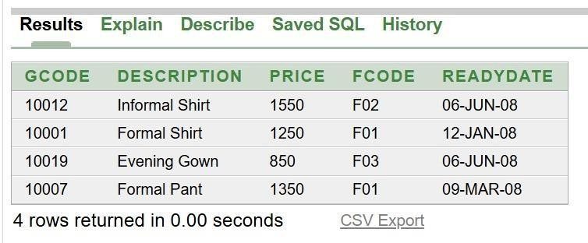

QUESTION:
- To display the average PRICE of all the GARMENT, which are made up of fabric with FCODE as F03.

INPUT:
SELECT AVG(PRICE) FROM GARMENT WHERE FCODE='F03';

OUTPUT:
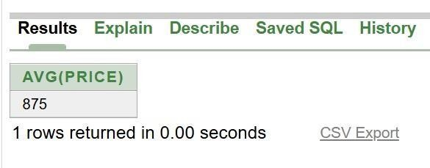

QUESTION:
- To display fabric wise highest and lowest price of GARMENT from GARMENT table. (Display FCODE of each GARMENT along with highest and lowest Price).

INPUT:
SELECT FCODE,MAX(PRICE),MIN(PRICE) FROM GARMENT GROUP BY FCODE;

OUTPUT:
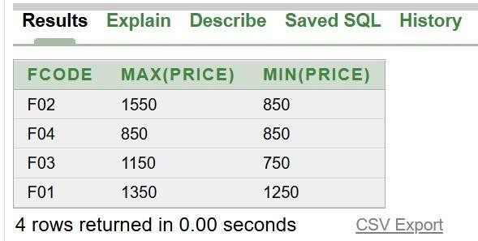

QUESTION:

- SELECT SUM (PRICE) FROM GARMENT WHERE FCODE = ‘F01’;

INPUT:
SELECT SUM(PRICE) FROM GARMENT WHERE FCODE='F01';

OUTPUT:
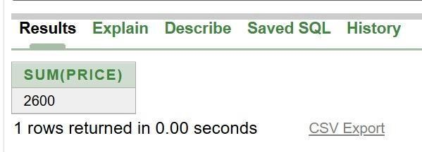

QUESTION:
- SELECT DESCRIPTION, TYPE FROM GARMENT, FABRIC WHERE GARMENT, FCODE = FABRIC.FCODE AND GARMENT.PRICE >=1260;

INPUT:
SELECT DESCRIPTION,TYPE FROM GARMENT G,FABRIC F WHERE G.FCODE=F.FCODE AND G.PRICE>=1260;

OUTPUT:
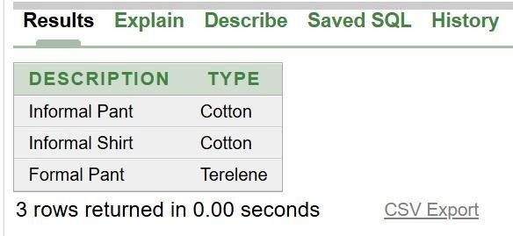

QUESTION:
- SELECT MAX (FCODE) FROM FABRIC;

INPUT:
SELECT MAX(FCODE) FROM FABRIC;

OUTPUT:
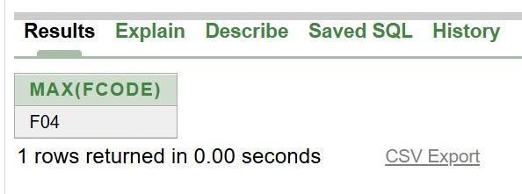

QUESTION:
- SELECT COUNT (DISTINCT PRICE) FROM GARMENT;

INPUT:
SELECT COUNT(DISTINCT PRICE) FROM GARMENT; OUTPUT:
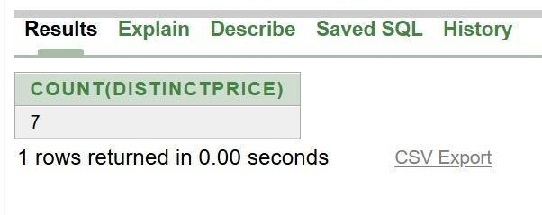

Given the following tables for a database FURNITURE : Write SQL command for (a) to
(f) and write the outputs for (g) on the bases of tables FURNITURE AND ARRIVALS. (a) To show all information about the baby cots from the FURNITURE table.
- To list the ITEMNAME which are priced at more than 15000 from the FURNITURE table.
- To list ITEMNAME AND TYPE of those items, in which DATEOFSTOCK is before 22/01/02 from the FURNITURE table in descending order of ITEMNAME.
- To display ITEMNAME and DATEOFSTOCK of those items, in which the DISCOUNT percentage is more than 25 from FURNITURE table.
- To count the number of items, whose TYPE is “Sofa” from FURNITURE table. (f) To insert a new row in the ARRIVALS table with the following data: 14, “Velvet touch”, Double bed”,
{25/03/03}, 25000, 30.
- Give the output of following SQL statement:
Note: outputs of the below mentioned queries should be based on original data given in both the tables i.e., without considering the insertion done in (g) part of this question.
  - Select COUNT(distinct TYPE) from FURNITURE;
  - Select MAX(DISCOUNT) from FURNITURE, ARRIVALS;
  - Select AVG(DISCOUNT) from FURNITURE where TYPE = “Baby cot”;
  - Select SUM(PRICE) from FURNITURE where DATEOFSTOCK < {12/02/02};

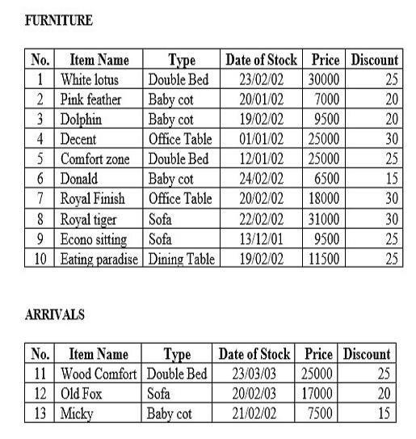

SYNTAX:
CREATE TABLE FURNITURE(NO INT PRIMARY KEY,ITEMNAME VARCHAR(30),TYPE VARCHAR(20),DATEOFSTOCK DATE,PRICE INT,DISCOUNT INT);
INSERT INTO FURNITURE VALUES(1,'White lotus','Double Bed',DATE '2002-0223',30000,25);
INSERT INTO FURNITURE VALUES(2,'Pink feather','Baby cot',DATE '2002-01-20',7000,20); INSERT INTO FURNITURE VALUES(3,'Dolphin','Baby cot',DATE '2002-02-19',9500,20); INSERT INTO FURNITURE VALUES(4,'Decent','Office Table',DATE '2002-01-01',25000,30); INSERT INTO FURNITURE VALUES(5,'Comfort zone','Double Bed',DATE '2002-0112',25000,25);
INSERT INTO FURNITURE VALUES(6,'Donald','Baby cot',DATE '2002-02-24',6500,15); INSERT INTO FURNITURE VALUES(7,'Royal Finish','Office Table',DATE '2002-0220',18000,30);
INSERT INTO FURNITURE VALUES(8,'Royal tiger','Sofa',DATE '2002-02-22',31000,30); INSERT INTO FURNITURE VALUES(9,'Econo sitting','Sofa',DATE '2001-12-13',9500,25);
INSERT INTO FURNITURE VALUES(10,'Eating paradise','Dining Table',DATE '2002-0219',11500,25);
CREATE TABLE ARRIVALS(NO INT PRIMARY KEY,ITEMNAME VARCHAR(30),TYPE VARCHAR(20),DATEOFSTOCK DATE,PRICE INT,DISCOUNT INT);

INSERT INTO ARRIVALS VALUES(11,'Wood Comfort','Double Bed',DATE '2003-0323',25000,25);
INSERT INTO ARRIVALS VALUES(12,'Old Fox','Sofa',DATE '2003-02-20',17000,20); INSERT INTO ARRIVALS VALUES(13,'Micky','Baby cot',DATE '2002-02-21',7500,15);

QUESTION:
    - To show all information about the baby cots from the FURNITURE table.

INPUT:
SELECT * FROM FURNITURE WHERE TYPE='Baby cot';

OUTPUT:
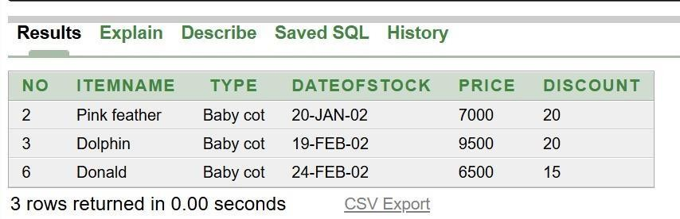

QUESTION:
    - To list the ITEMNAME which are priced at more than 15000 from the FURNITURE table.

INPUT:
SELECT ITEMNAME FROM FURNITURE WHERE PRICE>15000;

OUTPUT:
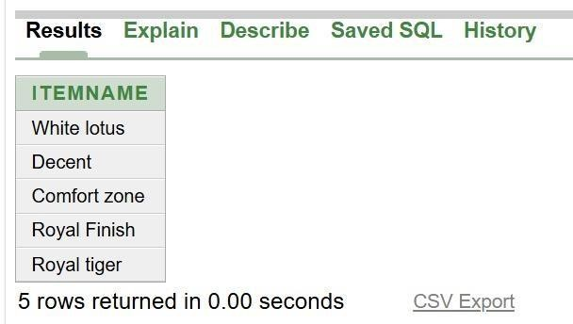

QUESTION:
    - To list ITEMNAME AND TYPE of those items, in which DATEOFSTOCK is before 22/01/02 from the FURNITURE table in descending order of ITEMNAME.

INPUT:

SELECT ITEMNAME,TYPE FROM FURNITURE WHERE DATEOFSTOCK<DATE '2002-01-01' ORDER BY ITEMNAME DESC;

OUTPUT:
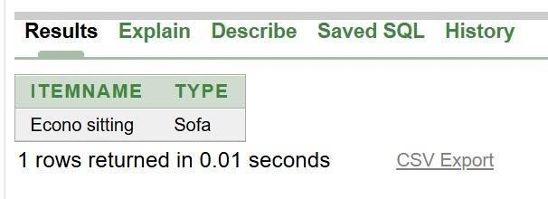

QUESTION:
    - To display ITEMNAME and DATEOFSTOCK of those items, in which the DISCOUNT percentage is more than 25 from FURNITURE table.

INPUT:
SELECT ITEMNAME,DATEOFSTOCK FROM FURNITURE WHERE DISCOUNT>25;

OUTPUT:
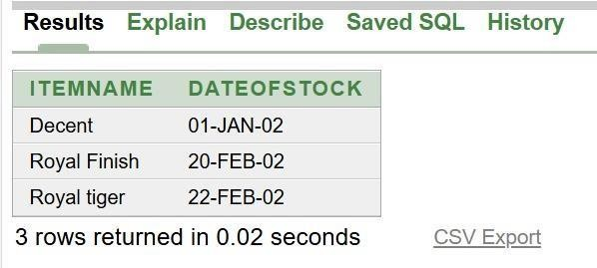

QUESTION:
    - To count the number of items, whose TYPE is “Sofa” from FURNITURE table.

INPUT:
SELECT COUNT(*) FROM FURNITURE WHERE TYPE='Sofa';

OUTPUT:
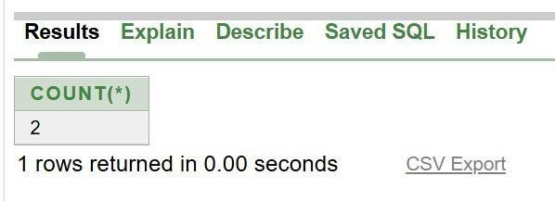

QUESTION:
    - To insert a new row in the ARRIVALS table with the following data: 14, “Velvet touch”, Double bed”, {25/03/03}, 25000, 30.

INPUT:
INSERT INTO ARRIVALS VALUES(14,'Velvet touch','Double bed',DATE '2003-0325',25000,30);

OUTPUT:
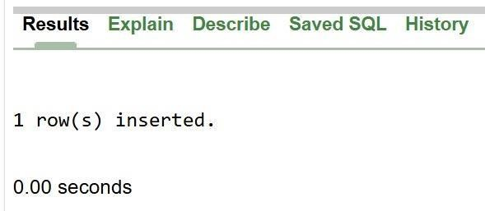

QUESTION:
    - Give the output of following SQL statement:
Note: outputs of the below mentioned queries should be based on original data given in both the tables i.e., without considering the insertion done in (g) part of this question.
      - Select COUNT(distinct TYPE) from FURNITURE;

INPUT:
SELECT COUNT(DISTINCT TYPE) FROM FURNITURE;

OUTPUT:
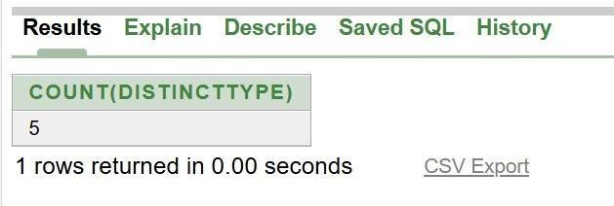

QUESTION:
      - Select MAX(DISCOUNT) from FURNITURE, ARRIVALS;

INPUT:
SELECT MAX(FURNITURE.DISCOUNT) FROM FURNITURE,ARRIVALS;

OUTPUT:
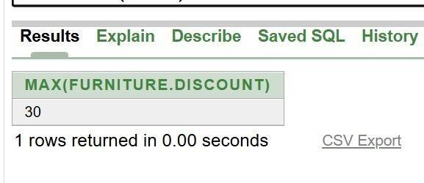

QUESTION:
      - Select AVG(DISCOUNT) from FURNITURE where TYPE = “Baby cot”;

INPUT:
SELECT AVG(DISCOUNT) FROM FURNITURE WHERE TYPE='Baby cot';

OUTPUT:
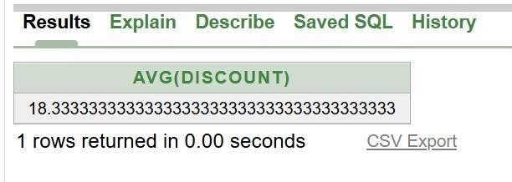

QUESTION:
      - Select SUM(PRICE) from FURNITURE where DATEOFSTOCK < {12/02/02};

INPUT:
SELECT SUM(PRICE) FROM FURNITURE WHERE DATEOFSTOCK<DATE '2002-02-12';

OUTPUT:
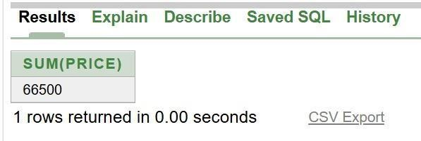
- Given the following COVID19 relation, write SQL commands for questions (a) to (f). a) Display all details of patients from Tamil Nadu.
b) Display the names of patients whose Status is Recovered. c) Display PatientName and Age in ascending order of Age.
- Display the names of patients who are Vaccinated = 'Yes'.
- Count the number of patients whose status is Active.
- Insert the following record into the COVID19 table: 108, 'Anitha', 'Puducherry', 39, 'Recovered', 'Yes'
- Write the output of the following SQL commands. a. SELECT COUNT() FROM COVID19;
- SELECT MAX(Age) FROM COVID19;
- SELECT COUNT() FROM COVID19 WHERE Vaccinated='Yes';
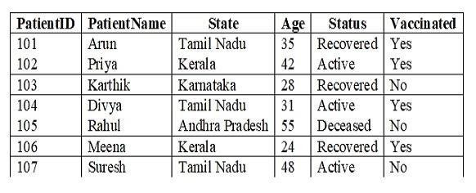
- SELECT MIN(Age)FROM COVID19 WHERE Status='Recovered';

SYNTAX:

CREATE TABLE COVID19 (PatientID INT PRIMARY KEY, PatientName VARCHAR(20),
State VARCHAR(30), Age INT, Status VARCHAR(15), Vaccinated VARCHAR(5)); INSERT INTO COVID19 VALUES (101, 'Arun', 'Tamil Nadu', 35, 'Recovered', 'Yes'); INSERT INTO COVID19 VALUES (102, 'Priya', 'Kerala', 42, 'Active', 'Yes');
INSERT INTO COVID19 VALUES (103, 'Karthik', 'Karnataka', 28, 'Recovered', 'No'); INSERT INTO COVID19 VALUES (104, 'Divya', 'Tamil Nadu', 31, 'Active', 'Yes');
INSERT INTO COVID19 VALUES (105, 'Rahul', 'Andhra Pradesh', 55, 'Deceased', 'No'); INSERT INTO COVID19 VALUES (106, 'Meena', 'Kerala', 24, 'Recovered', 'Yes');

INSERT INTO COVID19 VALUES (107, 'Suresh', 'Tamil Nadu', 48, 'Active', 'No');

QUESTION:
- Display all details of patients from Tamil Nadu.

INPUT:
SELECT * FROM COVID19 WHERE State = 'Tamil Nadu';

OUTPUT:
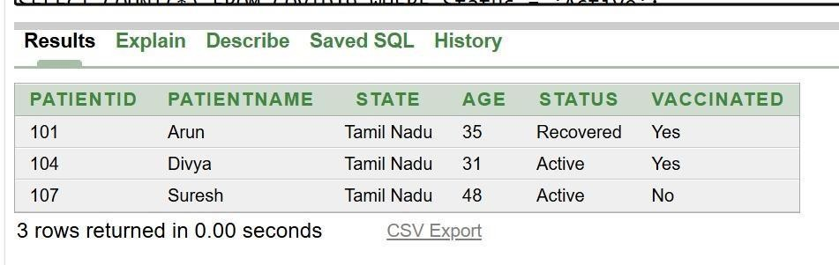

QUESTION:
- Display the names of patients whose Status is Recovered.

INPUT:
SELECT PatientName FROM COVID19 WHERE Status = 'Recovered';

OUTPUT:
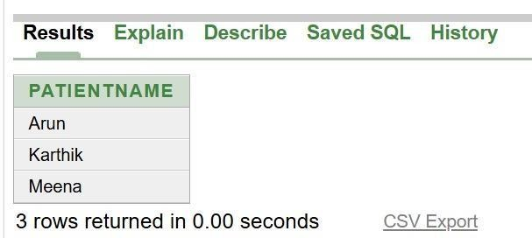

QUESTION:
- Display PatientName and Age in ascending order of Age.

INPUT:
SELECT PatientName, Age FROM COVID19 ORDER BY Age ASC;

OUTPUT:
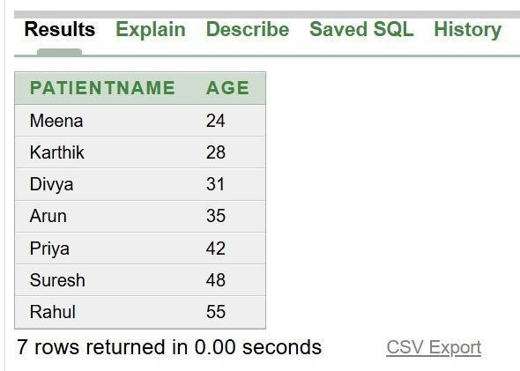

QUESTION:
- Display the names of patients who are Vaccinated = 'Yes'.

INPUT:
SELECT PatientName FROM COVID19 WHERE Vaccinated = 'Yes';

OUTPUT:
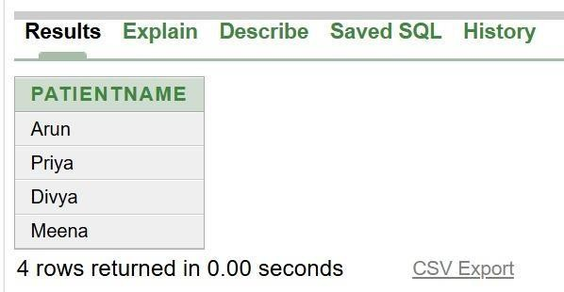

QUESTION:
- Count the number of patients whose status is Active.

INPUT:
SELECT COUNT(*) FROM COVID19 WHERE Status = 'Active';

OUTPUT:
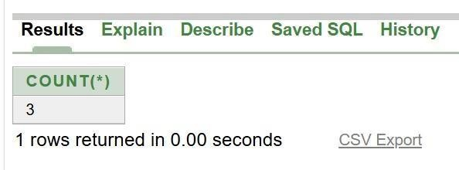

QUESTION:
- Insert the following record into the COVID19 table: 108, 'Anitha', 'Puducherry', 39, 'Recovered', 'Yes'

INPUT:
INSERT INTO COVID19 VALUES (108, 'Anitha', 'Puducherry', 39, 'Recovered', 'Yes');

OUTPUT:
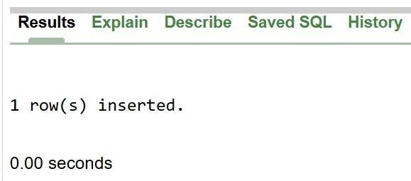

QUESTION:
- Write the output of the following SQL commands. a. SELECT COUNT() FROM COVID19;

INPUT:
SELECT COUNT(*) FROM COVID19;

OUTPUT:
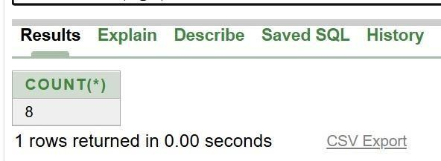

QUESTION:
- SELECT MAX(Age) FROM COVID19;

INPUT:
SELECT MAX(Age) FROM COVID19;

OUTPUT:
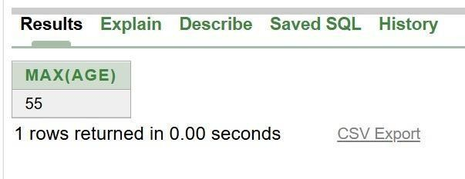

QUESTION:
SELECT COUNT() FROM COVID19 WHERE Vaccinated='Yes';

INPUT:
SELECT COUNT(*) FROM COVID19 WHERE Vaccinated = 'Yes';

OUTPUT:
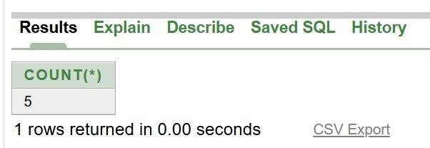

QUESTION:
- SELECT MIN(Age)FROM COVID19 WHERE Status='Recovered';

INPUT:
SELECT MIN(Age) FROM COVID19 WHERE Status = 'Recovered';

OUTPUT:
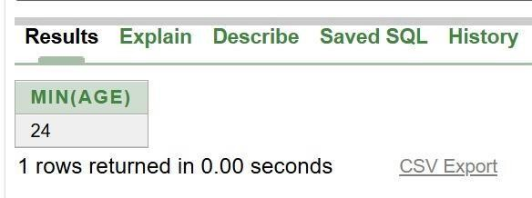

Given the following HOUSEPRICE relation, write SQL commands for questions (a) to (f).
- Display all houses located in Chennai.
- Display the Location and Price of houses having 3 Bedrooms. c) Display Location, AreaSqft, and Price in descending order of Price.
- Display the details of houses costing more than ₹70,00,000.
- Count the number of Apartments.
- Insert the following record: 208, 'Vellore', 3, 1700, 7300000, 'Villa' (g) Write the output of the following SQL commands.
(i) SELECT MAX(Price)FROM HOUSEPRICE;
- SELECT MIN(AreaSqft)FROM HOUSEPRICE;
- SELECT AVG(Price)FROM HOUSEPRICE WHERE HouseType='Apartment';
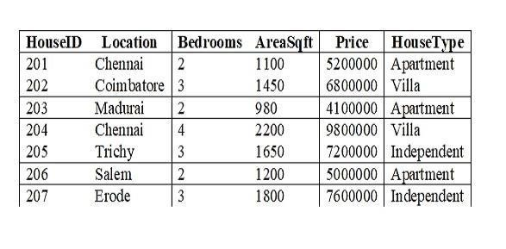
- SELECT COUNT(*)FROM HOUSEPRICE WHERE Bedrooms=3;

SYNTAX:

CREATE TABLE HOUSEPRICE (HouseID INT PRIMARY KEY, Location VARCHAR(20),
Bedrooms INT, AreaSqft INT, Price INT, HouseType VARCHAR(20));
INSERT INTO HOUSEPRICE VALUES (201, 'Chennai', 2, 1100, 5200000, 'Apartment');
INSERT INTO HOUSEPRICE VALUES (202, 'Coimbatore', 3, 1450, 6800000, 'Villa');
INSERT INTO HOUSEPRICE VALUES (203, 'Madurai', 2, 980, 4100000, 'Apartment');
INSERT INTO HOUSEPRICE VALUES (204, 'Chennai', 4, 2200, 9800000, 'Villa');
INSERT INTO HOUSEPRICE VALUES (205, 'Trichy', 3, 1650, 7200000, 'Independent');
INSERT INTO HOUSEPRICE VALUES (206, 'Salem', 2, 1200, 5000000, 'Apartment'); INSERT
INTO HOUSEPRICE VALUES (207, 'Erode', 3, 1800, 7600000, 'Independent');

QUESTION:
  - Display all houses located in Chennai.

INPUT:
SELECT * FROM HOUSEPRICE WHERE Location = 'Chennai';

OUTPUT:
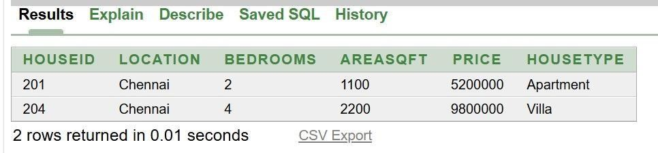

QUESTION:
  - Display the Location and Price of houses having 3 Bedrooms.

INPUT:
SELECT Location, Price FROM HOUSEPRICE WHERE Bedrooms = 3;

OUTPUT:
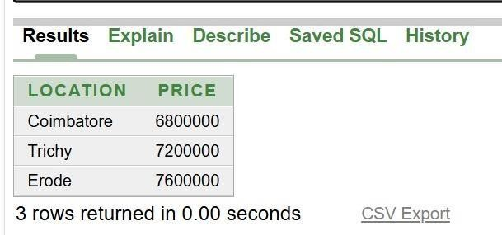

QUESTION:
  - Display Location, AreaSqft, and Price in descending order of Price.

INPUT:
SELECT Location, AreaSqft, Price FROM HOUSEPRICE ORDER BY Price DESC;

OUTPUT:
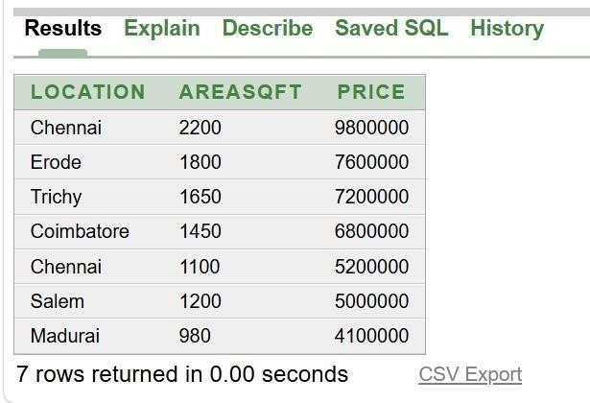

QUESTION:
  - Display the details of houses costing more than ₹70,00,000.

INPUT:
SELECT * FROM HOUSEPRICE WHERE Price > 7000000;

OUTPUT:
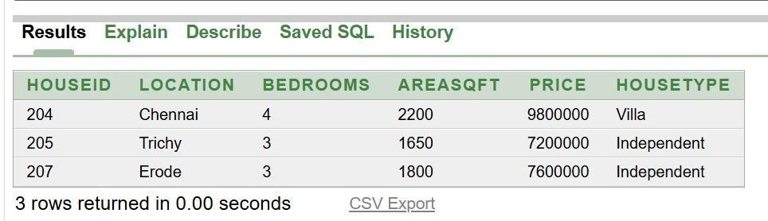

QUESTION:
  - Count the number of Apartments.

INPUT:
SELECT COUNT(*) FROM HOUSEPRICE WHERE HouseType = 'Apartment';

OUTPUT:
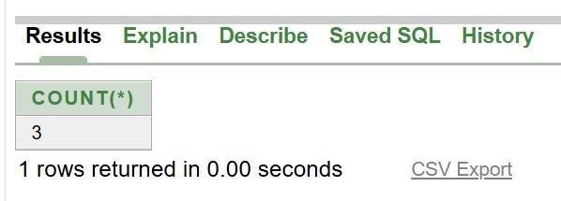

QUESTION:
  - Insert the following record: 208, 'Vellore', 3, 1700, 7300000, 'Villa'

INPUT:
INSERT INTO HOUSEPRICE VALUES (208, 'Vellore', 3, 1700, 7300000, 'Villa');

OUTPUT:
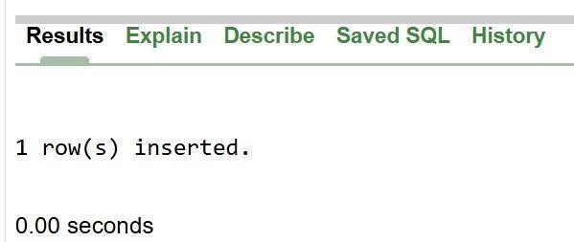

QUESTION:
- Write the output of the following SQL commands.
  - SELECT MAX(Price)FROM HOUSEPRICE;

INPUT:
SELECT MAX(Price) FROM HOUSEPRICE;

OUTPUT:
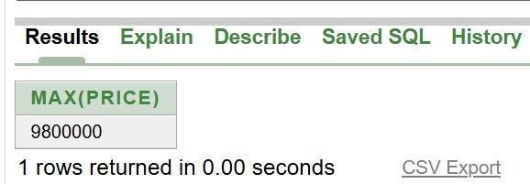

QUESTION:
- SELECT MIN(AreaSqft)FROM HOUSEPRICE;

INPUT:
SELECT MIN(AreaSqft) FROM HOUSEPRICE;

OUTPUT:
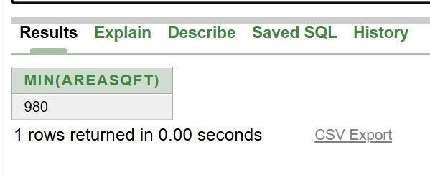

QUESTION:
- SELECT AVG(Price)FROM HOUSEPRICE WHERE
HouseType='Apartment';

INPUT:
SELECT AVG(Price) FROM HOUSEPRICE WHERE HouseType = 'Apartment';

OUTPUT:
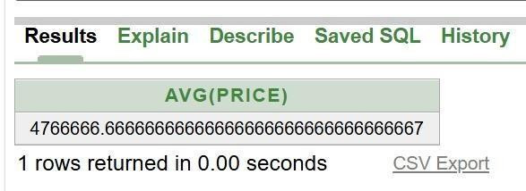

QUESTION:
- SELECT COUNT(*)FROM HOUSEPRICE WHERE Bedrooms=3;

INPUT:
SELECT COUNT(*) FROM HOUSEPRICE WHERE Bedrooms = 3;

OUTPUT:
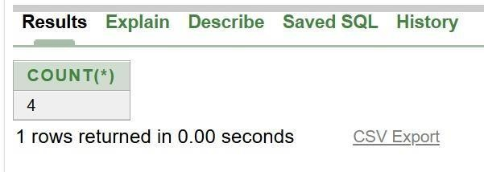

Given the following CANCERDATA relation, write SQL commands for questions (a) to (f).
- Display all patients diagnosed with Breast Cancer.
- Display the names of patients whose Stage is III.
- Display PatientName and Age in ascending order of Age.
- Display the names of patients having SurvivalYears greater than 5.
- Count the number of patients diagnosed with Lung Cancer.
- Insert the following record: 308, 'Anand', 'Leukemia', 50, 'II', 7 (g) Write the output of the following SQL commands.
  - SELECT COUNT(DISTINCT CancerType) FROM CANCERDATA;
  - SELECT MAX(SurvivalYears) FROM CANCERDATA;
  - SELECT AVG(Age) FROM CANCERDATA WHERE CancerType='Breast';
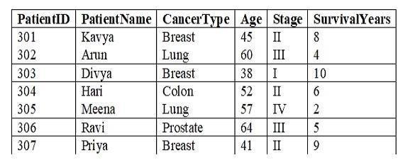
  - SELECT MIN(Age) FROM CANCERDATA WHERE Stage='II';

SYNTAX:
CREATE TABLE CANCERDATA (PatientID INT PRIMARY KEY, PatientName
VARCHAR(20), CancerType VARCHAR(20), Age INT, Stage VARCHAR(5), SurvivalYears INT);
INSERT INTO CANCERDATA VALUES (301, 'Kavya', 'Breast', 45, 'II', 8); INSERT INTO CANCERDATA VALUES (302, 'Arun', 'Lung', 60, 'III', 4);
INSERT INTO CANCERDATA VALUES (303, 'Divya', 'Breast', 38, 'I', 10); INSERT INTO CANCERDATA VALUES (304, 'Hari', 'Colon', 52, 'II', 6);

INSERT INTO CANCERDATA VALUES (305, 'Meena', 'Lung', 57, 'IV', 2); INSERT INTO CANCERDATA VALUES (306, 'Ravi', 'Prostate', 64, 'III', 5); INSERT INTO CANCERDATA VALUES (307, 'Priya', 'Breast', 41, 'II', 9);

QUESTION:
    - Display all patients diagnosed with Breast Cancer.

INPUT:
SELECT * FROM CANCERDATA WHERE CancerType='Breast';

OUTPUT:
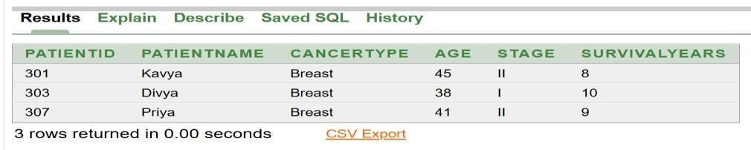

QUESTION:
    - Display the names of patients whose Stage is III.

INPUT:
SELECT PatientName FROM CANCERDATA WHERE Stage='III';

OUTPUT:
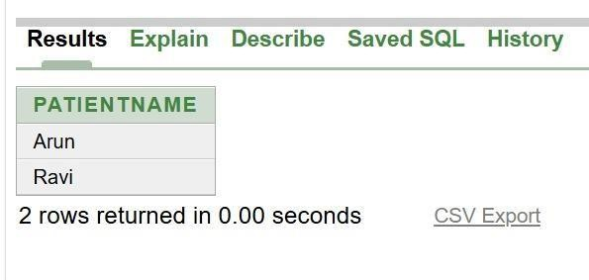

QUESTION:
    - Display PatientName and Age in ascending order of Age.

INPUT:
SELECT PatientName,Age FROM CANCERDATA ORDER BY Age ASC;

OUTPUT:
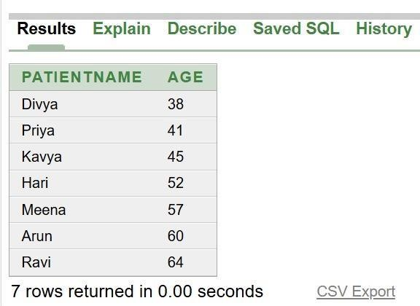

QUESTION:
    - Display the names of patients having SurvivalYears greater than 5.

INPUT:
SELECT PatientName FROM CANCERDATA WHERE SurvivalYears>6;

OUTPUT:
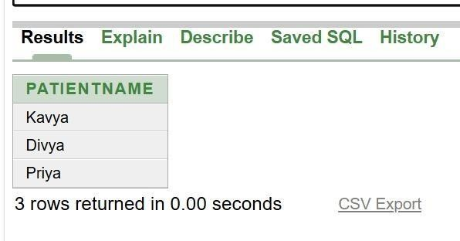

QUESTION:
    - Count the number of patients diagnosed with Lung Cancer.

INPUT:
SELECT COUNT(*) FROM CANCERDATA WHERE CancerType='Lung';

OUTPUT:
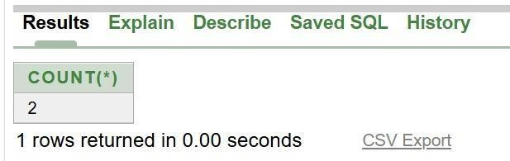

QUESTION:
    - Insert the following record: 308, 'Anand', 'Leukemia', 50, 'II', 7

INPUT:
INSERT INTO CANCERDATA VALUES (308, 'Anand', 'Leukemia', 50, 'II', 7);

OUTPUT:
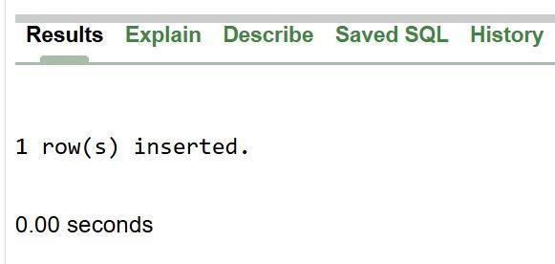

QUESTION:
- Write the output of the following SQL commands.
  - SELECT COUNT(DISTINCT CancerType) FROM CANCERDATA;

INPUT:
SELECT COUNT(DISTINCT CancerType) FROM CANCERDATA;

OUTPUT:
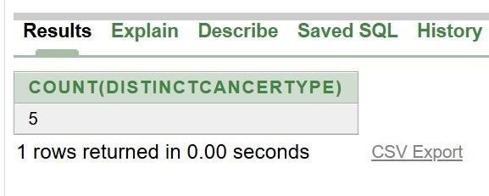

QUESTION:
  - SELECT MAX(SurvivalYears) FROM CANCERDATA;

INPUT:
SELECT MAX(SurvivalYears) FROM CANCERDATA;

OUTPUT:
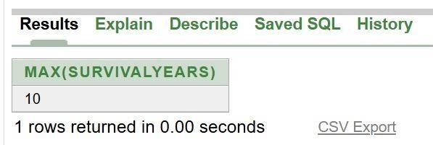

QUESTION:
  - SELECT AVG(Age) FROM CANCERDATA WHERE
CancerType='Breast';

INPUT:
SELECT AVG(Age) FROM CANCERDATA WHERE CancerType='Breast';

OUTPUT:
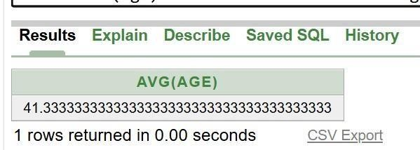

QUESTION:
  - SELECT MIN(Age) FROM CANCERDATA WHERE Stage='II';

INPUT:
SELECT MIN(Age) FROM CANCERDATA WHERE Stage='II';

OUTPUT:
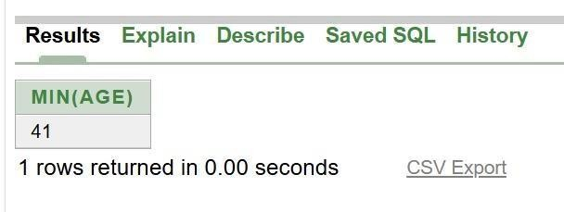

Write SQL queries for (a) to (f) and write the outputs for the SQL queries mentioned shown in (g1) to (g4) parts on the basis of tables ITEMS and TRADERS
  - To display the details of all the items in ascending order of item names (i.e. INAME). (b) To display item name and price of all those items, whose price is in the range of 10000 and 22000 (both values inclusive).
- To display the number of items, which are traded by each trader. The expected output of this query should be T01 2 T02 2 T03 1
- To display the price, item name (i.e. INAME) and quantity (i.e. QTY) of those items which have quantity more than 150.
- To display the names of those traders, who are either from DELHI or from MUMBAI.
- To display the name of the companies and the bane of the items in descending order of company names.
- Obtain the outputs of the following SQL queries based on the data given in tables ITEMS and TRADERS.
(g1) SELECT MAX (PRICE), MIN (PRICE) FROM ITEMS;
(g2) SELECT PRICE * QTY AMOUNT FROM ITEMS WHERE CODE = 1004; (g3) SELE CT DISTINCT TCODE FROM ITEMS;
(g4) SELECT INAME, TNAME FROM ITEMS I, TRASERS T WHERE I, TCODE AND QTY<100;

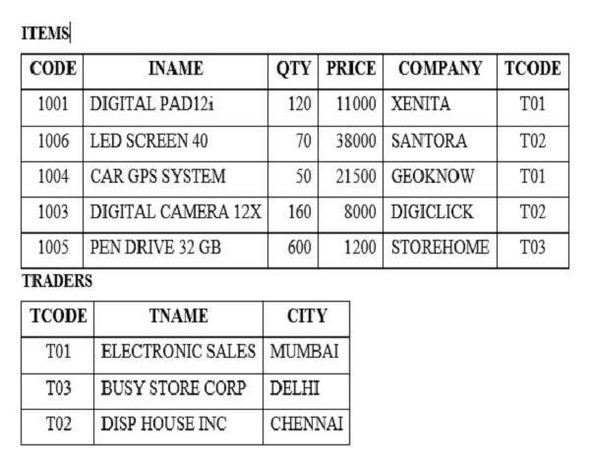

SYNTAX:
CREATE TABLE ITEMS (CODE INT PRIMARY KEY, INAME VARCHAR(30), QTY INT, PRICE INT, COMPANY VARCHAR(20), TCODE VARCHAR(5));
INSERT INTO ITEMS VALUES (1001, 'DIGITAL PAD12i', 120, 11000, 'XENITA', 'T01'); INSERT INTO ITEMS VALUES (1006, 'LED SCREEN 40', 70, 38000, 'SANTORA', 'T03'); INSERT INTO ITEMS VALUES (1004, 'CAR GPS SYSTEM', 50, 21500, 'GEOKNOW', 'T02'); INSERT INTO ITEMS VALUES (1003, 'DIGITAL CAMERA 12X', 160, 8000, 'DIGICLICK', 'T01');
INSERT INTO ITEMS VALUES (1005, 'PEN DRIVE 32 GB', 600, 1200, 'STOREHOME', 'T02');
CREATE TABLE TRADERS (TCODE VARCHAR(5) PRIMARY KEY, TNAME VARCHAR(30), CITY VARCHAR(20));
INSERT INTO TRADERS VALUES ('T01', 'ELECTRONIC SALES', 'MUMBAI'); INSERT INTO TRADERS VALUES ('T03', 'BUSY STORE CORP', 'DELHI'); INSERT INTO TRADERS VALUES ('T02', 'DISP HOUSE INC', 'CHENNAI');

QUESTION:
- To display the details of all the items in ascending order of item names (i.e. INAME).

INPUT:
SELECT * FROM ITEMS ORDER BY INAME ASC;

OUTPUT:
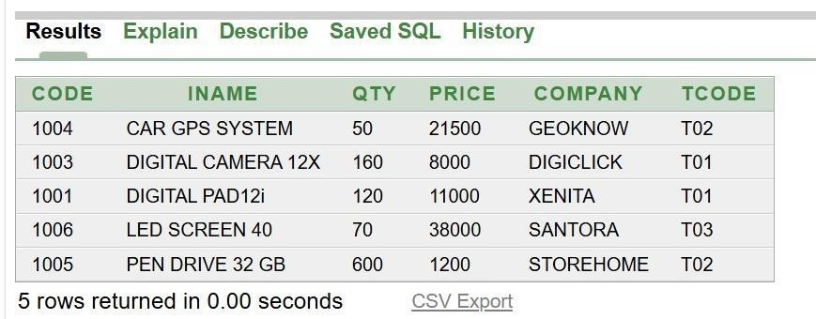

QUESTION:
- To display item name and price of all those items, whose price is in the range of 10000 and 22000 (both values inclusive).

INPUT:
SELECT INAME, PRICE FROM ITEMS WHERE PRICE BETWEEN 10000 AND 22000;

OUTPUT:
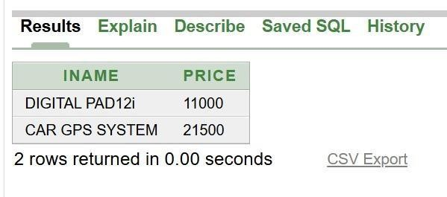

QUESTION:
- To display the number of items, which are traded by each trader. The expected output of this query should be T01 2 T02 2 T03 1

INPUT:
SELECT TCODE, COUNT(*) FROM ITEMS GROUP BY TCODE;

OUTPUT:
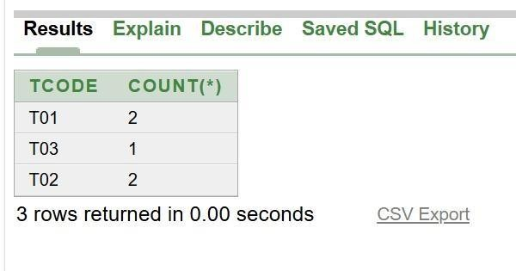

QUESTION:
- To display the price, item name (i.e. INAME) and quantity (i.e. QTY) of those items which have quantity more than 150.

INPUT:
SELECT PRICE, INAME, QTY FROM ITEMS WHERE QTY>150;

OUTPUT:
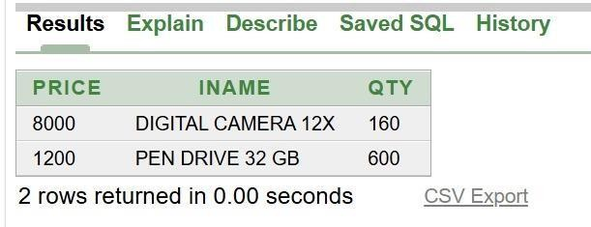

QUESTION:
- To display the names of those traders, who are either from DELHI or from MUMBAI.

INPUT:
SELECT TNAME FROM TRADERS WHERE CITY='DELHI' OR CITY='MUMBAI';

OUTPUT:
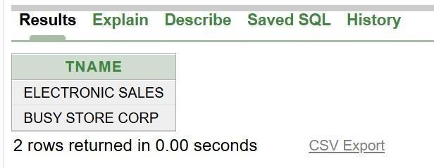

QUESTION:
- To display the name of the companies and the bane of the items in descending order of company names.

INPUT:
SELECT COMPANY, INAME FROM ITEMS ORDER BY COMPANY DESC;

OUTPUT:
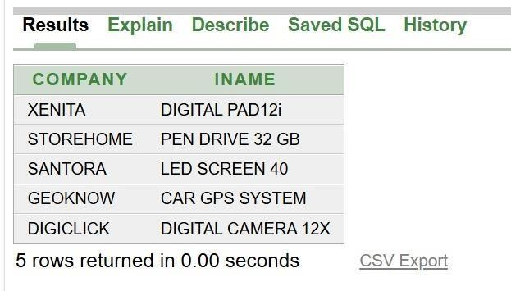

QUESTION:
- Obtain the outputs of the following SQL queries based on the data given in tables ITEMS and TRADERS.
(g1) SELECT MAX (PRICE), MIN (PRICE) FROM ITEMS;

INPUT:
SELECT MAX(PRICE), MIN(PRICE) FROM ITEMS;

OUTPUT:
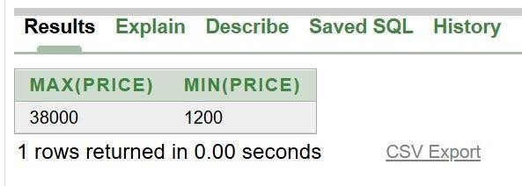

QUESTION:
(g2) SELECT PRICE * QTY AMOUNT FROM ITEMS WHERE CODE = 1004;

INPUT:
SELECT PRICE*QTY AS AMOUNT FROM ITEMS WHERE CODE=1004;

OUTPUT:
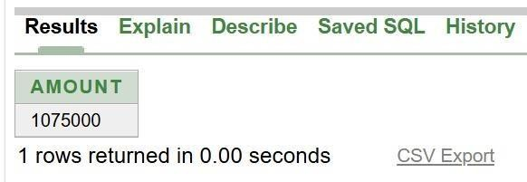

QUESTION:
(g3) SELE CT DISTINCT TCODE FROM ITEMS;

INPUT:
SELECT DISTINCT TCODE FROM ITEMS;

OUTPUT:
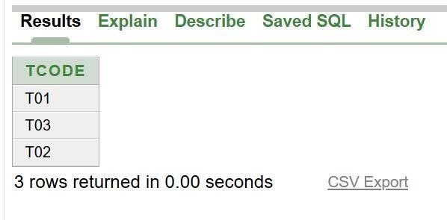

QUESTION:
(g4) SELECT INAME, TNAME FROM ITEMS I, TRASERS T WHERE I, TCODE AND QTY<100;

INPUT:
SELECT INAME, TNAME FROM ITEMS I, TRADERS T WHERE I.TCODE=T.TCODE AND QTY<100;

OUTPUT:
